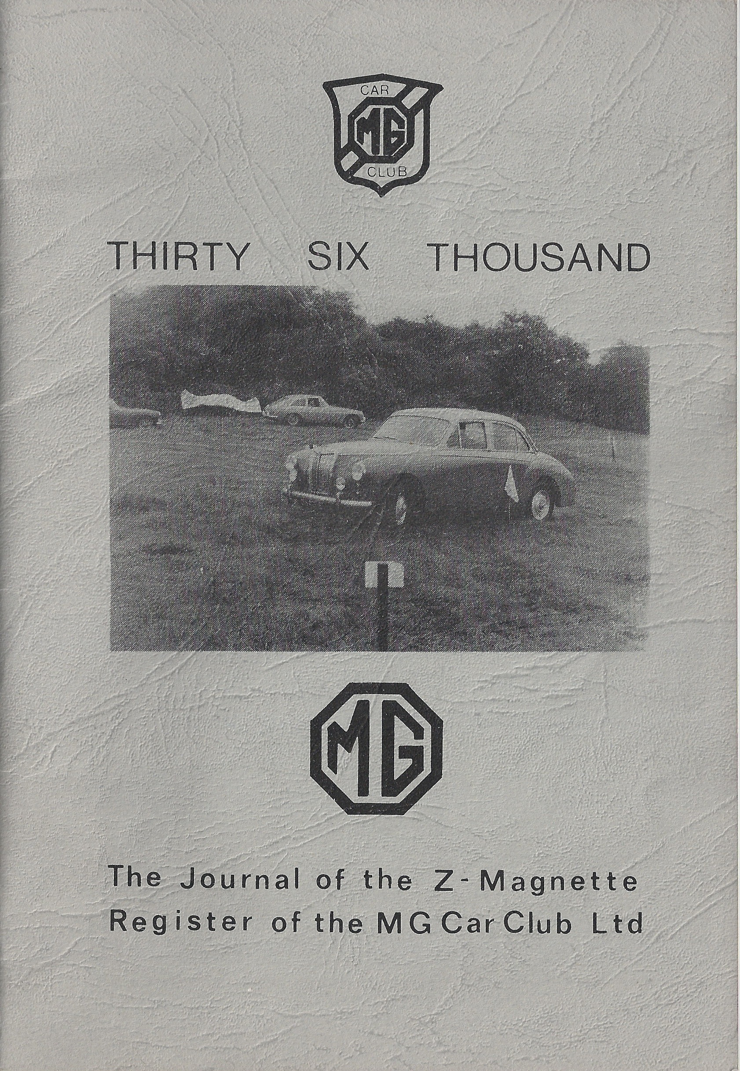
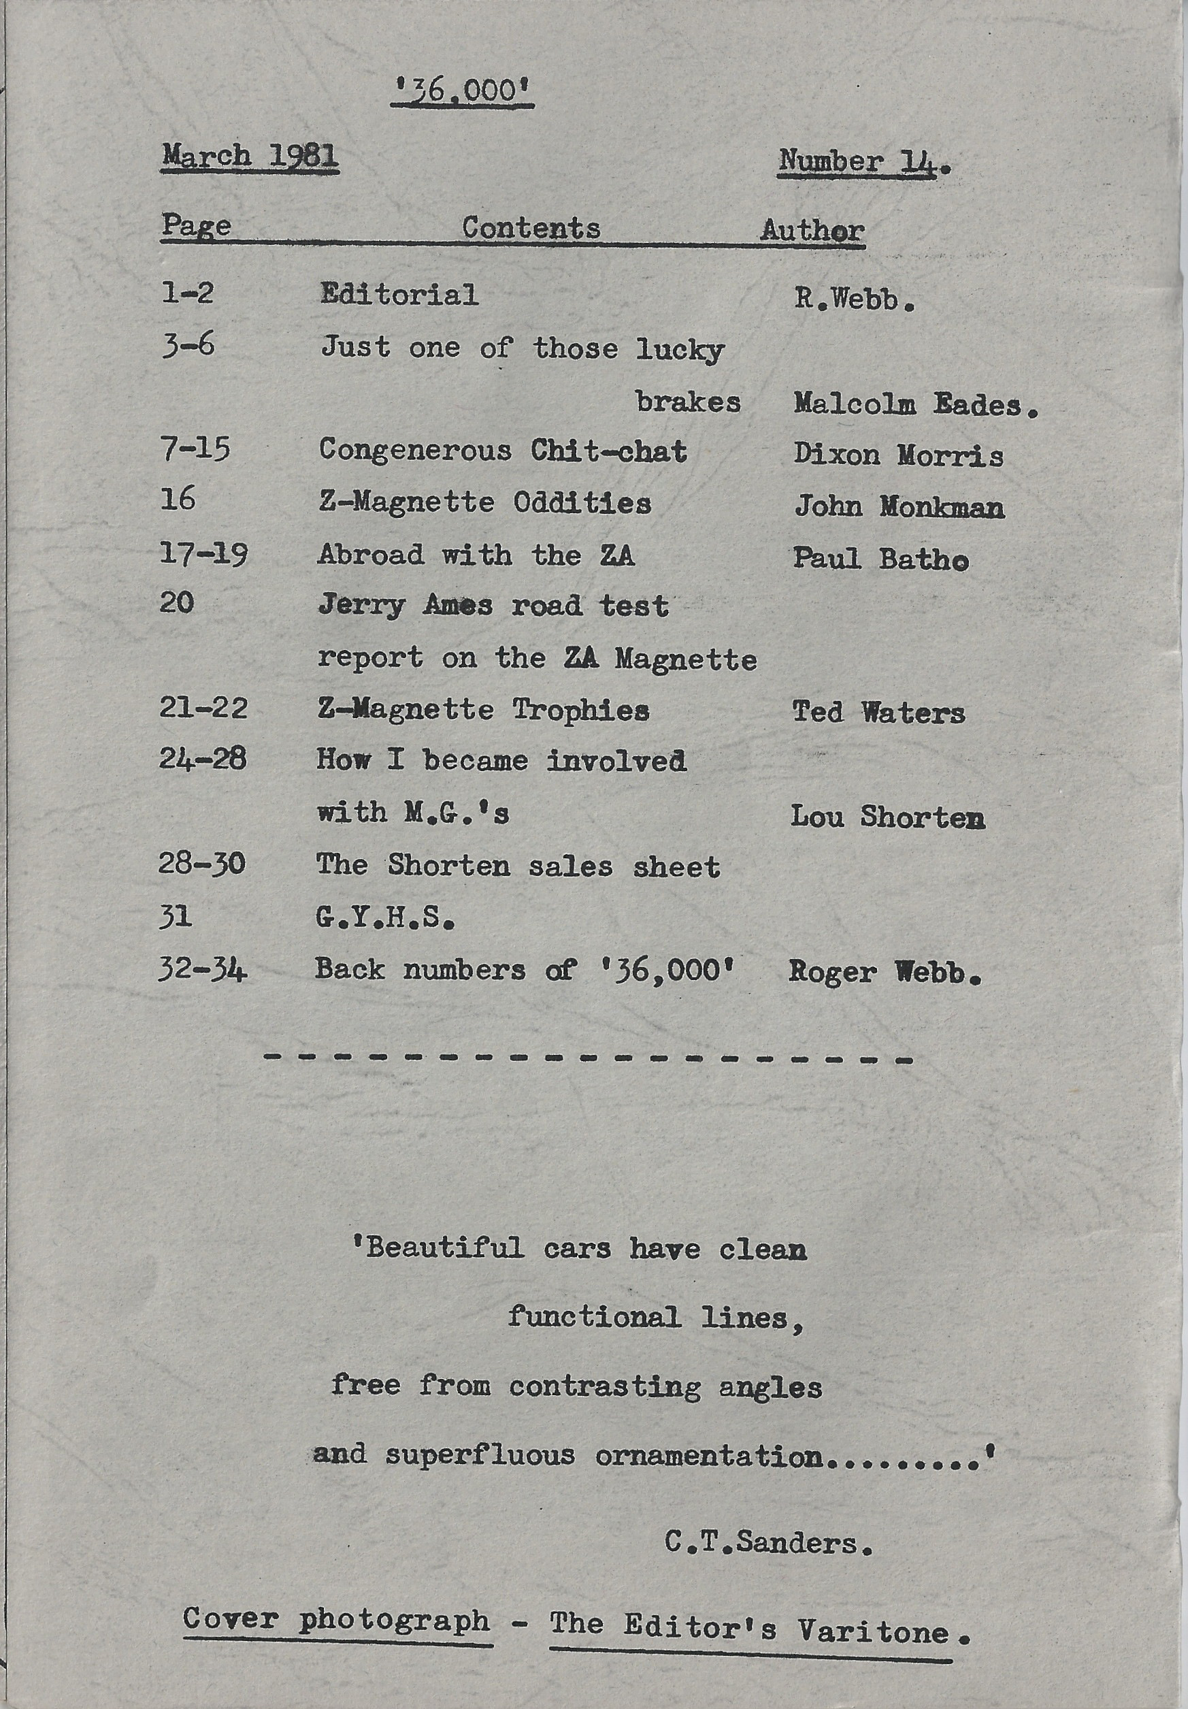
HOW I BECAME INVOLVED IN MG’S

I am very often asked: how I, as a mere female, got involved in ‘messing’ about with cars, and anyway what is so special about MG’s. No need to answer the latter in these circ1es! As for the former, it began a long time ago. Having on fewer than five brothers older than myself, and being the only girl in the family at that, time, I was brought up in a world full of talk about aeroplanes, cars and Brooklands. The latter always comes to mind as we lived only a few miles from the magic track. I used to wish I was old enough to be allowed to accompany my brothers when they went to a race meeting, but no such luck.
None of my brothers were allowed to have motor bikes, so they went through a succession of various cars. There were the usual Austins, Morris and one decrepit Citreon with a dicky purchased for £4, which never seemed to go, as we were always having to lend a hand to push it, Then there was a BSA which shed a rear wheel in Wales while struggling up a steep gradient, carrying too many of us on an expedition to climb Snowdon. (It was not until 1975 that I managed to complete that mission, when John and I went to Wales in one of the Magnettes).
After that came an Opel which worked very hard in 1940 making many trips from London to Staffordshire moving a great deal of our household effects. My eldest brother had bought this car for £12 which must have been very reasonable even in those days as it was hardly a year old. however, he lent it to a fellow RAF officer one night, who kindly drove it through a bridge into a canal, so that was the end of her and also the last of the oldies. Of all these and many others there had never been an MG in the family. One brother did have a friend with an ‘M’ type, and I always used to think he must be very well off to own such a beautiful car. That was the first MG that I can remember, and the car that started for me the ‘Magic of MG’.
Many years later I bought my first car for £40. This was a 1934 Vauxhall 14. She did not live very long as she suffered from serious crankshaft problems. Soon after she arrived we had to strip the engine down and re-metal the big ends. This held out long enough for me to learn to drive, but after 300 miles she went again. Not wanting to stretch the patience of various friends with her problems, I decided to tackle the problem myself. I must have been either crazy or desperate as I had only handful of spanners, ancient ones at that, but low co behold the operation was a success and she continued for several more miles until I finally sold her for scrap.
It was several months before I could afford another car particularly as I did not went a repeat performance of the Vauxhall. This time I found a 1937 Rover 12 sports saloon. She was a good, fast car but parts were very expensive, so I decided to trade her in at the same garage for a 1950 Hillman Estate, This too was a good reliable vehicle but not exactly my idea of a real car • Finances forced her to remain for over 2 years.
What is all this rambling to do with I4Ps you are saying?
In 1956 I was working on a farm in Sussex, and one morning I had to get some gear out of the harness room, there, blocking the door was a gleaning black saloon car. Yes, you have guessed. A brand new ZA. I don’t know how long I stood gazing at this wonderful piece of machinery, but I saw the keys were in the ignition and plucked up courage to get in and reverse her out of the way. That was the definite beginning of my mania for MG’s. I had never seen such a fantastic car.
The following year, after moving to Norfolk, we decided the time had come to get rid of the Hillman and find a bigger and core comfortable car. As we had had two reliable cars from the garage in Sussex, we planned a visit during our holidays.
We had decided on a Jaguar or Sheerline, as these larger cars were going for a song in those days, partly owing to the Suez crisis. Full of expectations we arrived at the garage only to find they had nothing to offer but the usual cheaper economy types. Nothing would tempt me to consider any of them, disgusted and disappointed I dragged my feet beck to the Hillman (not what I was calling it by this time), with the Salesman making helpful suggestions about coring back at a later date to see if they had anything else in stock. Out on the road stood a black ZA. With a very superior look, I turned to the poor Salesman and said “THAT is what I call a car’. Imagine my surprise when he said, “Well you can have it if you want it.” Some poor misguided soul had just traded her in for a new Renault Dauphin! Of course she was considerably more than the £450 we bad in mind, but it was the chance of a lifetime as far as I was concerned. YPG 136 or WIPY as she has been affectionately known every since, had only 10,000 miles to her credit, but during the following 12 years added another faithful 240,000 miles. She has been in retirement since the late 60’s, and waits patiently for the day when she can return to the road.
No Z could ever have suffered the hard life of Wipy. She was treated more like a commercial vehicle, except that even they can expect an oil change or a service. In her time she frequently carried half a ton of poultry food (in the boot and inside on the front and back seats), also crates of poultry, young calves and once a 6 month old Hereford hobbled on the back seat for over 40 miles. The seats stood up to the bad treatment very well and still look quite respectable as I always cleaned her out afterwards! In her prime she was capable of speed, in excess of 100 mph and once topped 107 mph against a stop watch. Her fuel consumption was exceptional, hardly ever under 37 mpg, usually 42 mpg on long runs and on one occasion when she ran out of petrol she covered 94 miles on two gallons.
Unfortunately, her carbs eventually got a bit tired, so she was treated to a new pair. She was never quite the same again and her consumption was never better than 35 mpg after that, and her top speed was down to 98 mph. I would like to add at this point, for the benefit of those who find this hard to believe, that in 1965 I had two other ZA’s that also topped the 100 mph, although their fuel consumption only about 32 mpg I have also never driven a ZB or Varitone that would match this performance, most of which find it hard going to reach 90 mph.
In 1963 Wipy started chucking oil out of her back main oil seal. I consulted a local main dealer who suggested that they should give her engine a major overhaul. Not relishing the thought of another Vauxhall episode, I was only too happy to get them to do the job properly. To this day I have never been able to fathom out exactly what they did to her because after 1,000 miles her big ends started to rattle. Back she went to the garage. Another 1,000 miles and the same thing happened. Back again. This time at about 500 miles the crankshaft broke. That was the only time in her life she never completed a journey under her own steam. So this time she had a gold seal transplant.
Maggie no. 2 was purchased in 1964 for £60 for spares, from a garage where I was working at the time. She had been traded in when she developed big end trouble. She was a ZA, very scruffy but with very good chrome and no rust. Far too good to dismantle, so when another one was advertised locally a few weeks later as a repairable write off, for £50, I rushed off to have a look. This one had just been fitted with a Gold Seal engine, so now we had Maggie no. 3, with a good engine for no. 2. Of course things did not work out that way. This one was far too good also. This is when I really started the ‘messing’ about with MGs. With a new radiator and an exchange front bumper, a front end respray after straightening a wing and a kink in the bonnet, she was back on the road looking almost as good as new. (I had just spent a tedious month practising spraying on Wipy).
Having gained confidence with this successful exercise I decided to tackle the engine on Maggie no. 2. I stripped this down and found she had had the top end done but the crank had been neglected. False economy with these engines. I had the crank re-ground and got a new oil pump and soon had her running perfectly. I also resprayed her (getting better by this time), and although I eventually sold her, I got her back 2 years later when she met with a fatal accident. I still have her engine and gearbox hidden away so may be one day I will have a ton up ZA again.
From the mid 1960’s I was beginning to find it difficult to get parts, so being determined to keep the Magnettes on the road, I started collecting as many almost beyond repair Z’s as possible. Many of these have been dismantled for spares and one or two are, awaiting rebuilds. XPW 329 took us over 4 years of available spare time to complete. She was rescued from stock car fate. I have lost count of the Z’s now especially as we have a few other varieties to keep us busy. With all the rust problems that increase with age these jobs take longer and longer. John is in his element tackling the rusty bodies. He does all the chassis and body rebuilding leaving only the spraying for me to do. He has just finished the chassis and mechanicals on our 1939 Wolseley 10 and has got stuck into the very difficult task of trying to reconstruct her body. I am afraid I would not have the patience to try and do this and anyway I would not know where to begin. When this project is completed I hope we can star on another Z.

Lou Shorten
Originally published in 36000 magazine – a magazine dedicated to MG Magnettes - March 1981

