**The Grand Tour of the Ohio Valley**

**Wednesday, October 1, 2025**

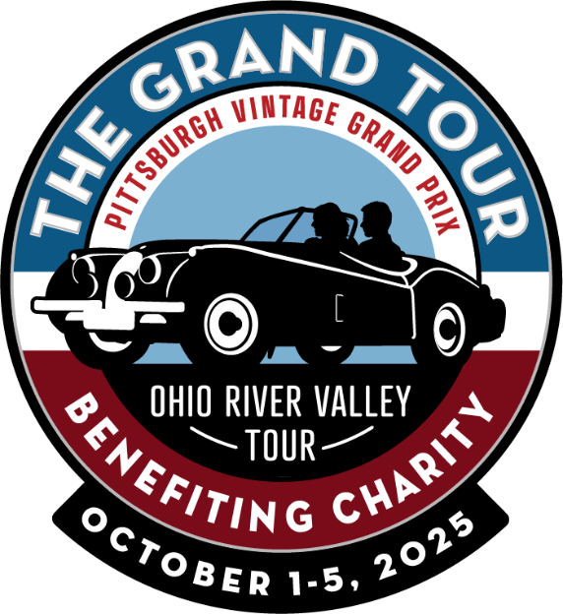October 1 through 5, 2025. In keeping with the Pittsburgh Vintage Grand Prix tradition of exciting and successful automotive-related events, we are announcing the ‘Grand Tour’, a new touring event starting this fall! The tour will include an exciting, informative schedule of events exploring the Ohio River Valley, shopping, meals, and other points of interest.

The Grand Tour is a five-day, all-inclusive event featuring vintage sports and GT cars. This driving tour will feature a delightful collection of scenic, twisting, and lightly traveled back roads, and we will cover approximately 100 miles per day.

Our inaugural event will be held in Marietta, Ohio, where we will experience the rich history of the Ohio River and surrounding area. Guests will stay at the historic Lafayette Hotel, where they can experience the classic elegance of the grand riverboat era. Security is included in our parking area.

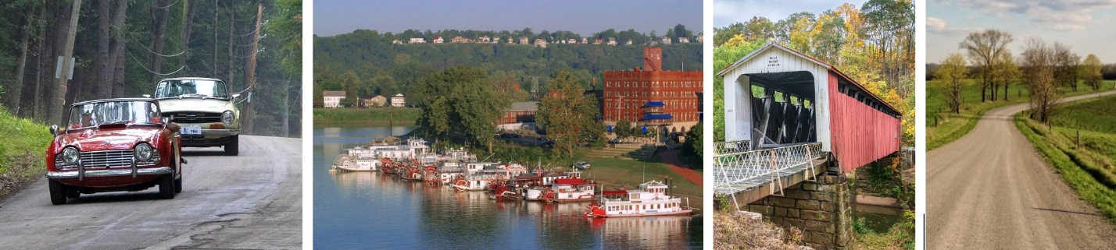

Please visit the Pittsburgh Vintage Grand Prix website, (pvgp.org), or contact Thomas Reed, 724 544-5985, for additional information.