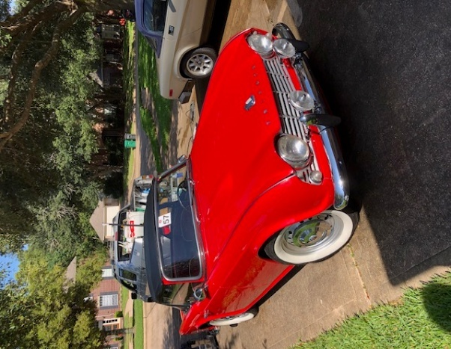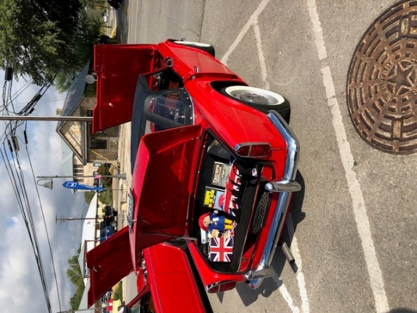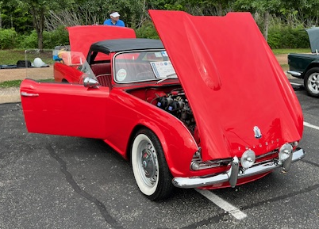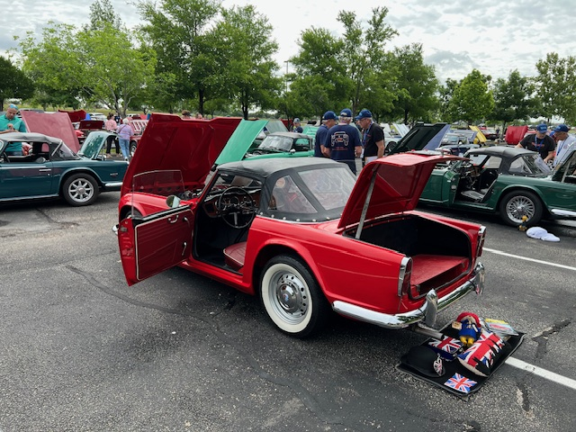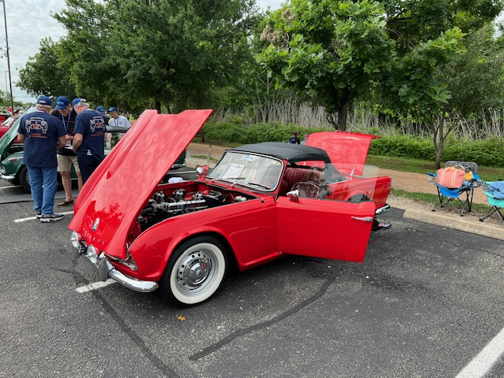
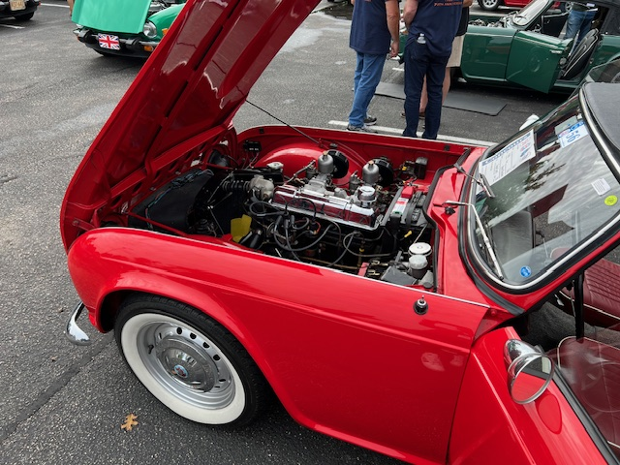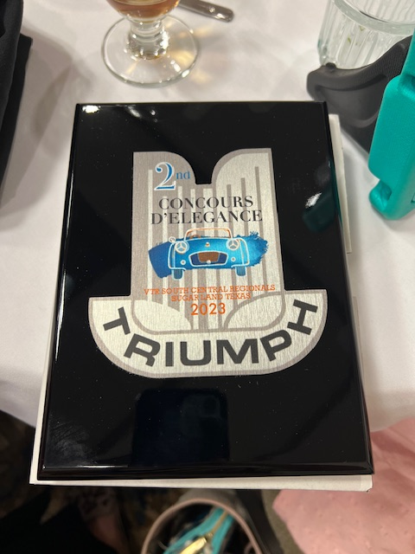
1962 Triumph TR4 - $27,500
- Won 2nd in Class in Concours d’Elegance 2023 VTR Regionals
- Won 1st in Class TR4/TR4A in Concours d'Elegance 2018 VTR Regionals
- 1962 TR4 is CT17490L
- Overdrive, Excellent condition leather top, Original TR4 wheels with beautiful white wall tires,
Updated interior
- TR4 is running and kept in garage storage in Sugar Land
- Selling to be used by a more active member and to go towards college!
- This TR4 was purchased in Oklahoma City from the President of the OKC VTR chapter in 2006
- Engine and Transmission were rebuilt by Mike Hado
- Majority of car updates/work by Mike Hado, Vern Burnett, Jerry Gruss, Russ Seto, with many other Triumph friends/enthusiasts from our local TTR Chapter
- Advice and Original Parts also from Randy DeRuiter
- Running in great condition. Inspected and Maintained and Updated in 2024 by Chris Dybala of Dybala Auto
Please contact: Anne Heyden by email dicks@okstatealumni.org
