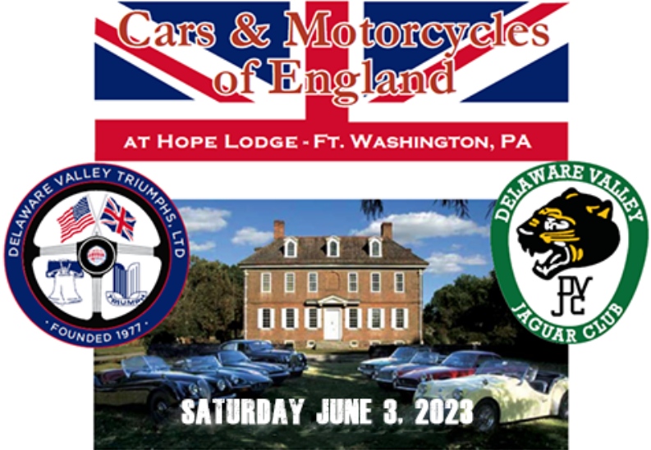

All-British Marque Judged Motorcar and Motorcycle Concours  
*and* a Nationally Sanctioned Jaguar Concours d’Elegance  
Field opens at 8:30AM – Judging begins at 10:00AM  
Hosted by Delaware Valley Triumphs Ltd. (DVT) and The Delaware Valley Jaguar Club (DVJC)  
Pre-Registration Only – Hope Lodge is a state owned Historical Property, subject to CDC/PA Guidelines  
Visit [www.dvtr.org](http://www.dvtr.org) for more information  Follow us on Facebook at “Cars and Motorcycles of England”



NOTE: For JCNA Concours Registration, visit [www.delvaljaguarclub.com/event](http://www.delvaljaguarclub.com/event)

|  |  |
| --- | --- |
| Name ________________________________________________  Address ______________________________________________  Telephone _____________________________________________  Email ________________________________________________    Marque _______________________________ Year __________  Model _________________ Award Class __________________  (*see reverse*) Check this box if you are bringing a trailer | **Pre-Register before May 27th: Cars $20, Motorcycles $10** Make checks payable to “DVT”  Mail registration form and check to:  Robert DeLucia  2593 Trewigtown Rd.  Colmar, PA 18915-9752 To join DVT, include a separate check for $30 payable to “DVT” Show Info Hotline: (267) 258-7071 or [yukon80@comcast.net](mailto:yukon80@comcast.net) Hope Lodge Information: [www.historichopelodge.org](http://www.historichopelodge.org)  $25 Pre-Register Only  Description of car/material ________________________________  _______________________________________________________ |

