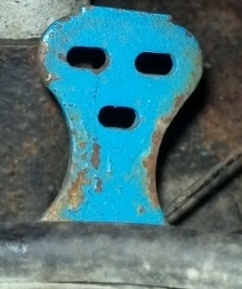

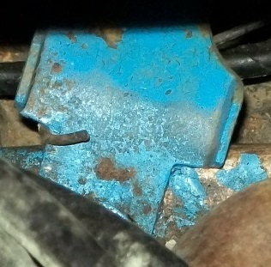 photos by RonFraser

C2OZ-9741-B Bracket Accelerator return spring