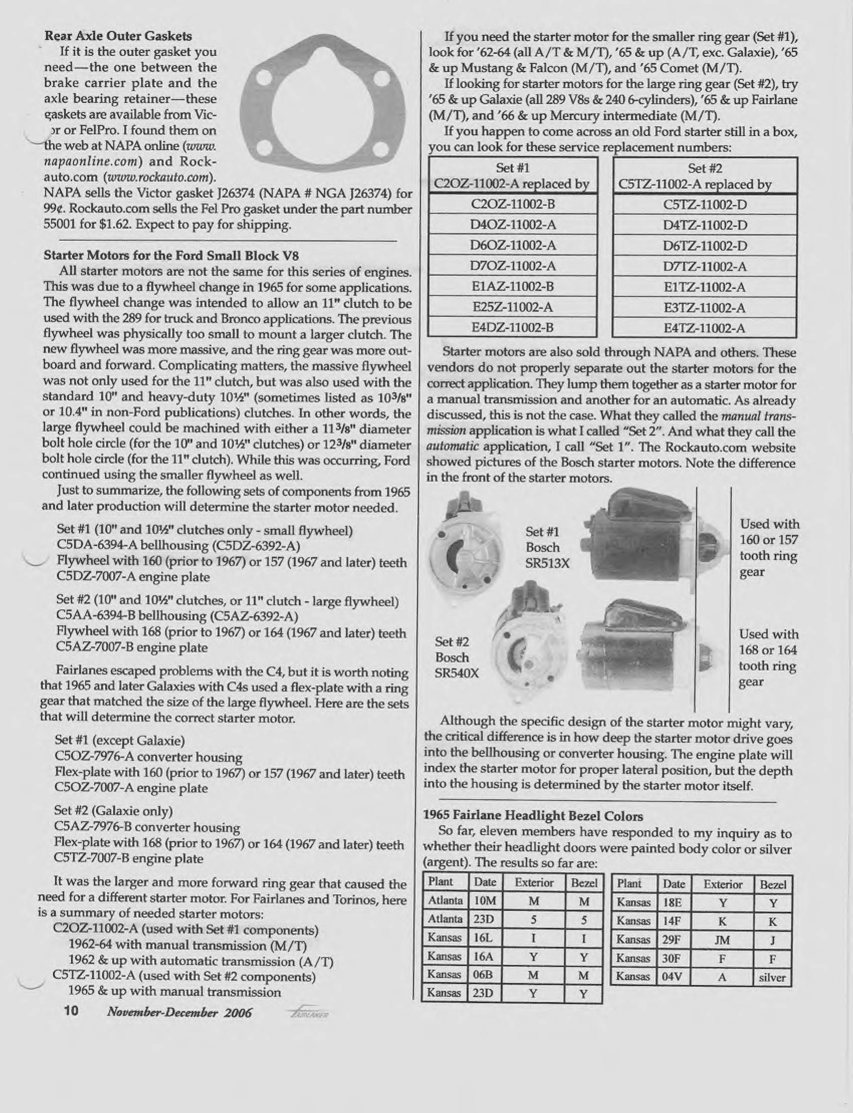
http://www.allfordmustangs.com/forums/attachments/classic-tech/85626d1260824206-1964-1-2-mustang-starter-replace-starters-001.jpg

This is an article by Bob Mannel
Nov – Dec 2006 Fairlaner

Take a look at the attachment I posted earlier on this thread. This was written by the Ford Fairlane and Ford small block guru, Bob Mannel, who is the resident expert on the Fairlane Club of America site. It explains that the parts stores have the starters incorrectly identified as either being for "manual" or "automatic" applications. However, it is not the type of the trans, but rather the size of the flywheel that determines the starter type. They probably sold you the shorter snout starter that they sell as a "manual trans" application, but you need the deeper snout starter that they identify as an "automatic trans" application. Did you compare the length of the snouts on your old starter with the new one?
The problem started when Ford went to larger clutches back in 1965 for the Broncos and later expanded that usage into the Galaxies and trucks. They needed larger diameter flywheels and flex plates that sit closer to the engine block, requiring a shorter reach, more offset starter, or what the parts store incorrectly call the "manual" trans starter. Look at the picture in the attachment.
I know this because I had the same problem with my 4 speed, 289, 64 Fairlane. I had gone out and bought a later model "manual trans" starter off ebay, not knowing that there was a difference and not researching it beforehand. When I tried to bolt this starter up, there was an interference problem right away but I was able to suck it into my bellhousing using the bolts. Luckily I decided that something wasn't quite right so I pulled the starter out and compared it to my old starter which I still had. The difference was obvious. I needed a longer snout starter which was compatible with the earlier 157 or 160 tooth flywheels common to the early small block Fairlanes and Mustangs.
Go back to the parts house and see if they have a starter for an "automatic" application as that is what I think you need. But, chances are now that the new starter is ruined along with some of the teeth on your flywheel.
From Joe Bean 12/17/2009 Allfordmustang.com forum

