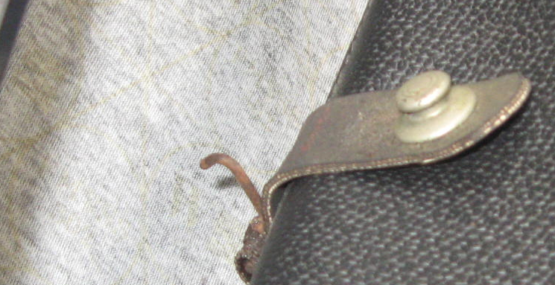

What is purpose of "J' hook?
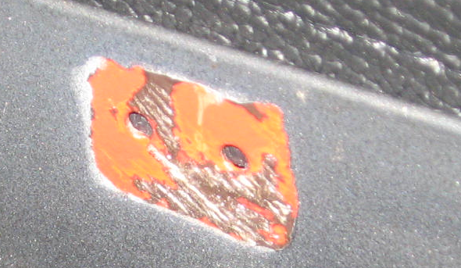

Looks like this is where it attaches to the trunk inside vertical shelf?

