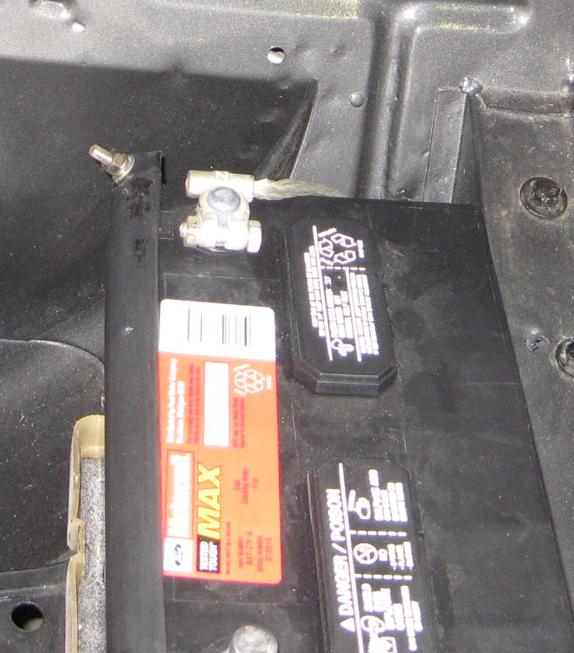
What is this hole for? Plug?

I believe this hole was for the battery fumes of the original battery?

