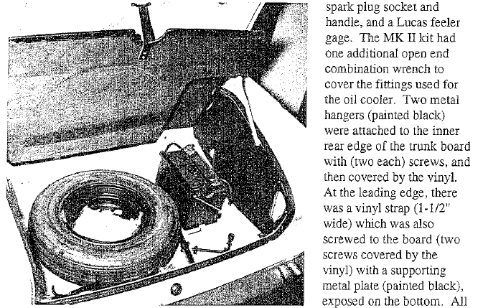

The vinyl strap (1- ½ wide) – What would be the length of this strap? I have determined that where only ‘black’ is indicated for color – this would be ‘gloss black’ unless otherwise indicated – good or bad assumption?

