Stapleton/Doiron hose identification (this version at 1 Dec 20)
Stapleton, cross flow, top  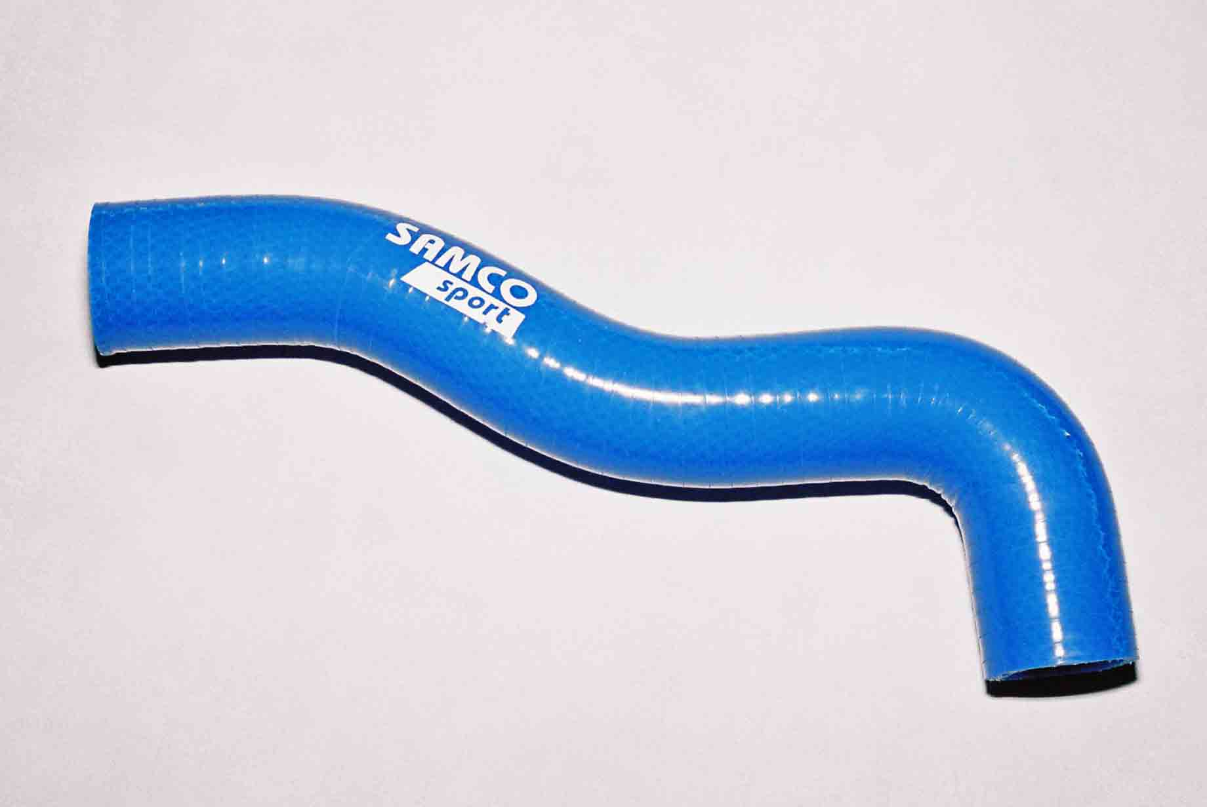  13-STA-SM-TH | Stapleton, cross flow, water pump  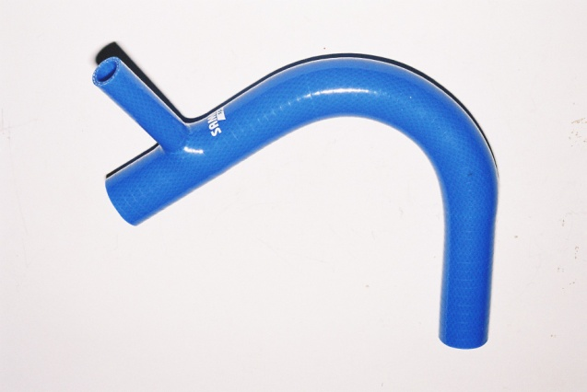  13-STA-SM-WP | Samco 90 degree  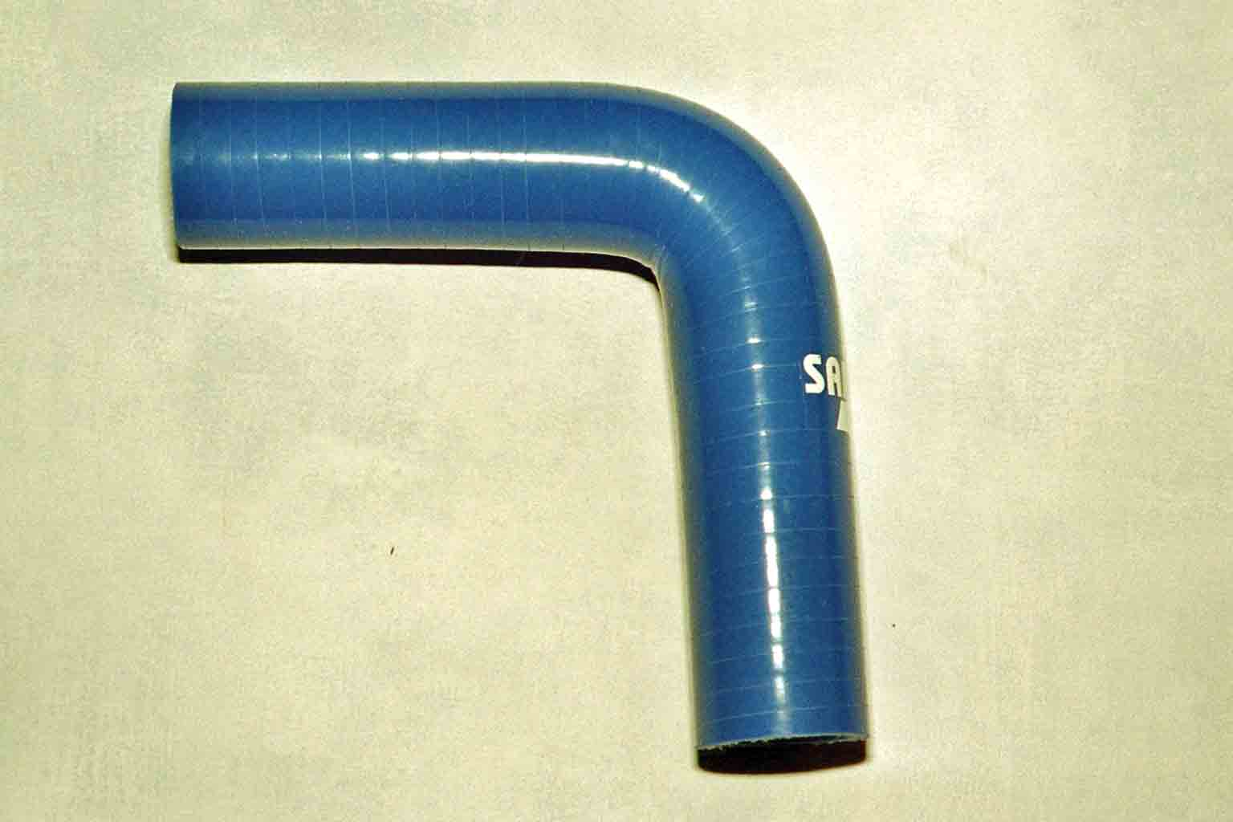  Samco E90-25 (13-STA-SM-BH)
Doiron, vertical flow, top  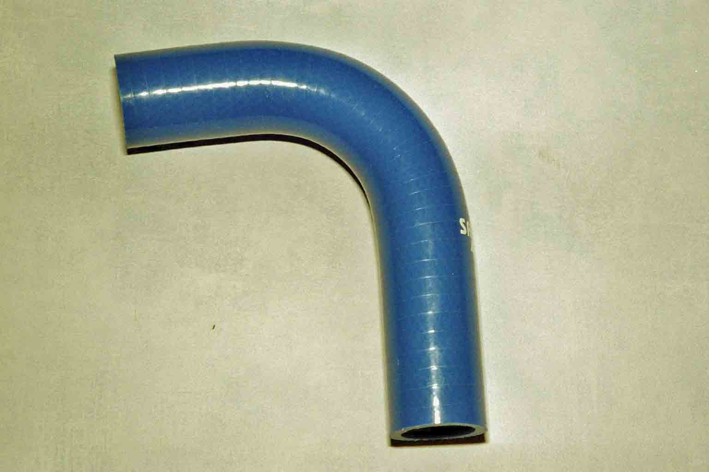  13-DD-SM-TH | Doiron, vertical flow, water pump  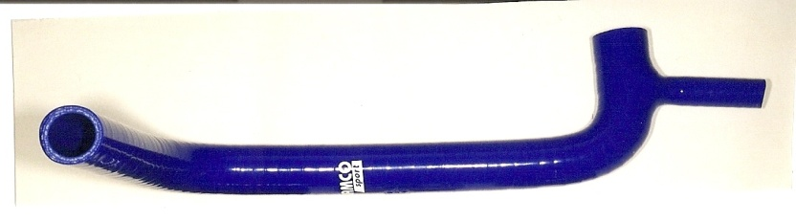  13-DD-SM-WP | Doiron, heater hose, question mark  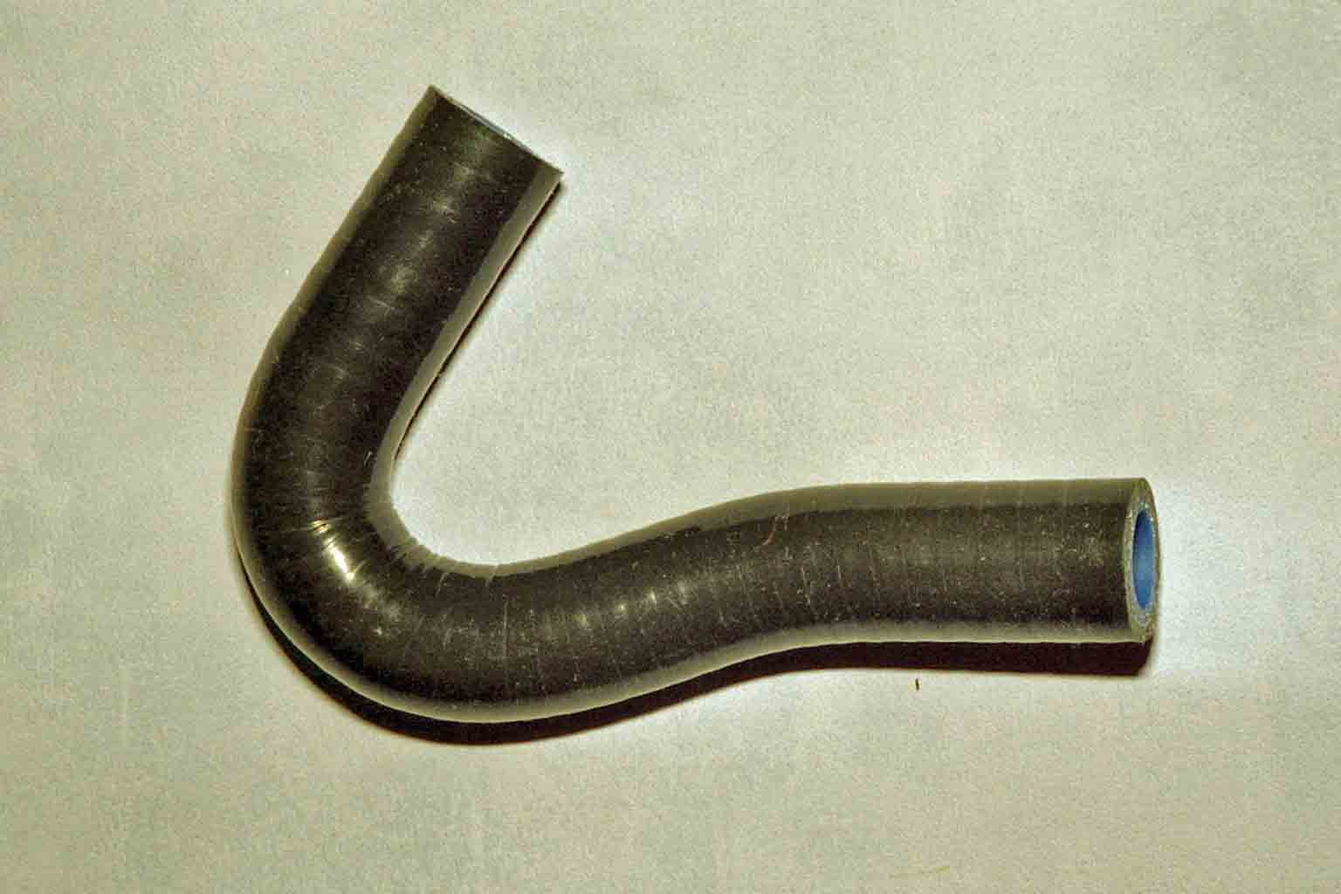  13-DD-SM-HH
Doiron heater pipe straight

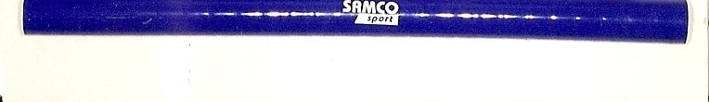
13-DD-SM-HP

