Frank & Diane Clarici's '60 Bugeye
PDLJMPR Web Magazine, April 1, 1996
Return to Table of Contents
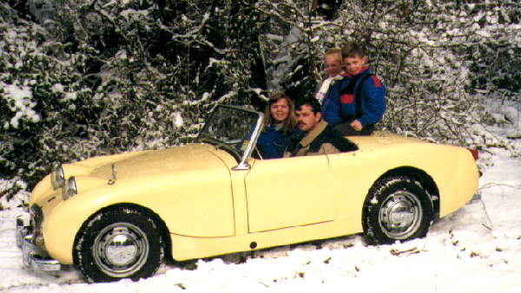
I have owned over 35 Sprites or Midgets. I bought my first Sprite from my dad for $400.00 in 1972. The deal was $50.00 when you have it until it was paid off - I may still owe him some money. I then fixed up a parts car for my girlfriend in 1974 (click for photo of Frank at age 19, working on this car).
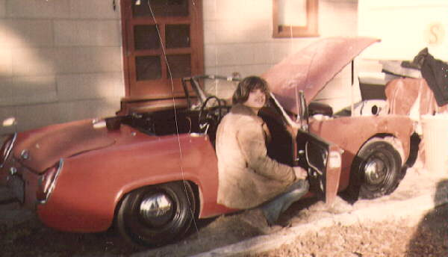
She is now my wife of 18 years and still drives a Sprite every day as long as she doesn't have to take both kids. My son who is only 16 and will not have his driver's license until July, 1996 owns a 63 Mini woody wagon (Countryman). My daughter wants a lavendar Morris Minor convertible. She is only 13 so I'm not actively searching as of yet.
Since my first Sprite of many years ago I am finally finishing my ultimate Sprite, a 1959 Bugeye with disc brakes, 1275 built engine, custom interior, factory hardtop, and comfortable seats with no headrests. The 5-speed gearbox is next, but for now I'm running a factory new, not rebuilt - that's a brand new, old stock, ribcase gearbox. I will send a photo around April 1, 1996.
My wife's current driver is a roll-up window, fold-down top, right-hand drive, Bugeyed Sprite with a slightly tweaked 1275. We also have a 1960 Bugeye on the road as a spare, but this car is going up for sale soon.
Just to keep the neighbors wondering, we have a 1966 MKIII waiting restoration and I picked up a 1958 Bugeye on 3/6/96 as a parts car - its future is still unknown.
Frank Clarici
Sprite Nut
From Buster Evans:
(I am still getting reports from people who have NOT received this post.
So, I will try it again, but this time in two parts.)

I have been a professional wordsmith all of my life. And yet, today I
cannot find the words to describe how I feel on Frank's passing. I am
simply bereft beyond all comprehension at the loss of a friend like no other
I have had in this life. I think that because for two incredibly fantastic
weeks, Frank and I were on a unique odyssey traveling the highways and
byways of England, I had a quite different insight into Frank than others
might have had. He was simply a remarkable man, inside and out.

I am afraid that when Diane called with the news, I was shattered and I came
to pieces. So, too, was Pam; how she and Diane were able to understand
each other through their mournful crying I do not know. My own sobbing has
been inconsolable. Since that moment, Frank has never left my mind and I
think of the good times we shared in our almost daily contact, either by
telephone or through e-mail; the tears never far away.

How does one describe Frank Clarici? Pam said that the first thing that
came to mind was "happy", and he was certainly that. How else to describe
him? Larger than life, happy-go-lucky, never knew a stranger, generous, big
hearted, magnanimous, good hearted, kind, open handed, unselfish, unsparing,
overgenerous. All, without question, apply to Frank.

Like several others, I first met Frank at the BusterCluster in 2006. Oh, I
had exchanged e-mail with him through the Spridget list, realizing that he
and I had both signed up on its first day in business. At the
BusterCluster, Frank was everywhere working with different small groups
tasked with a small piece of the action. Throughout those mystical, magical
three days, Frank was the "go to guy" whenever someone was faced with a
thorny problem. How I remember the big joke was that Frank was going to
lift the engine in single-handedly. He didn't, of course, but
unfortunately, he took home a hernia for his effort.

I can honestly say that I have never met anyone other than Frank who has
shared so well my warped sense of humor. The cartoons and jokes we shared
to each other but no other, were to me a measure of the man. Naturally, so
many of them revolved around "Chinese Crap" and his great, uh.errr. "love"
of everything Chinese. Once, I bought a computer program for learning
Chinese, sending it to him in a package with everything in Chinese
characters. Then there was the time I sent him tickets to a Chinese New
Year's Ball. And stuff from the Chinese embassy. And whenever I called,
it was either from the Chinese take-out asking about his order, or I was
asking Diane for "Ching Chang Charry Carici".

(See Part 2) for the rest.

Buster Evans

The BusterCluster Sprite

http://www.ado13.com/BusterCluster.html

http://www.youtube.com/watch?v=fs1klEzra24

http://bustercluster.blogspot.com/
Of course, never again in life will I pass a Horrid Fright or Horrible
Destruction without thinking of Frank. Ah, the memories will be with me
forever.

One of the highlights of our trip to England was when we visited friends of
mine in the small (pop. 300) village of Wishford. There, he and Gary
Butcher, a woodcutter for Lord Pembroke, went down to the Royal Oak, the
local pub, and teamed up to win the weekly "Quiz Night". The people at the
Oak still remember with fondness that happy-go-lucky American. And oh, how
he loved driving the narrow, twisting chicanes of those quiet English
country lanes. How he did revel when Alan East-Jones took us to Donald
Healey's pub for a pint. None of his friends, I dare say, every saw Frank
as humble as he was in Salisbury Cathedral. In Warwick, I was envious
watching Frank scramble up the 530 steps to the highest pinnacle of Warwick
Castle, while most others (especially me) were barely able to drag
themselves up one step at a time. Going down to Hampshire, we stayed with
Jim and Vicky Lodder and took in the two-day Beaulieu Autojumble, where I
had met them previously. Frank was duly impressed, for Beaulieu was far
larger than Carlisle. But the hail fellow well met Frank that we all knew
so well disappeared when we went we visited his late aunt's convent, and
especially when he visited the grave site. The elderly nuns were fantastic,
and they took Frank in as one of their own.

I had hoped to be there to say my final farewell to Frank, but the doc has
other ideas (I am undergoing a series of test for the next week, and must
also go in for the surgeon to slice and dice on Tuesday). So, although I
will not be there in person, I will be in spirit.

And now, my thoughts and prayers turn to Diane, Tiffany, Frankie and Frankie
Five. Diane will, of course, will be hurting for years to come. Now is the
time that she will need the support of all of us, and I would urge all of
you to begin to repay Frank's generosity and friendship by keeping in touch
with her. Simply because Frank is no longer there to help us is no reason
to leave her in her time of greatest need.

Buster Evans

The BusterCluster Sprite

http://www.ado13.com/BusterCluster.html

http://www.youtube.com/watch?v=fs1klEzra24

http://bustercluster.blogspot.com/
ME:
Frankie, Dianne, and Family,
The LIST is in shock as you as are. I cannot tell you how many times I've tried to compose something to send and everything is blank.
I haven't gotten any work accomplished today but yet I have. I've been looking over the pictures of Holy Sprite, LoTO, Frank's Elkhart Lake visit, and other pictures.
Ron Soave and I have been sending some email pics back and forth. It doesn't help. As a heart bypass veteran, I know one can go any minute, as they say. I envy Frank
as he was doing something he loved. I'm sad for those remaining and have to deal with a great loss. But hey!, he's probably talking with Donald and Geoff Healey as we speak
and suggesting ways they could've improved the Sprite! (no Chinese parts would be a start!)
I must say the first thing I thought of is, "O.S.H.I.T."! You are going to receive a lot of love from this group. Frank and all of you were/are family to all of us.
It was fabulous seeing you all at LoTO and the assembly of the Holy Sprite. Your Mother is a Saint! (She had to be, right?) No one, I mean NO ONE, has helped
more people get started with Spridgets or helped maintain them. Like the Energizer Bunny, Frank gave and gave and gave. He passed that on to "youse" guys.
Frank brought people together that would never have otherwise met up. Shoot, he got a Methodist, a Jew, atheist, and who knows who else to attend Mass with Fr. Jack!
I don't think Mother Teresa even did that! Your Dad, Frankie, will always be St. Frank, Patron Saint of Spridgets, to us.
So know that our thoughts and prayers are with you and your family. We celebrate Frank's life and what he represented to each one of us. We shall miss him terribly and will never
ever forget him. God Bless you Frank and may God grant your family Peace.
Sincere condolences,
Dave and Terri Woerpel
Burlington WI
AN5/17606 leaf green (see attached. 1st 2 pics at Elkhart 1999, 1st generation digital camera, 3rd pic Holy Sprite window at Mike's)
Friends
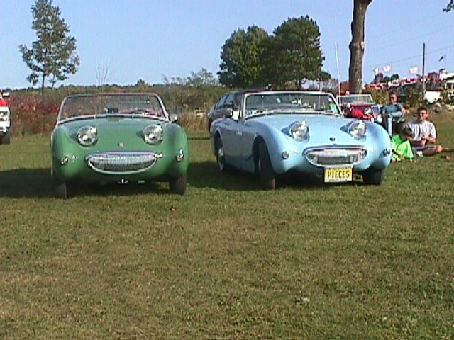

I need another beer

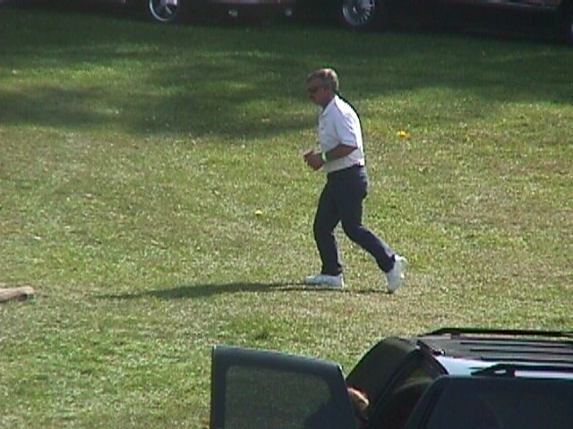

Damn bootleg rubber!

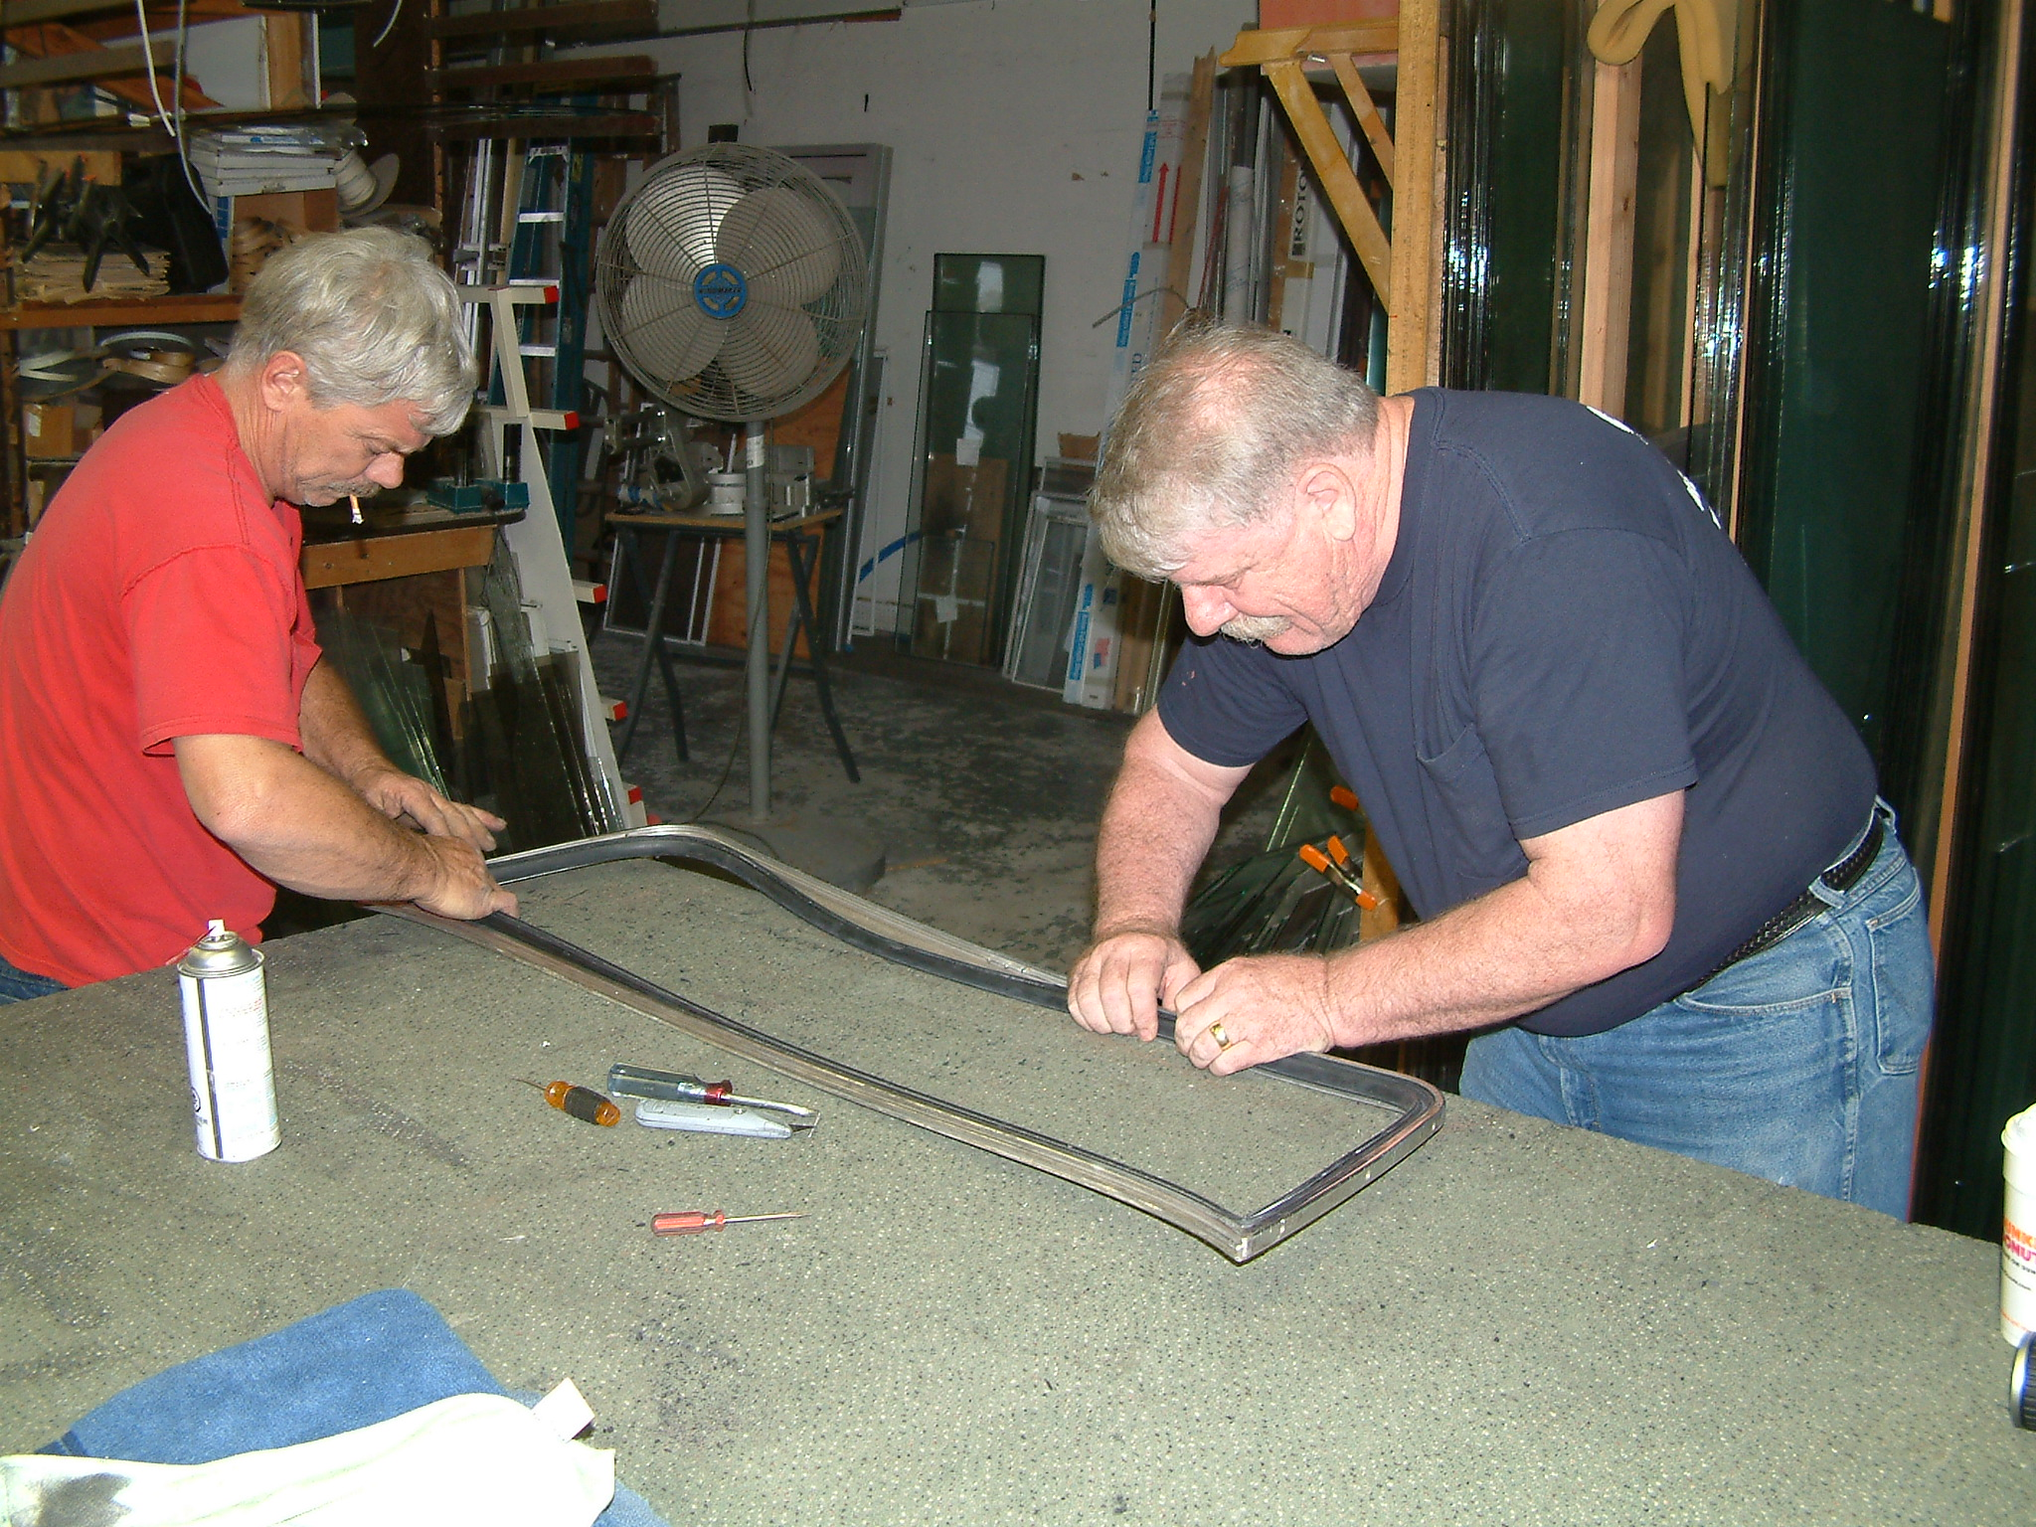

From Linda Grunthaner:

My Dear Spritely Friends,

It is Sunday, we have put our dear friend Frank to rest yesterday and the
dust is starting to settle with a vast hole in our hearts. We have all been
through an emotional roller coaster desperately seeking him, following link
after link of his photos and text messages in hopes that he is still out
there. In hopes that his memory stays alive. I have never felt quite this
sad about anyone in my life other than my own parents. I am left with
emptiness and dismay as I try to make sense of it all. But it is life though
short as it may be for some and through illness as long as it shouldn’t be
and we have to accept it.

We cannot move forward without remembering the message that he has
generously left with us to carry on with, the message of hope and kindness
which we must carry in our hearts and share with others. I have been
fortunate enough to have been able have spend time with Frank others who
have been closer to the man we all loved spent greater moments than I. But
we have all had some kind of a connection with him in one way or another. We
have all in some way have been touched by the man known as Spritenut.
Whether a lurker or one who shares on this list we are all connected to him.
We cannot forget his beautiful message of kindness to others, by giving a
technical message or offering a kind deed such as helping your neighbor with
a project that they are struggling with.

I truly hope that you all stay on this list and offer a hand in any way as
that to me was his message. If in fact you move forward without this
particular list I hope that you continue to do a good deed each day in your
lives. Frank worked exceedingly hard to help others, he exhausted his energy
to do that. He paid it forward day after day. During the sermon though I am
not what I would call a religious person I listened to father Jack with
intent and respect for Franks religious beliefs and I suddenly realized that
Frank was not taken from us with malice. Frank was taken from us because he
was done with his Earthly duties on earth. Frank was taken to be with God
because he earned his wings to be with God. We still are left behind because
we have not done enough. Or that is what I want to believe. I suppose if I
want to live on Earth longer I need to continue to argue with my siblings or
my co workers about trivial things. But if I want to return to where I came
from I would do as Frank had done countless times and be granted the gift to
return. It is simply up to me now. I personally have much more to do here on
Earth to get my Spritely wings so I strongly doubt I will return to my maker
anytime soon, basically because I can still be very selfish.

Let us not forget to be just a little kinder to others for Frank, for his
memory and for the countless messages this man had sent to us while here on
Earth so that perhaps we will one day see him and other we so deeply loved
again and earn our wings.

With loving memory of Frank and remembering his message of love and kindness
to others,

Linda

62 deep pink Sprite “Pinky”

