2006 Jaguar XKR Supercharged Convertible — 70,000 Miles — $17,000

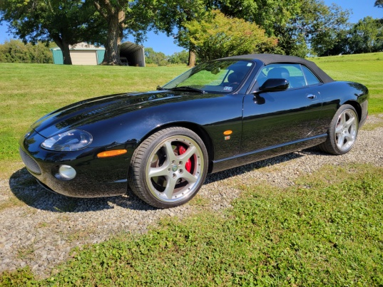
Collector-quality 2006 Jaguar XKR Supercharged Convertible — Black on Black — Only 70,000 Miles

Offered for $16,000.

This beautiful 2006 Jaguar XKR Supercharged Convertible is an excellent example of Jaguar’s performance and luxury heritage. Finished in a stunning all-black combination with black exterior, black convertible top, and black interior.

Powered by the 390-horsepower supercharged V8 with twin cams, this XKR delivers exceptional performance while maintaining the comfort and refinement Jaguar is known for.
The car has been well maintained, is mechanically sound, and rides and drives great. It has only 70,000 miles and presents as an excellent example for someone looking for a special Jaguar to enjoy, preserve, and potentially add to a collection.

Highlights
- 70,000 original miles
- 390-horsepower supercharged V8
- Convertible
- Black exterior
- Black convertible top
- Black interior
- Brembo brakes
- Original wheels
- Michelin 255/35ZR20 tires
- Lots of tread remaining
- Well maintained
- Mechanically sound
- Excellent condition
- Title in hand

Asking: $16,000
This is a collector car and is priced accordingly. Offers considered.
A distinctive, powerful, and increasingly desirable Jaguar with the classic XKR combination of supercharged performance, luxury, and timeless styling.

Title in hand. Serious inquiries only 412-554-2383

