**Overdrive Drain Plug**

I normally start by denying all knowledge of anything to do with four cylinder Healeys. In this instance the article touches upon all “Big” Healeys, ie 4 and 6 cylinder models.

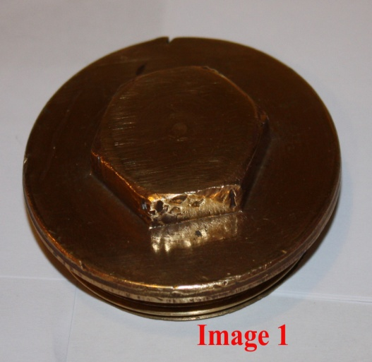**Image 1** shows the overdrive plug fitted to BN1s and BN2s up to 1956 or so friends tell me. I’d guess that the slotted version, (Image 4), was probably phased in around 1957 and I’d further guess that all 6 cylinder cars have it.

The plug is made of brass. I imagine that brass is used because a “magnetic washer” sits on the inside face of the plug, beneath the filter, and an iron plug would render said “magnetic washer” useless. (These washers are referred to as “Drain plug washer”, no reference to magnetism, in the BMC Workshop Manual which is rather naughty; the BMC Parts Manual does refer to “magnet for plug”. Anyhow, they cost pennies and are well worth having.) The hex nut is 11/16” BSW - 3/4” BSF, apparently with no AF match. A 30mm socket fits fine; depending on the state of your plug’s hex nut you might need to grind the socket’s lip down a little as the nut is quite shallow. So, you have a plug with a hex nut which is a slightly obscure size but that’s half the fun of it all? Anyhow, a big adjustable, carefully used, will do the job although its length will make it awkward. See **Images 2 & 3**, below.

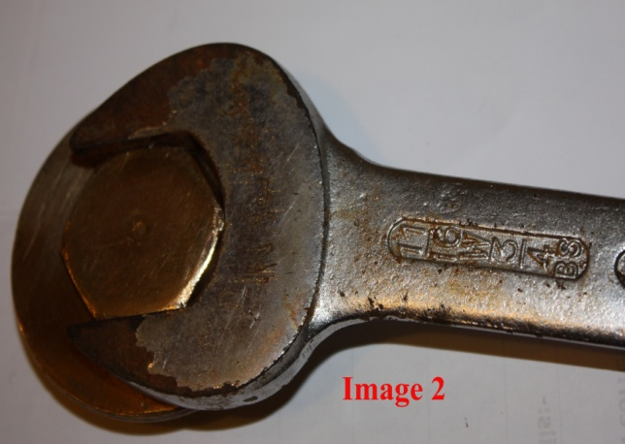 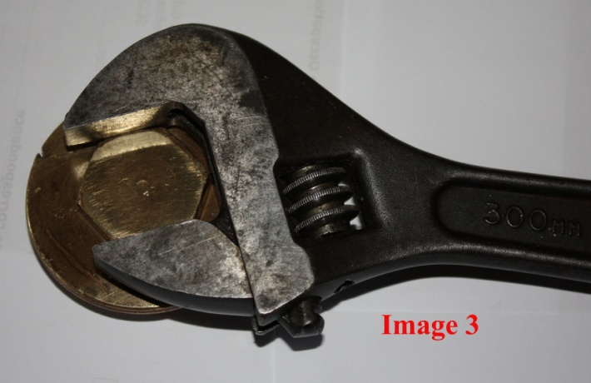

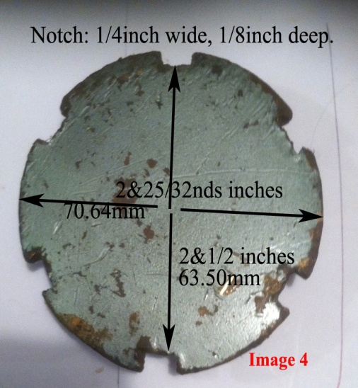The overdrive drain plug on my MkII 3000 is per **Image 4**. It is flat and is also made of brass. It is a handsome thing in its way but, in my opinion at least, it is peculiarly unsuited to its environment. Any plug in that location needs to be highly functional ie it must keep the oil in the box and it must be easy to remove and refit. Brass is soft and easily mangled by inappropriate tools – drifts, cold chisels etcetc – and, precisely because they are **not** easy to remove, most of these drain plugs are a sorry sight by now as they have been indeed been mangled for the last 50+ years. The plug’s shape is unique and, as such, needs a special tool. The BMC Workshop Manual’s “Section T, Service Tools” shows dozens of strange implements including 12 specifically for the overdrive but nothing for the drain plug. Laycock de Normanville overdrives were found in many different cars and the appropriate tool must have emerged. However and as to the plug being functional......The plug projects from the overdrive casing to almost the same distance from the ground as the bottom of the chassis members on either side of it. Thus it is only really accessible(!??!) from the RHS as the exhaust is in the way on the LHS. If you have a decent workshop ramp and get the car up in the air then everything become easier but this discussion remains germane. The earlier “special” tools were simple enough. See **Image 5.** This is quite a short version; longer ones gave more leverage but grazed more knuckles in the limited space. Norman Nock of British Car Specialists (BCS) partially solved the problem by putting a crank on the handle of their (handmade) version (the “BCS 10”)........more access but harder to keep the tool in the notches. See my tool, **Image 6**, noting the Great Man’s writing on the handle!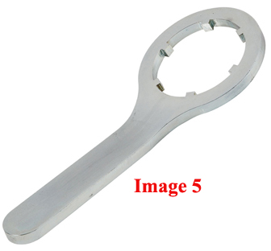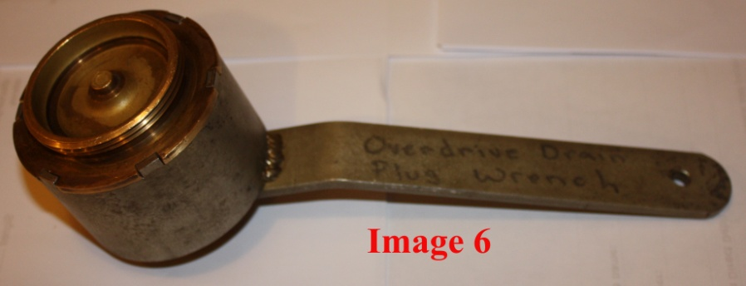 I do not know if BCS still sells it. Probably. Anyhow, the tool has morphed into something a little handier which is driven by a ½” drive breaker bar. See **Image 7.** This can be found on American eBay and will reach the UK for about $65:00, inc. tax and postage, which is a lot. Denis Welch also manufactures a tool which looks good and is yours for +/- £50:00. See **Image 8.**

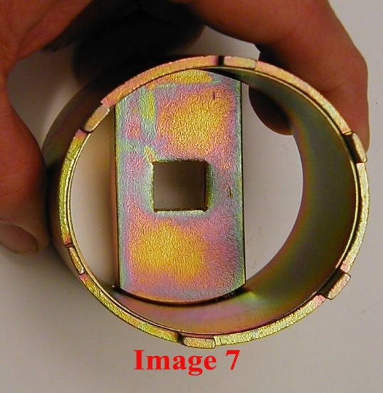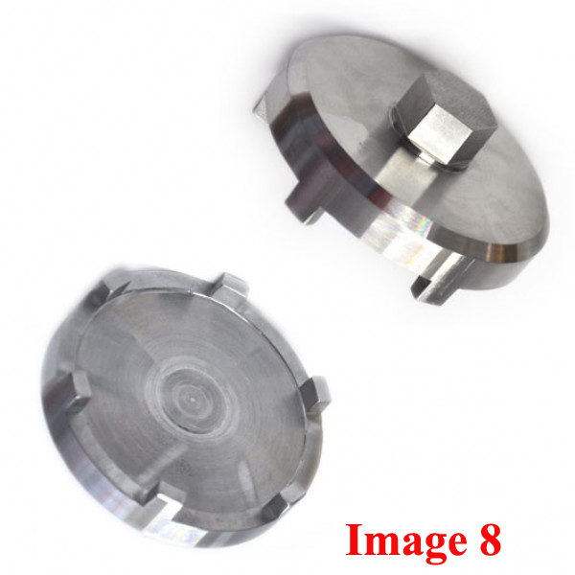

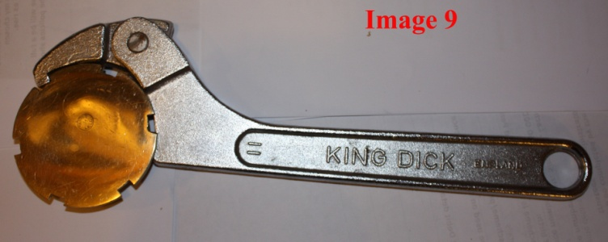Another route is via the “C-spanner” or “Hook wrench”; see **image 9**. Some of the Healey parts people sell these over here. Or you can find them on Ebay.....they are used on front forks on motor bikes so one could visit one’s local Donorcycles R Us and buy one there. I bought one on eBay; it’s the one pictured. Yes, it does the job but it’s not ideal, a bit long and clumsy. A smaller one would have been preferable, but shorter handles give less leverage....

One caveat which will apply to all of these tools: They may not *initially* fit your own actual drain plug. I doubt if the plugs were 100% identical when they were new; now, after half a century of abuse, they will need to be filed and beaten back into

shape. Ideally, you will work on the plug rather than on the tool. In my case, I did have to file the BCS handmade creation down a trifle; the lugs were a little too deep and a little too wide all round.

If you want to drain your overdrive and you are faced with one of these slotted monstrosities and you have neither the tool nor the time or inclination to get one, try this:- Take a short length of hard wood, preferably an actual hardwood, and make sure that both ends are cut square. (Chippendale, Sheraton....whatever you’ve got lying around).You’ll hope to find something about 18” long by about 1½” square. Simply stick one end into one of the notches and, making sure you’ve got the angle of attack right, give the other end a good whack with a hammer! Brass is harder than wood and you won’t deform the notch, but hardwood is hard enough to transfer a considerable impact without collapsing into splinters. I’ve used that method in the past...never failed. A big plumber’s Stilson wrench padded out with bits of cardboard will also serve but that’s not in everybody’s tool chest.

Which tool is best? Subjective, but I prefer mine per **image 6** and may convert it to something like **image 7**. Also, the hardwood and hammer works well though it does lack the other versions’ finesse!. I find the C-spanner, mine at least, to be a bit clunky and quite hard to locate and keep in the notch. Regardless of the tool, keep the threads perfectly clean and all you will need to do is loosen the plug by, say, half a turn. Thereafter you should be able to do it by hand.....it’s big enough to grip and the notches help one get a good purchase. Of course, now that someone has given me the hex nut version, I shall swap to that. There a few little bits under the two plugs that are not interchangeable. I have these bits and I’ll do the swap ASAP.

Simon Lachlan 2015

Addendum, from my notes….

So, almost a year later I decided to swap to the original/older type ie the one with the hex.

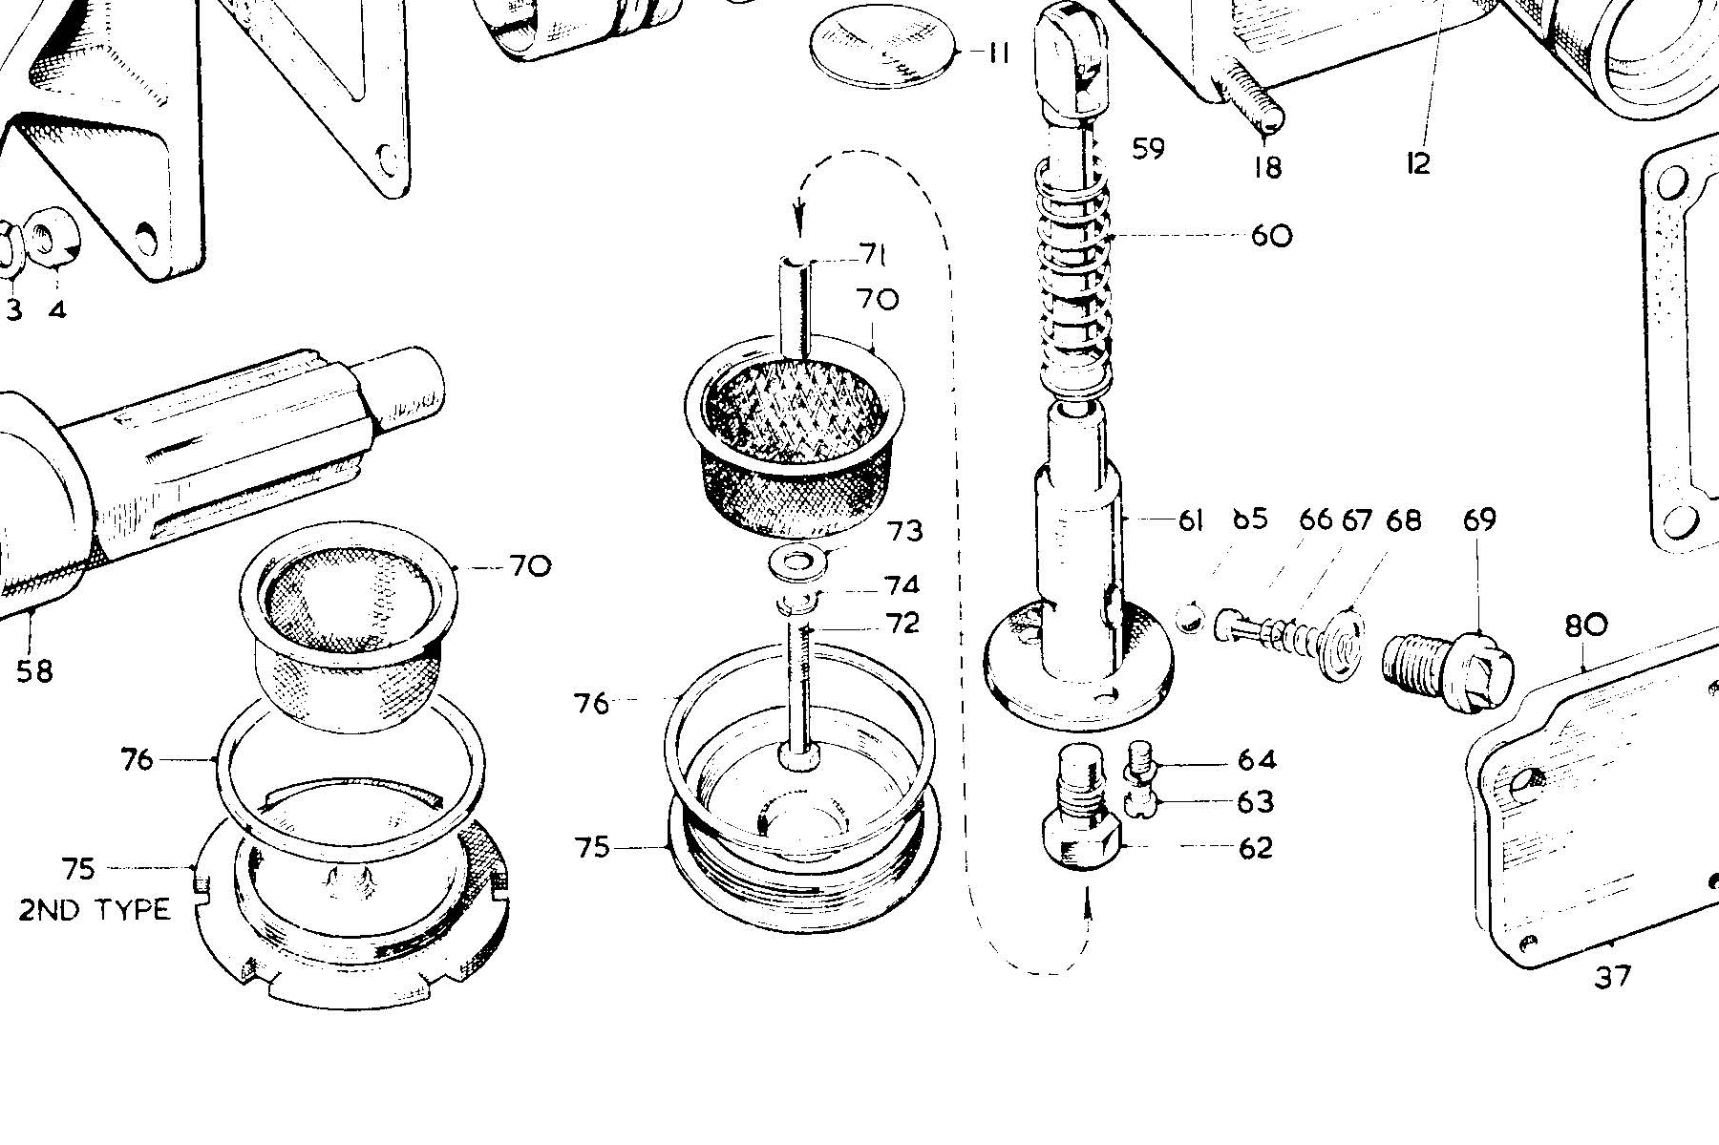

In order to swap from the “2nd Type”, LHS, to the older type, RHS, one has to purchase the following parts:- #72, #74, #73, #70 and #62. The latter, #62, is a hex bolt which screws into #61 which is the oil pump body. Both versions have a #62 but the older version’s bolt has a threaded hole into which screws #72, thus holding the filter permanently in situ.

There are two “Screws, body to front casing” #63. These get in the way when one tries to remove #62 and have to be removed before one can get a 5/8 socket onto the bolt, #62. Removing the two screws is easy enough if one creates enough access. The pump body won’t fall down; it’s a press fit requiring a special tool to extract it. It’s all quite simple.

A 30mm socket is a precise fit on the plug’s hex and the drain plug is a joy to remove and tighten!

One for the more erudite gurus......

I have never been a great admirer of the so-called “2nd type” of overdrive drain plug. You know the thing....big flat notched brass plug which replaced the similar sized (+/-) brass plug with a hex on the bottom for eas(ier) removal. And, yes, I’ve got the various tools to make the job bearable.

So.......if one looks at the parts book pages, attached, you’ll see that we’re swapping the left hand plug for the right hand plug.

I have bought the necessary extra bits ..71, 72,73, 74 and 62 which, in the ”2nd type” lacks the threaded hole into which one screws 72.

I find that, when I get my socket in there in order to swap the unthreaded 62 for the threaded version, it is blocked by the pair of parts 63 & 64.

Question:-

if I undo 63 & 64, will - in the normal Tom & Jerry fashion – half the overdrive land in my drip tray as a zillion little springs burst out and cavort around the workshop floor???

Or, seems unlikely, will the assembly remain together and permit the substitution???

It looks like one of those areas where one needs to tread with caution. Being too gungho here could be a disaster in terms of time and effort. .......I always expect the worst and am seldom let down in my expectations!!

Simon

1. Simon

You should be OK just taking the two screws out but by no means try to withdraw the pump body…..

Best regards

John Harper.

1. Simon,

The oil pump housing (#61) is a press fit in the OD casing. Removing the two screws (#63) and washers (#64) to get a socket on the threaded plug (#62) shouldn't mess things up…..

Cheers,

Bob Haskell

AHCA 3000 MkI registrar

1. Simon

Bob is correct. However, a word of caution... be careful that in tightening the #62 the pump body does not turn. I would recommend a long piece of 10/32 thread in at least one hole to eliminate that possibility. If it does turn it is really hard to re align and the pump non return valve will not work...as in no overdrive.

Michael

To Michael:- “God, now they tell me! I’ve done it up nice and tight! Would the two screws, #63, line up if I’d managed to rotate the pump? Simon

1. Simon

You can rest easy.  If the screws went in the pump didn't move. 😊  
Michael

Simon Lachlan