How to Wire a Control Head without Disassembling the Unit

Tools needed:

- 7/32” Socket screwdriver Note: Please NO NOT use needle nose pliers to remove the brass nuts.
(These are “metal eating tools” only used by “ham fisted” previous owners [POs] and will chew up
the brass nuts ☹)
- Small flat blade screwdriver
- Thin (but not too flexible) flat bladed knife
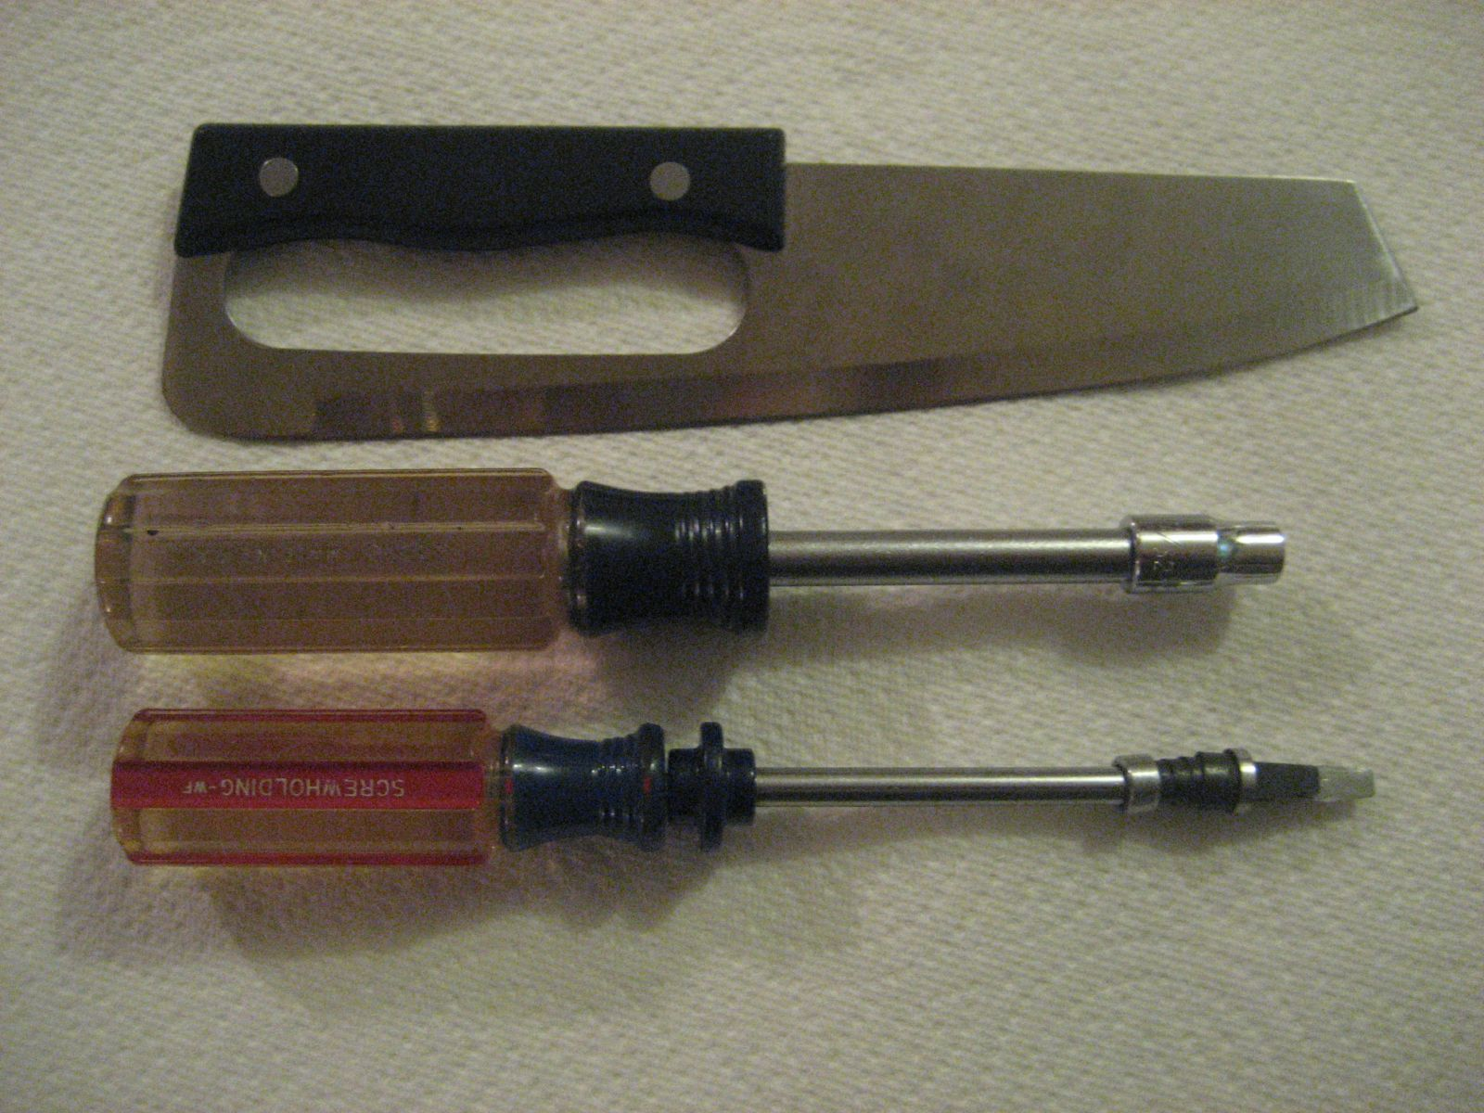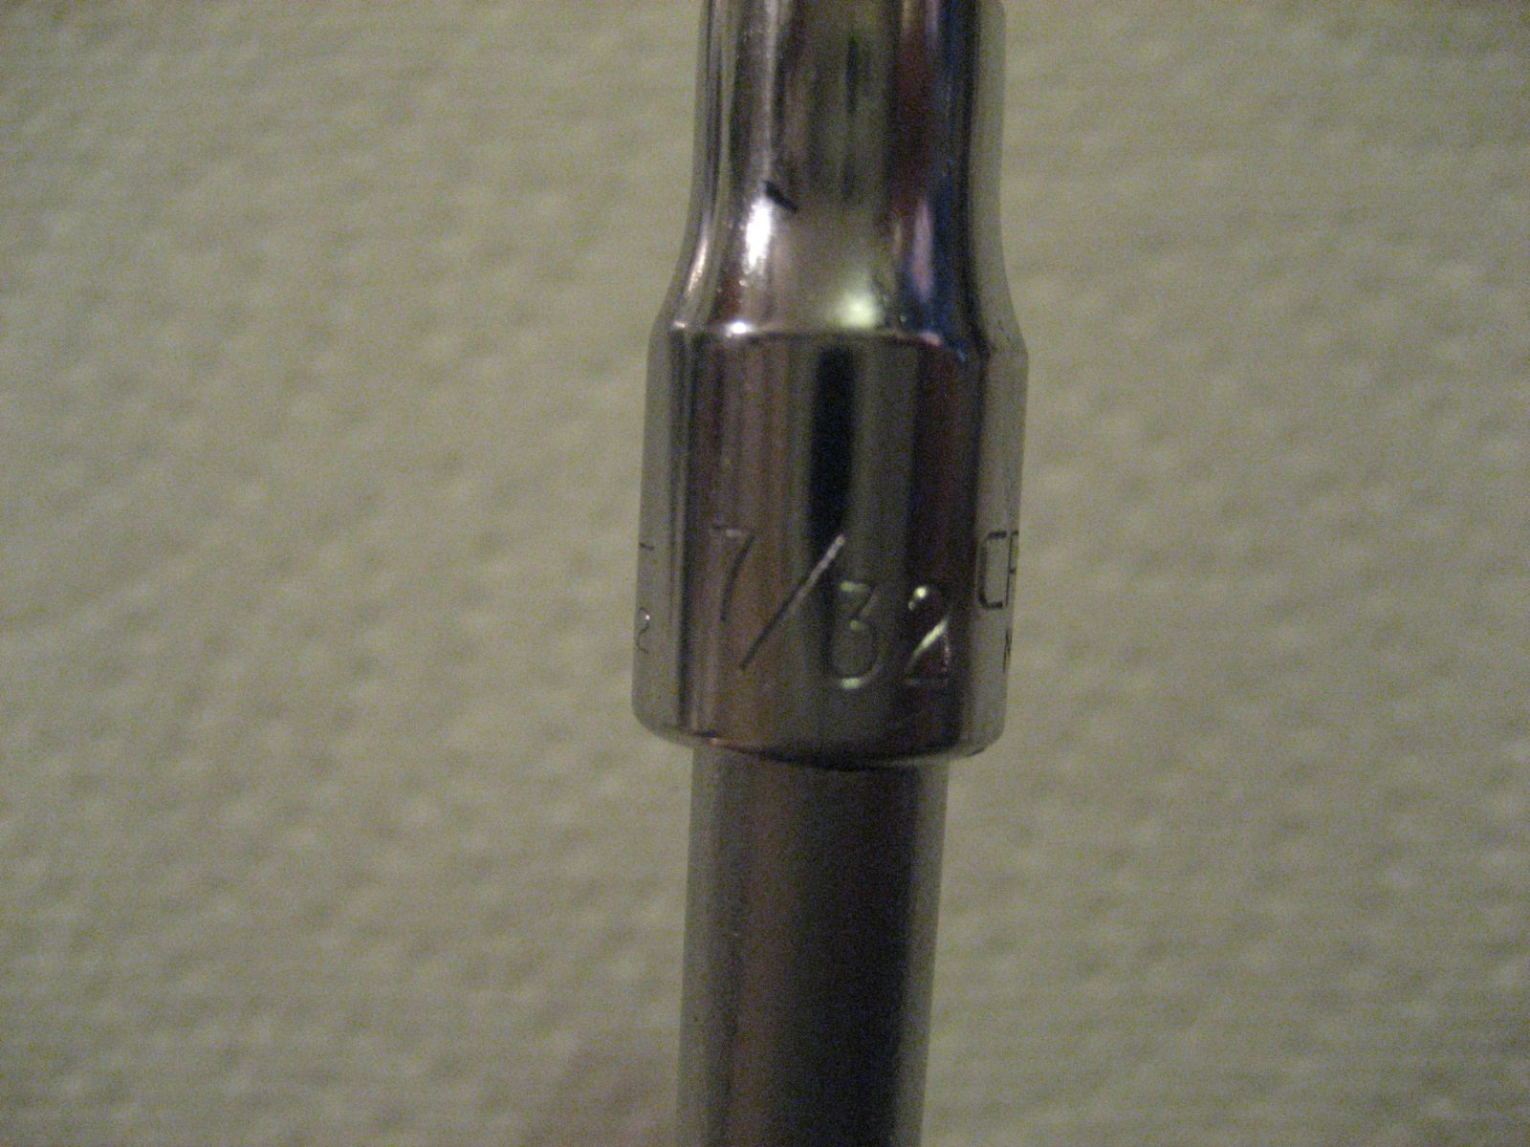

Step 1.) Remove the horn button, chrome retaining ring and spring.

As shown below, use a thin flat blade knife to carefully pry up the chrome retaining ring as pictured. This is required to access the brass screw head for the attachment of the (brown) ground wire.
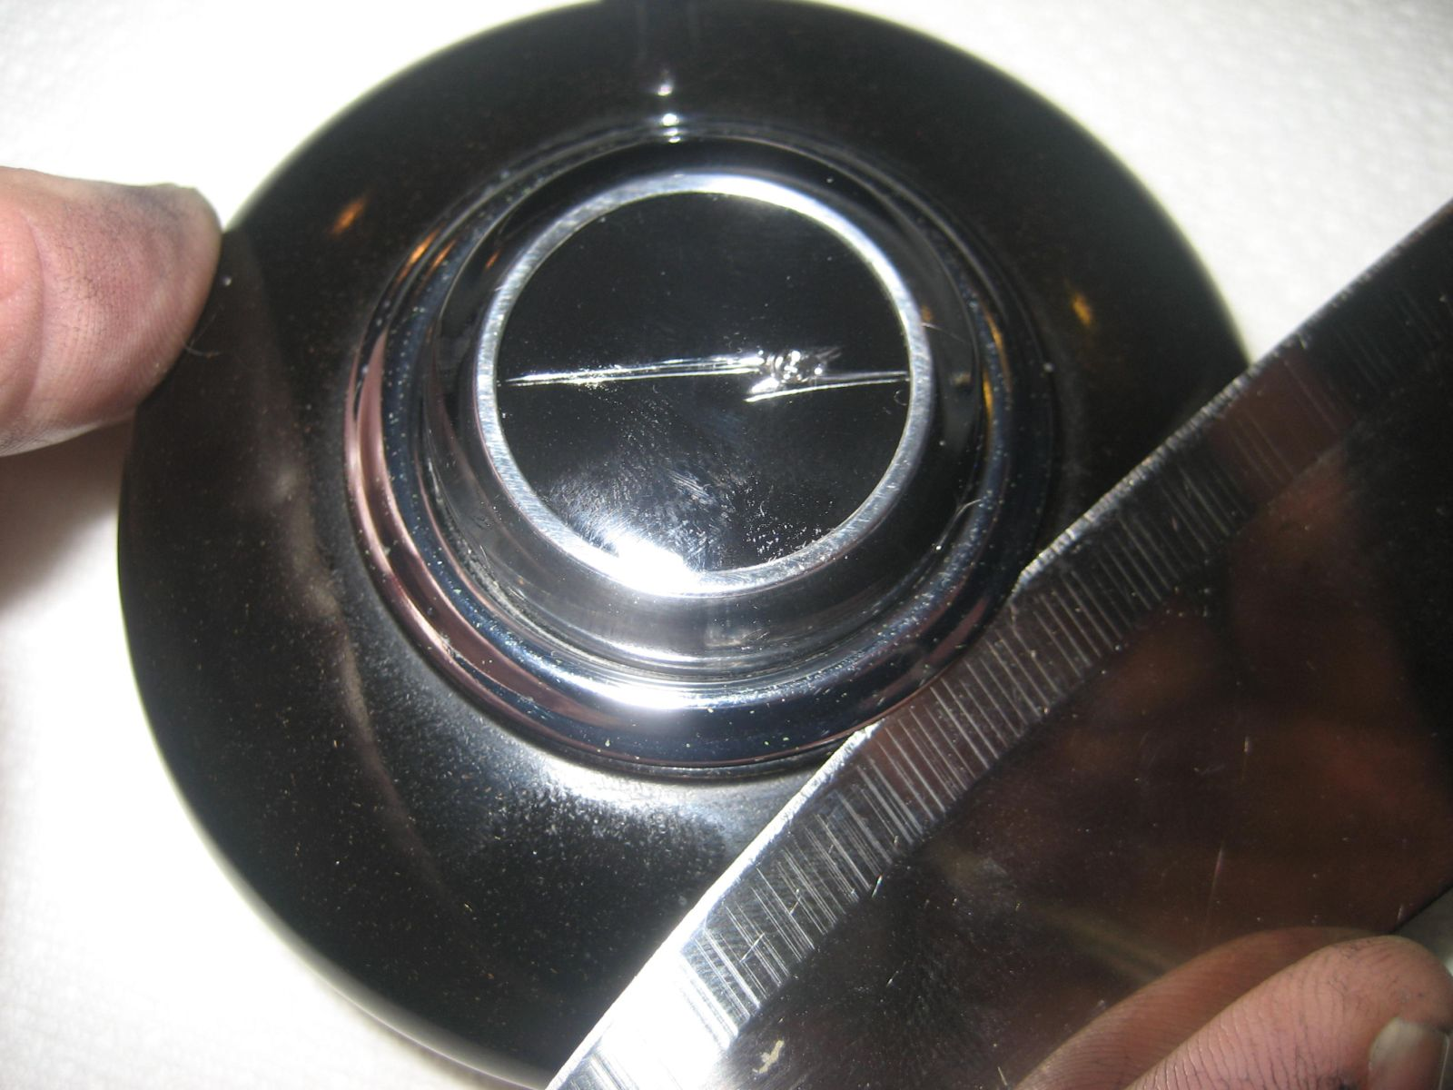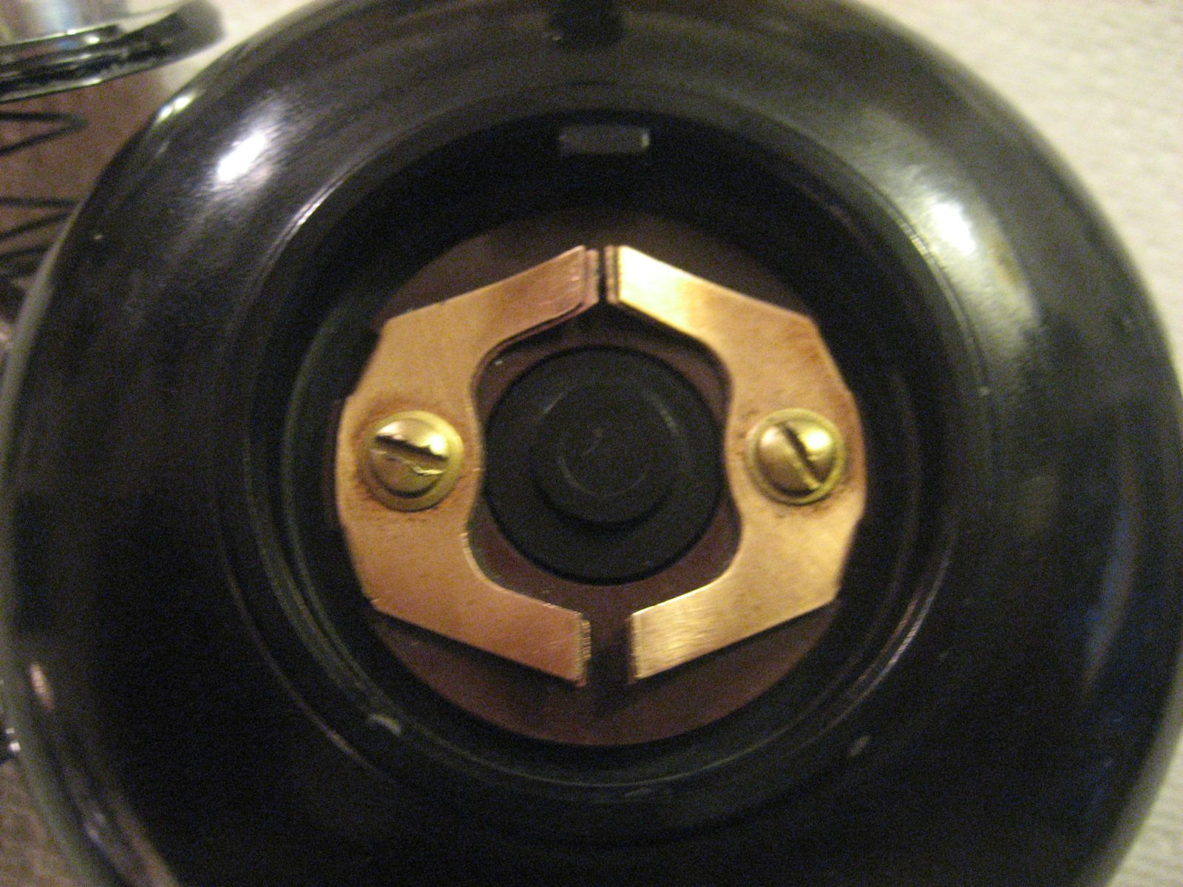

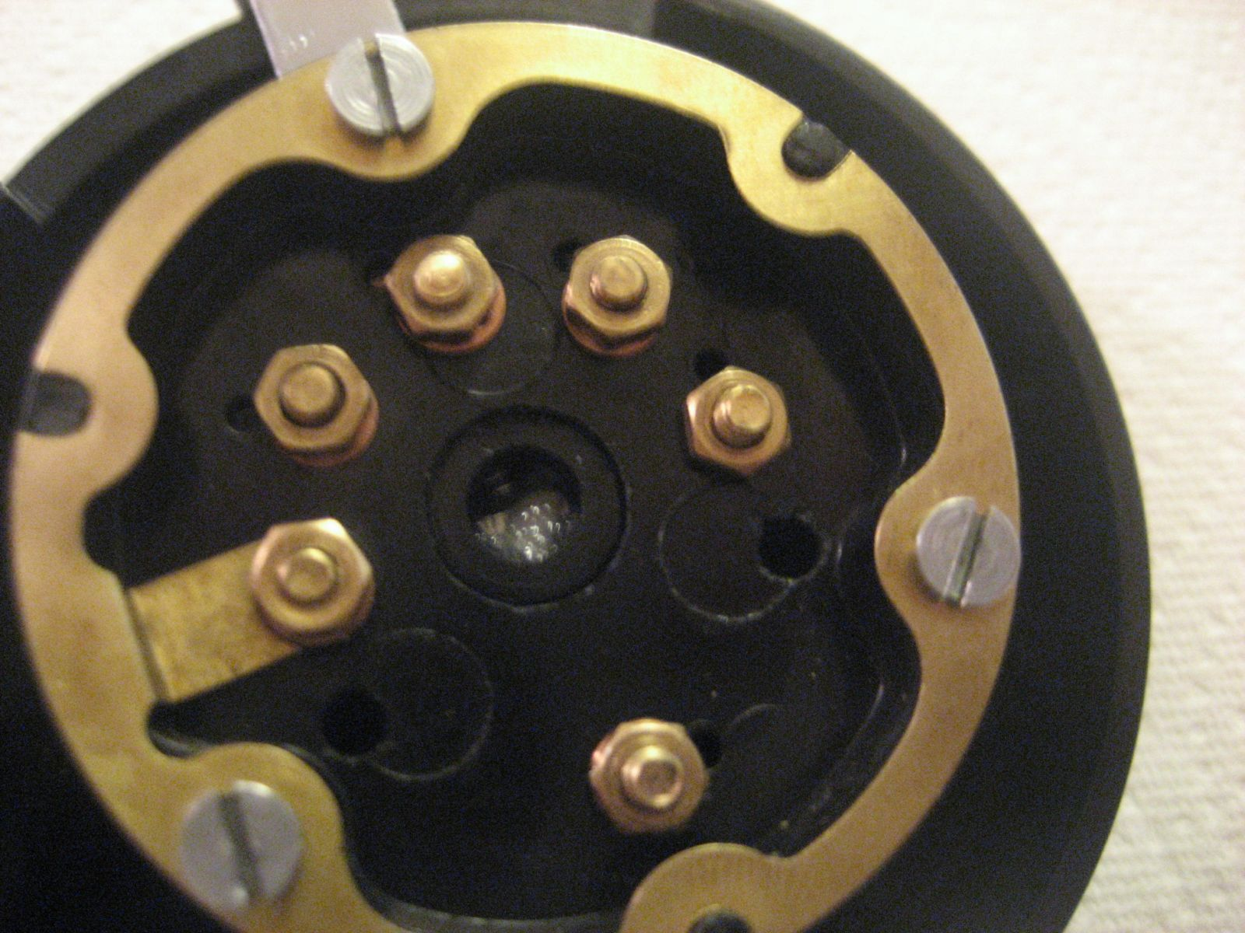

Step 2.) With the back of unit facing you, Unscrew the corresponding brass nut and remove it along with its washer. Attach the brown ground wire as pictured below.
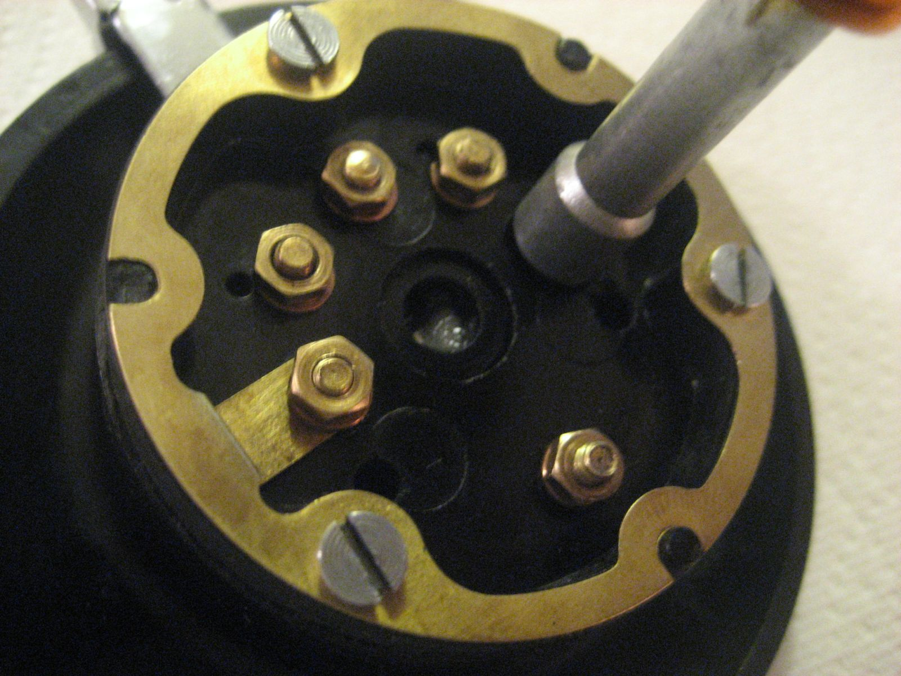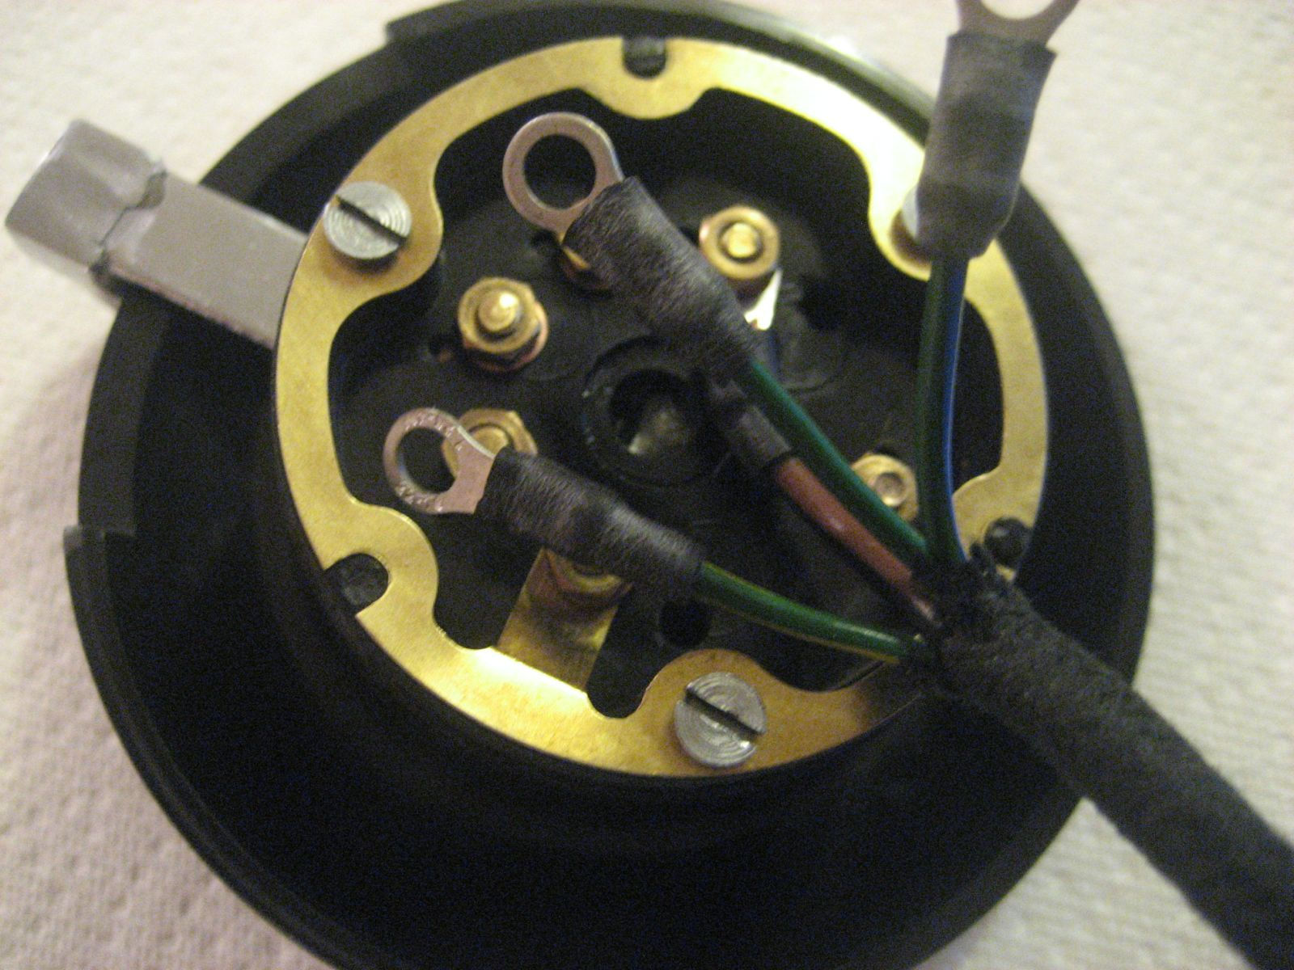
Step 3.) Still with the back of unit facing you, move the signaling lever to the right (left turn position) and hold it in place. Unscrew the corresponding brass nut and remove it along with its washer. While still holding the lever in place, attach the green/blue wire as pictured and secure with the washer and nut.
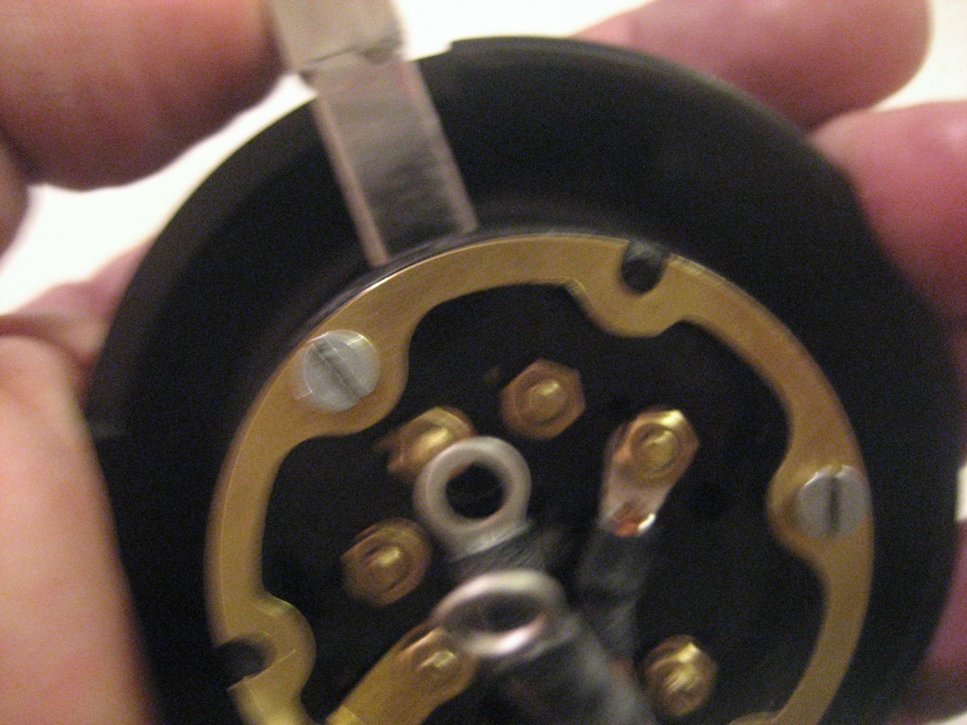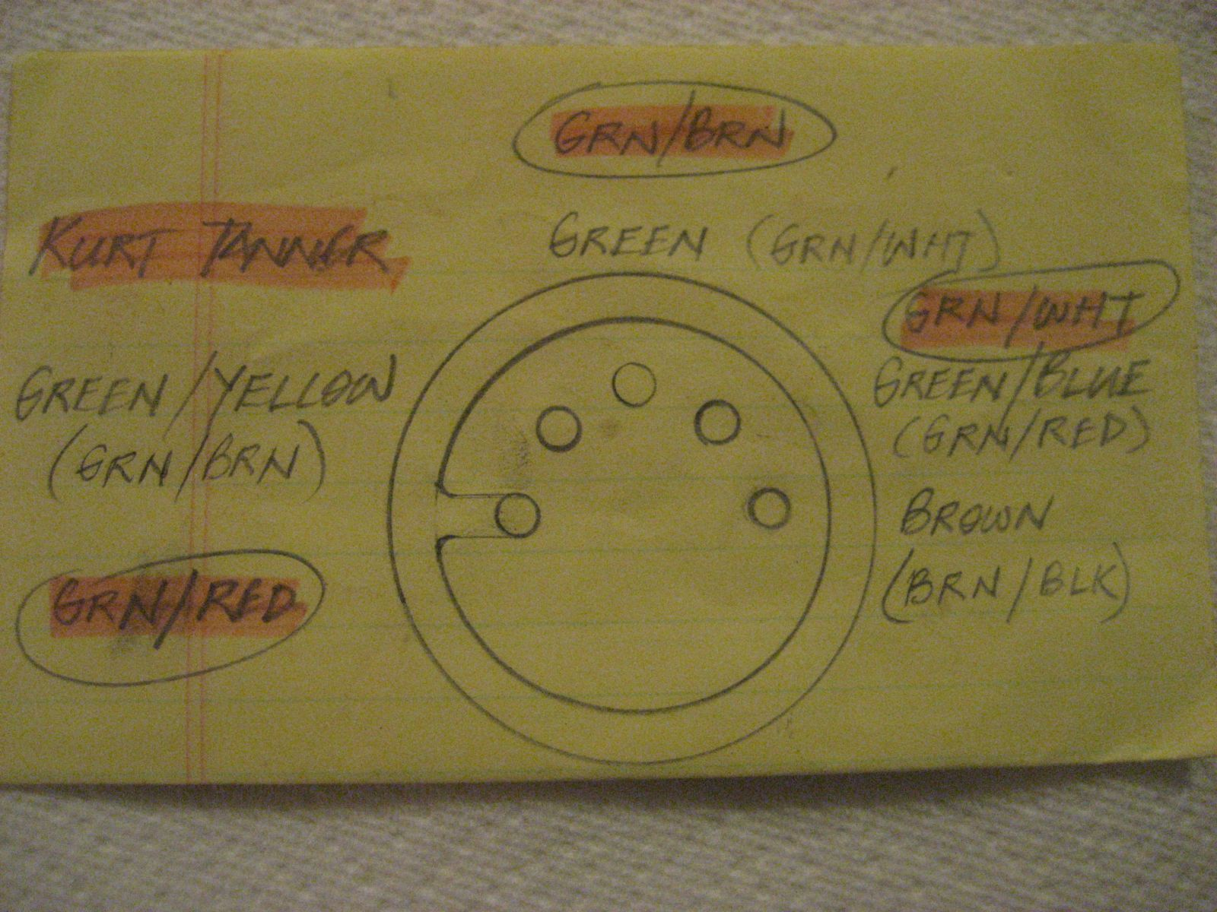

Step 4.) With the back of unit facing you, move the signaling lever to the center position and hold it in place (it should easily remain there). Unscrew the corresponding brass nut and remove it along with its washer. Attach the center solid green wire as pictured and secure with the washer and nut..
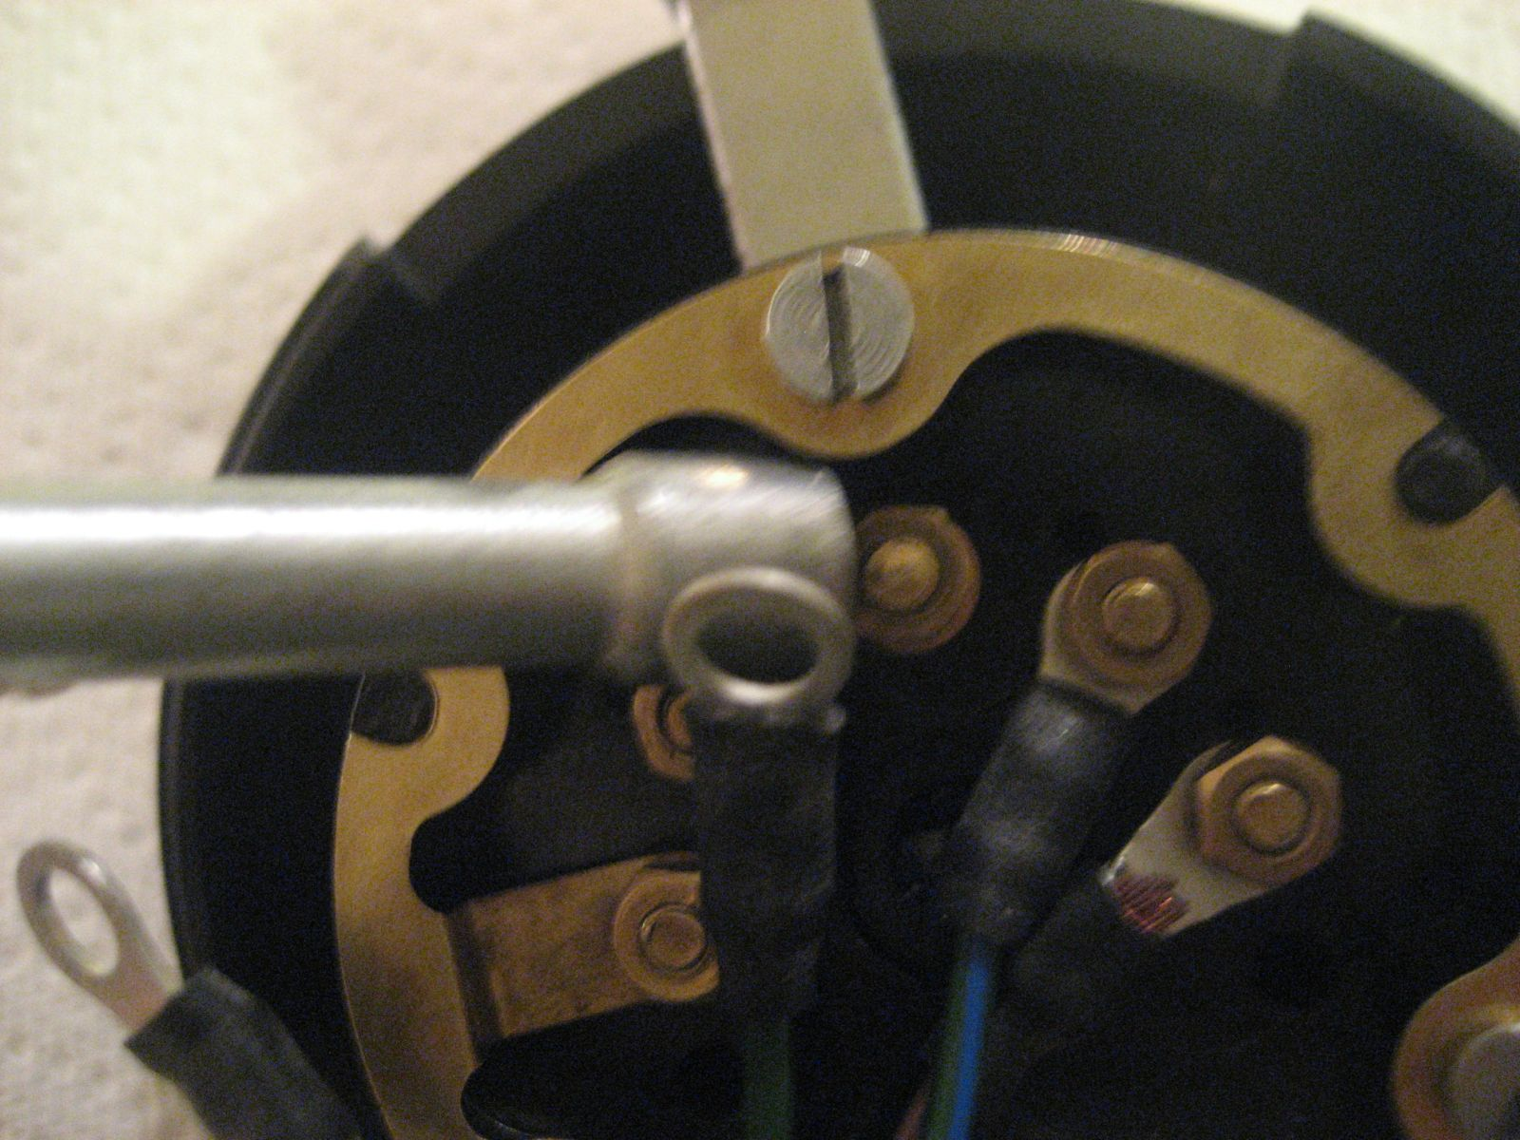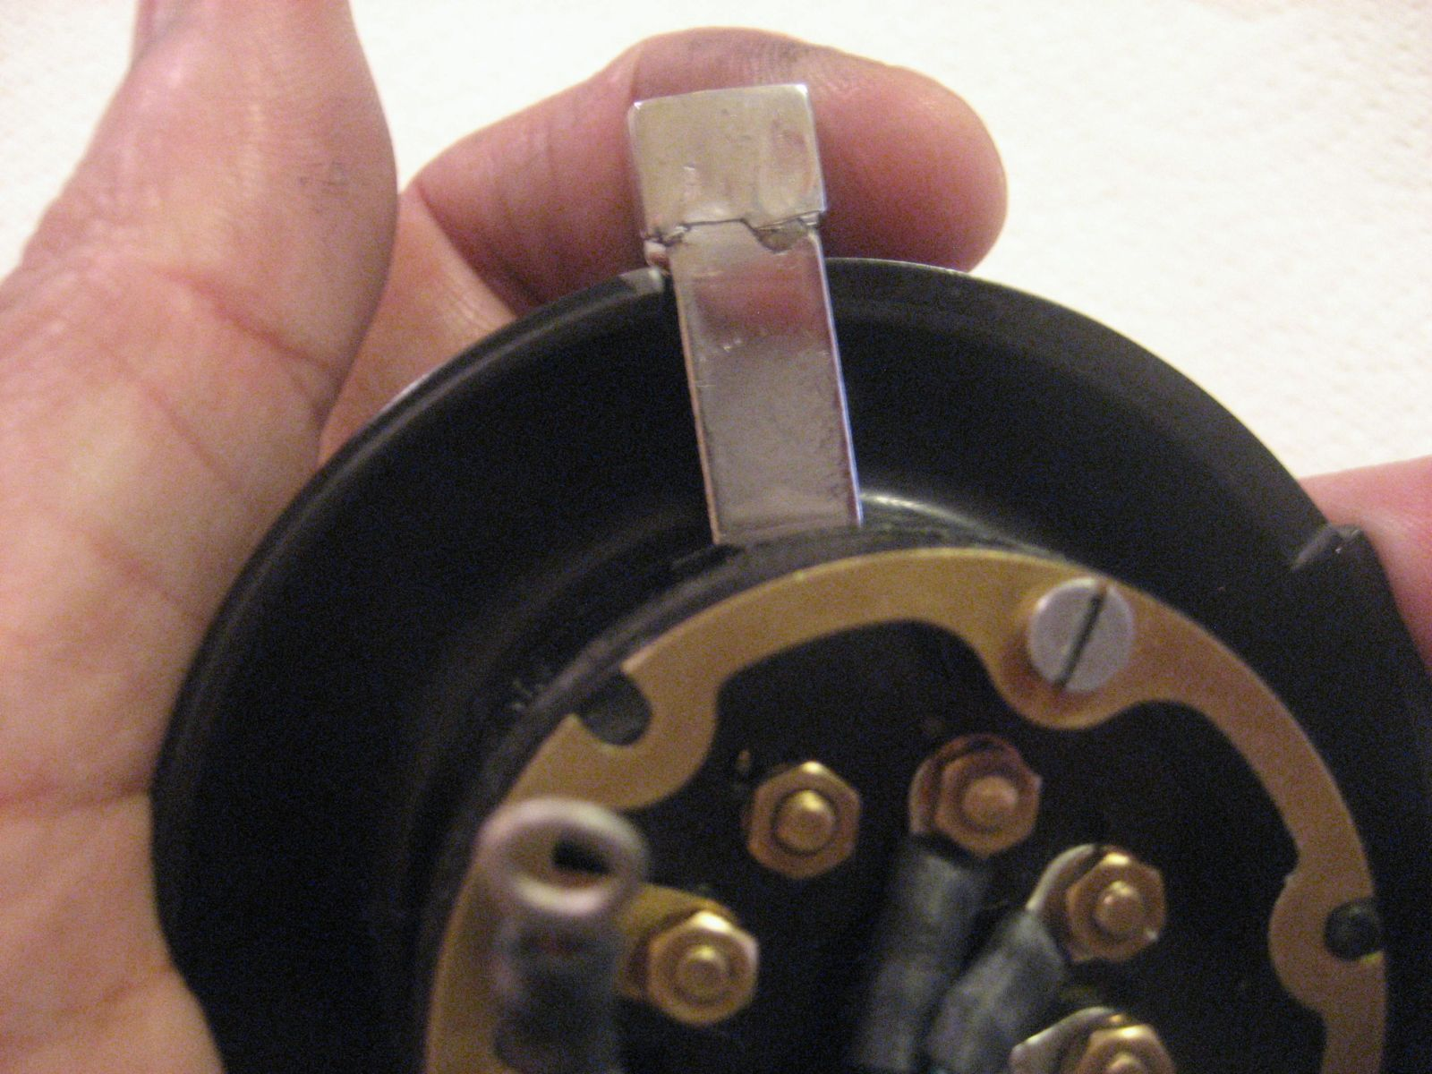

Step 5.) With the back of unit facing you, move the signaling lever to the left (right turn position) and hold it in place. Unscrew the corresponding brass nut and remove it along with its washer. While still holding the lever in place, attach the brown green/yellow wire as pictured and secure with the washer and nut. Reinstall the horn button and spring. You are finished.
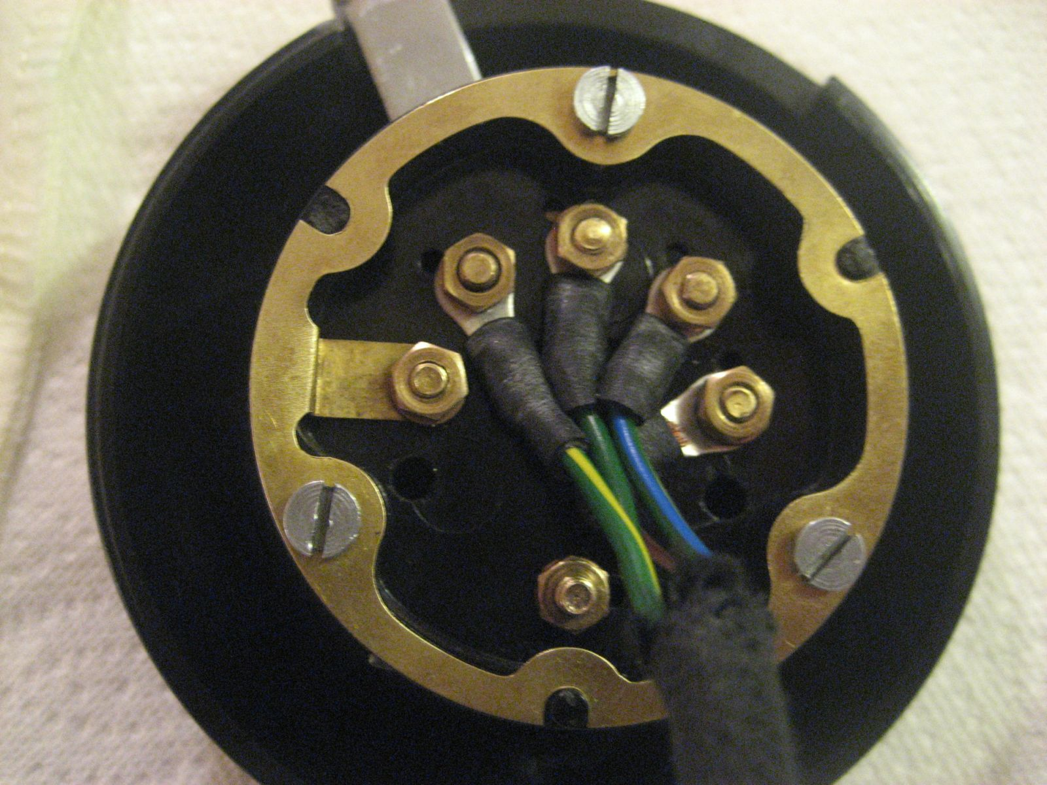

* Obviously, it is very important to move the lever over the corresponding contact and hold it there while wiring it so that the contact does not fall off inside the unit!

If you have questions, then call me. (760) 458-1926 cell. If you screw this up, you will be sending the unit back to me to disassemble and fix. This is why I request that you send the wiring harness to me when I do the restoration.

