Disc Brakes on 100-6 [Derek Job]
C:\Scott's Files\British Cars\Austin Healey\Individuals\Job, Derek\Website\Disc Brakes on 100-6 [Derek Job].doc
C:\Scott's Files\British Cars\Austin Healey\Tech\M - Brakes\Disc Brakes\Dunlop\Disc Brakes on 100-6 [Derek Job].doc
 100-Six
Disc Brakes
http://www.healeysix.net/DiscBrakes.htm
_____________________________________________________________________________
The 40 Homologation Cars
The 40 Homologation cars were not the only 100-Sixs to be fitted with disc brakes as these were an option available from dealers such as the Donald Healey Motor Company in the UK and Hambro in the US. (see Dealer Options)
In the UK a full set of disc brakes cost 85 pounds compared to 37 pounds for a radio! There is no record of how many cars were fitted with the brakes but two examples are featured below.
Healey expert and archivist Joe Jarrick (AH Club Queensland, Australia) was told by Geoff Healey that there were 40 100-Six cars produced at Warwick with 4-wheel disc brakes to homologate them for competition. (This would make these cars rarer than a 100S!). It’s unclear if they were separately classified but as of today, it would appear they were not.
Bill Piggott, author of the "Austin Healey" edition of the Haynes Great Cars series, writes in the book that he once owned a 100-Six registered XNX 56 that was one of the 40 (or 50) homologation cars mentioned above. The car was a 6-port BN4 built in late 1957 at Longbridge

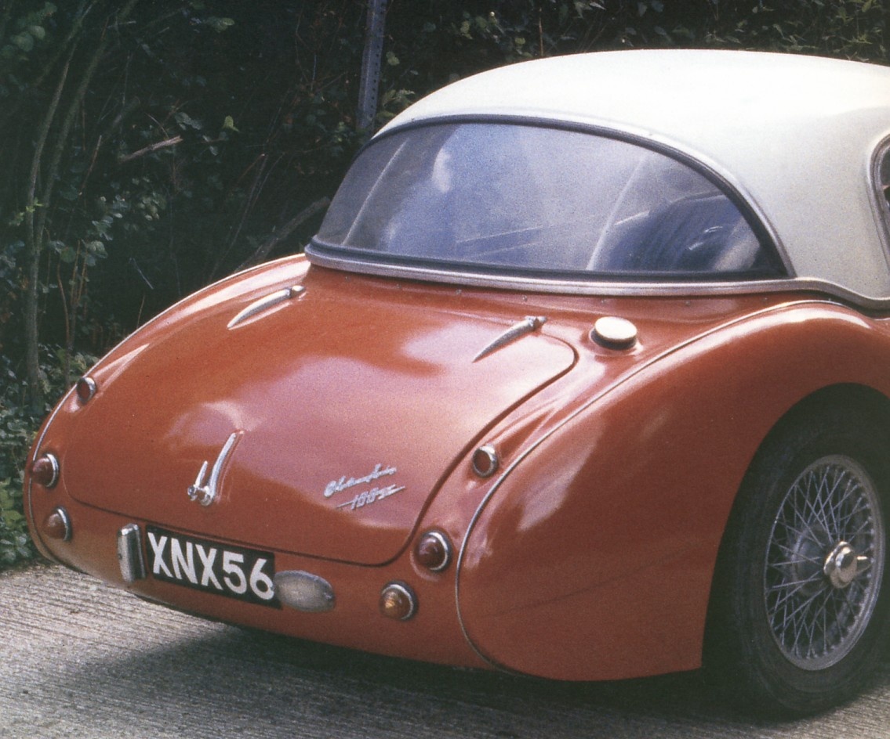 | XNX 56 owned by Bill Piggott and sporting 4 wheel Dunlop disc brakes  from  Austin Healeys  Haynes Great Cars
In addition, a 100-Six, registered XNX 399 & owned by Mike Self also has the four wheel disc brakes. This is another Warwick car from the same, late 1957 production period and corroborates the information provided by Joe Jarrick and Bill Piggott.

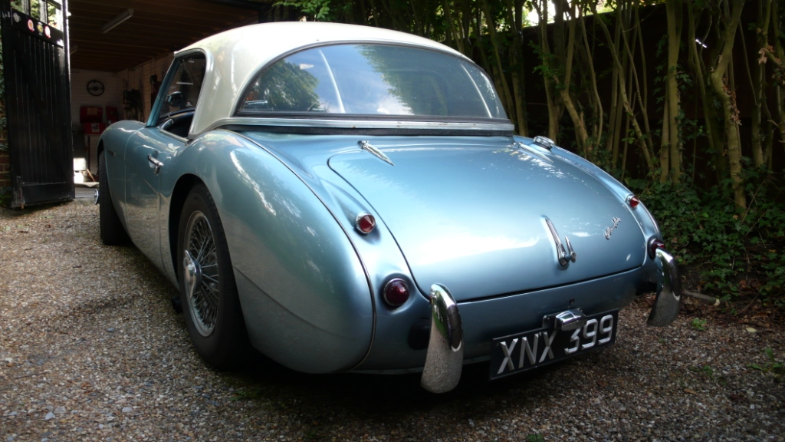

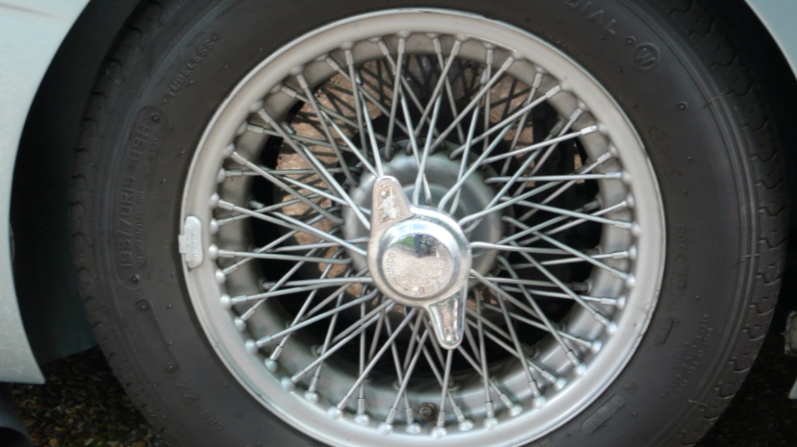 | 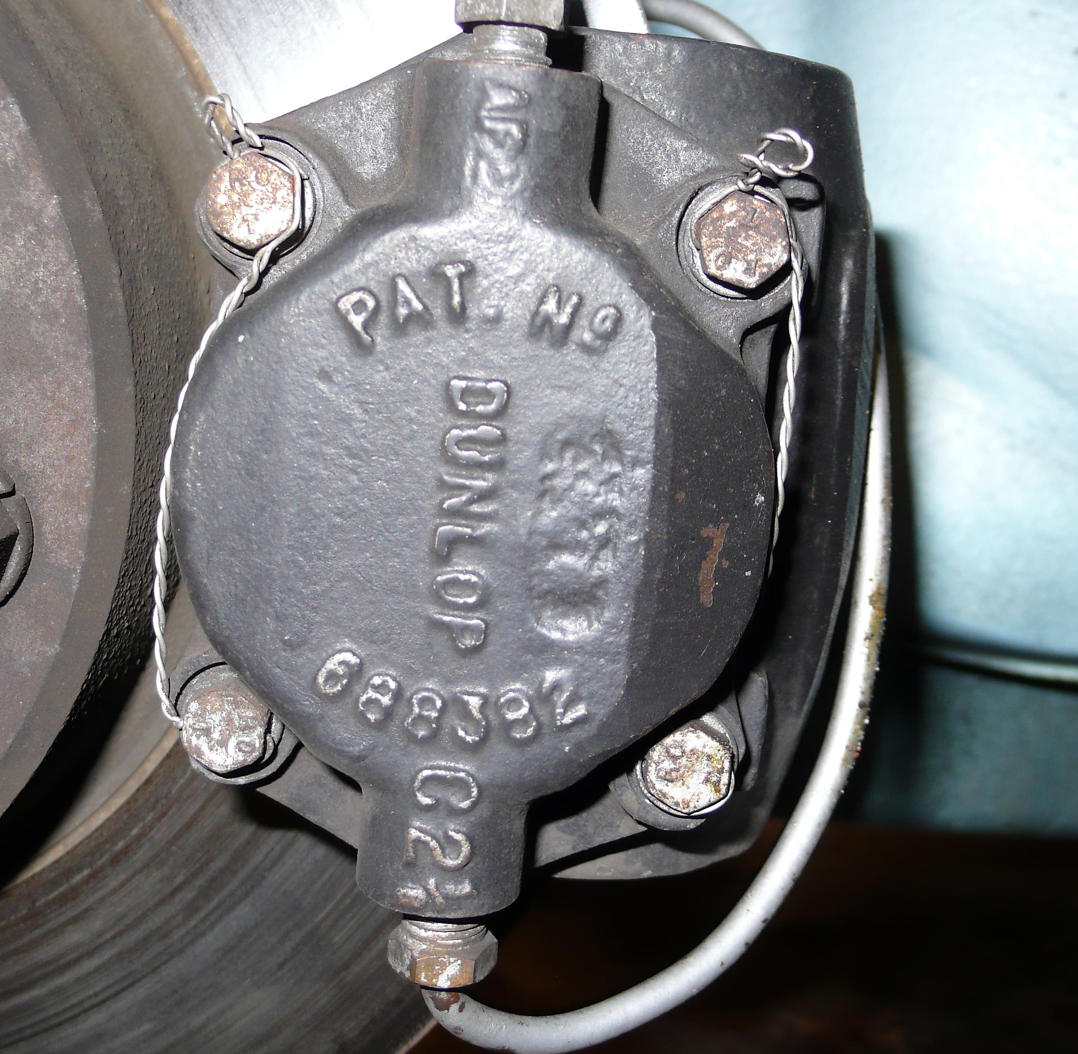
Details from XNX 399 - The brakes were made by Dunlop, unlike the Girling disc brakes that were used on Austin Healeys from the 3000 onwards.
The timing of the homologation in November 1957 makes sense as it coincides with the introduction of the six-port head, which was first run in the 1957 Mille Miglia, plus homologation at this time would enable disc brakes to be used in competition for the 1958 season when cars were run at Sebring in March and the official BMC Healey rally team was debuted.
Disc Brakes as dealer Options
The 40 Homologation cars were not the only 100-Sixs to be fitted with disc brakes as these were an option available from dealers such as the Donald Healey Motor Company in the UK and Hambro in the US. (see Dealer Options)
In the UK a full set of disc brakes cost 85 pounds compared to 37 pounds for a radio! There is no record of how many cars were fitted with the brakes but two examples are featured below.
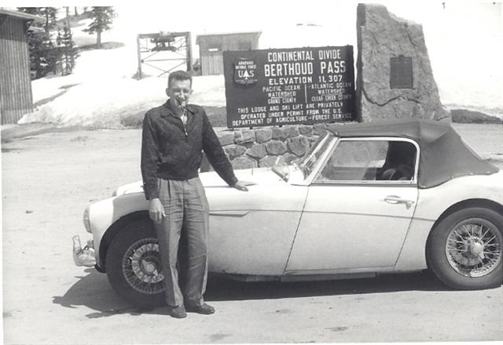
US Club racer, Norm Perkins and his 100-Six with disc brakes ordered from new through Hambro.
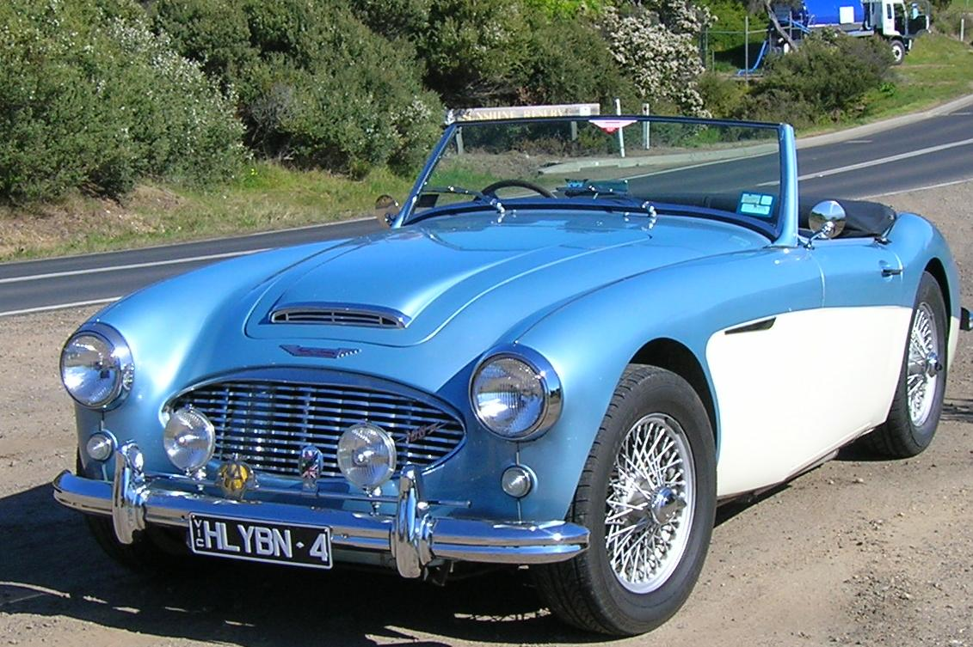
A late 1958 BN4 owned by Andrew Neilson in Australia. The car has disc brakes ordered from new by it`s original owner, Frank Muir, the famous British radio and TV wit and raconteur.
[Andrew Neilson of Victoria, Australia owns this BN4 which has original 4-wheel disc brakes purchased as an option.]

