CONVERTING FROM POSITIVE TO NEGATIVE GROUND

1. Disconnect the battery cables. Turn the battery around so that the (+)

post is now toward the front of the car, and reconnect the cables to

the battery. The negative battery post should now be connected to

ground. Note: the battery negative post is smaller than the positive

post. Be sure the cables fit completely and securely on both battery

posts. Change the cable terminals if necessary.

2. Reverse the white wire and white/black wire connections at the ignition coil.

[older ignition coils have terminals marked SW (ignition SWitch) and CB

(Contact Breaker, or points). Later coils are marked + and -. For

***positive*** ground, the white wire is connected to the SW (or –) coil

terminal.

For ***negative*** ground, the white wire is connected to the CB (or +) coil

terminal. Also, the older type coils are polarized for positive ground.

They will work with negative ground, but not as efficiently].

3. Re-polarize the generator:

a. Disconnect the smaller of the two wires connected to the generator (this

is the generator Field, or “F” terminal. The wire is normally brown with

a green tracer).

b. Connect a jumper wire from a 12V source (you can use the terminal where

the battery cable connects to the starter relay) and touch the other end

several times (briefly) to the terminal on the generator where you

disconnected the wire (be careful to touch only the generator F terminal,

and not a grounded surface with the jumper wire). Sparking will occur

when you touch the wire to the generator terminal, but it is normal.

c. Remove the jumper wire and reconnect the brown/green wire to the

generator.

4. Modify or replace the fuel pump with one that will work with negative-ground.

[earlier pumps are supposed to work with either polarity, but later pumps

have a diode that will burn out under reverse polarity, unless the diode is

reversed first]. I preferred to buy a negative-ground SU from Moss during a

sale.

5. Conversion to negative ground is now complete. Start the car and monitor the

ignition warning light. It should function just as it did before. It should

go out at about 1000 RPM. If it stays on when you turn off the ignition,

immediately remove the large brown/yellow wire from the generator. Be aware

that sometimes reversing the polarity can cause a marginal voltage regulator

to fail if it was on the verge anyway.

***Note: the following applies only to BJ8s, which have an electronic tachometer***

6. Modify the tachometer, after removing it from the dash (DON’T LOSE THE FLAT-

BOTTOMED U-SHAPED METAL CLIP THAT COVERS THE WHITE WIRE LOOP INDUCTION

BLOCK!):

a. Remove the tachometer chrome trim ring by turning it to align the bent-

over tabs with the slots in the tach case. [Originally, there was a

rubber gasket under the chrome ring, but this may have deteriorated and

glued the ring to the glass. If necessary bend the tabs out slightly and

wick a small amount of solvent such as acetone, 3M Adhesive Remover, etc.

between the glass and chrome ring to make it easier.]

b. Remove the glass. Again, if the glass is difficult to remove, it might

be made easier by wicking a small amount of solvent around the edges. Be

patient, and be careful not to pry on the glass too much and break it.

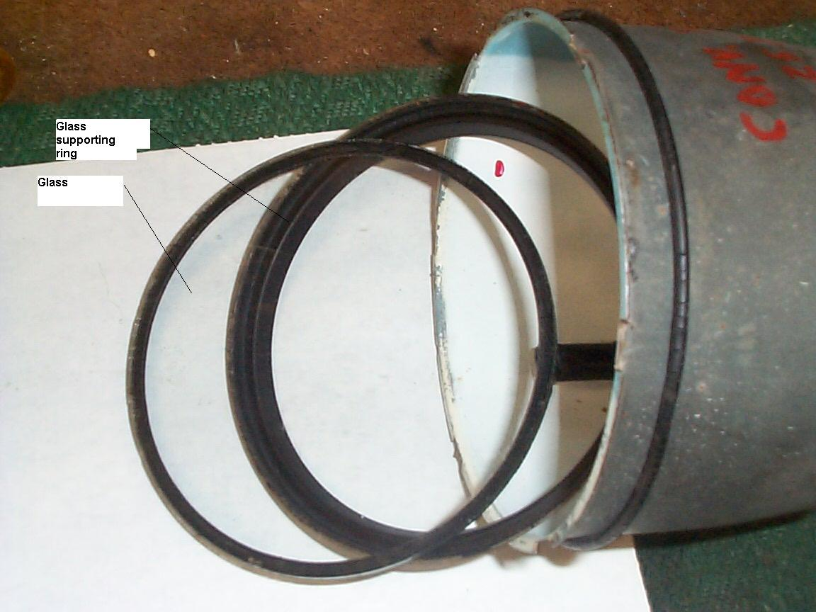

c. When the glass is out, remove the glass supporting ring from the tach case.  
 d. Hold the tach in your hand, face down. Note that of the four slotted-head screws on the back   
 of the tach, the tach case is cut out around the heads of two of them. These two screws hold   
 the internal parts together, and should not be touched. Remove ONLY the two screws A and B  
 as shown below. The internal assembly of the tach will drop into your hand. Be careful not to  
 touch the tach needle, or the black face of the instrument.

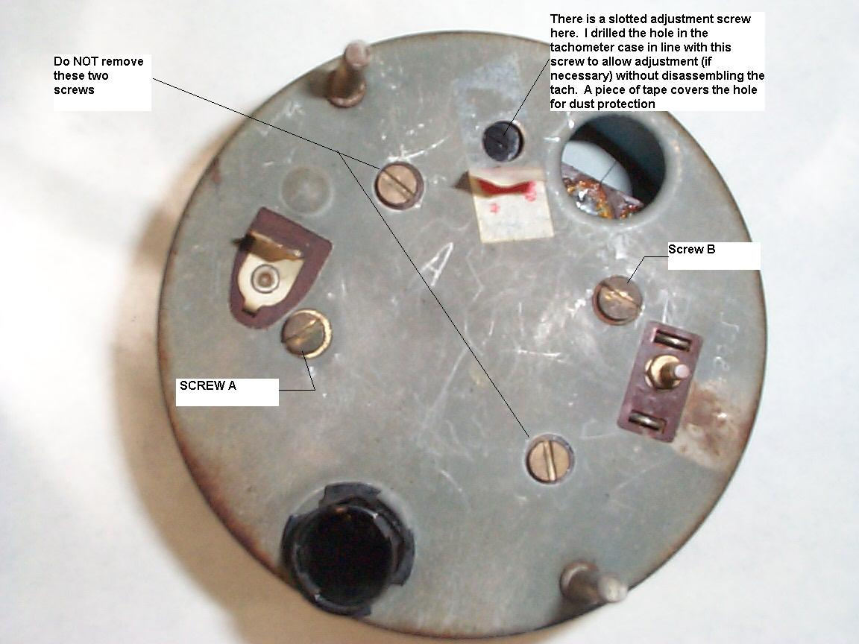

The photos below show my tach AFTER it had been converted to negative ground. On your tach, on the back of the internal assembly, note the blade terminal (to which the green power wire from the harness is normally connected) and the rivet. Before modification, the green wire inside the tach is soldered to the rivet, and the big gray resistor has one lead soldered to the blade terminal. For negative ground, these connections merely have to be reversed. The resistor lead will then be connected to the rivet at Point B, and the green wire will be connected to the blade terminal at Point D.

This is pretty simple to do. Just unsolder the green wire from the rivet and reattach it to the blade terminal at Point D. The only problem I ran into is that the resistor lead was too stiff to just unsolder and bend it over to the rivet. I had to cut the lead near Point D, then solder on a length of wire (same gauge as the green wire) long enough to reach Point B.

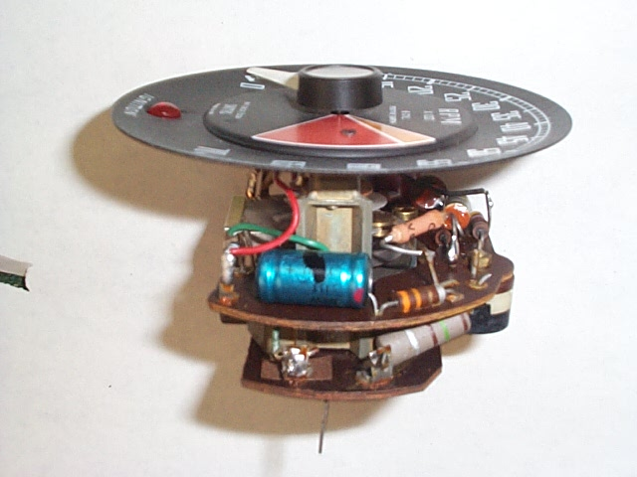

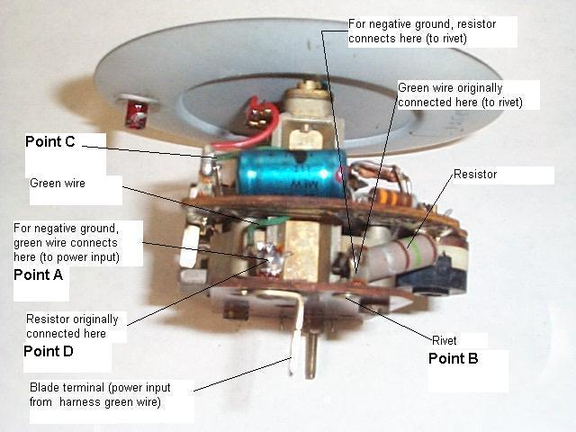

e. The modification of the tach itself is now complete, and it is ready to be reassembled, which is a   
 reverse of the disassembly process above. Note that there is a round black plastic adjuster on   
 the back of the assembly, with a slotted head for a screwdriver. Although this allows for   
 adjustment/ calibration of the instrument as necessary, it is not accessible with the tach   
 assembled into the case. To make it accessible, I drilled a suitably-sized hole in the tach case  
 aligned with the adjuster. This allows adjustment without disassembling the tach again. I   
 covered the hole with a piece of tape to keep out dust and dirt. This is shown in the second   
 photo above.

Note: although I did not re-adjust or calibrate my tach after the modification, some experts say   
 that it is almost always required. When I checked my tach calibration against a newly-  
 purchased dwell/tachometer instrument from Sears several years after the modification,  
 it was perfect without any additional adjustment.

f. The tach can now be installed back into the dash, but before connecting all the wires it is   
 necessary to reverse the induction loop in the white wire that is attached to the back of the   
 tach. This can be done a couple of ways, whichever you prefer. You can cut off the terminal of   
 the white wire that is connected to the ignition switch (leave enough of the wire attached to the terminal that it can be re-soldered to the rest of the wire), remove the wire from the plastic block  
 and route it the opposite way, then reattach the cut off terminal; or, you can leave the loop as it  
 is in the block and modify the wires as shown below:

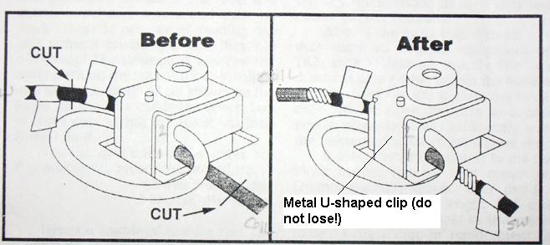

I made this conversion after installing a new wire harness, the white wire terminal of which was not   
 attached so that the new wire could be threaded into the plastic block holes).

The photo below shows the correct routing of the loop for **negative** ground. It can be confusing, but get the loop direction correct or the tach will not work. The loop diameter should be about ¾ inch.

