WHEEL BEARING ADJUSTMENT

1. You'll need several circular wheel bearing shims of each thickness: 0.003, 0.005, 0.010, and 0.030 (Moss Motors has them). If you are planning to remove, degrease, inspect, re-lubricate, and re-use the existing bearings, check for in-and-out movement (“end float”) of the hub before disassembly. If there is no detectable movement, then the existing shim thickness is correct and may be reused as is. Changing a bearing probably will require a different shim stack thickness.
The adjustment is done before you pack the outer bearing with grease, to make it easier and less messy to install and remove the bearing until you get the proper thickness of shims. The easiest and best way to do it is to use a dial indicator to determine “end float”, but I don't have one so it amounted to trial and error.

2. Be sure the axle spacer with the inner conical surface that goes over the axle and butts up against its base is in place. The conical surface goes inboard. The outer diameter of the spacer provides a machined surface for the lip of the oil seal to ride on. Lubricate the machined surface of the spacer and the lip of the oil seal with grease (lightly). The oil seal should be installed so that the spring inside is TOWARD the inner bearing.

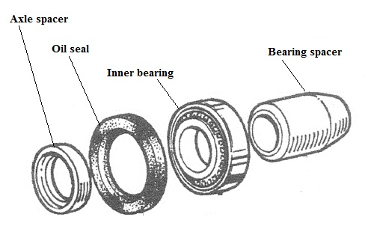

Figure 1

3. With the bearing spacer (conical end outboard), lubricated inner bearing and oil seal (spring cavity packed with grease) installed in the hub, slide the hub onto the axle.

4. Slide a total thickness of about 0.040 - 0.050 shims over the axle and down to the bearing spacer. It’s hard to install these shims (especially the thinner ones) with fingers alone due to the depth of the splined part of the hub and the restricted space. I fiddled around with several tools to make the job easier, but none of them was really ideal. Especially for the thinner shims, it’s easy to think you have them in place and find out later that you trapped one or two during the nut torquing process and have mangled them, not to mention getting misleading results. Try to ensure that all shims are flat against the bearing spacer before installing the outer bearing. It helps to stick the shims together with a light film of grease before installing them as a group.

5. After the shims are in place, install the un-lubricated outer bearing, the tabbed washer, and the hub nut. Torque the nut to 40 lb-ft, while turning the hub back and forth to seat the bearing and ensure it’s not binding. Do not install the hub nut cotter pin at this point.

6. Once the nut is torqued, push and pull the splined hub in an inboard/outboard direction and note any movement that can be felt. If the total shims installed are too thick, there will be movement that can be felt and maybe heard as a click. If you don’t feel play, then you haven’t installed enough shims. Add more (are you having fun yet?). If you had a dial indicator to measure the movement, then you would know what thickness of shims to remove and all you would have to do is disassemble, remove that many shims, and reassemble. Without the indicator, this becomes trial and error, and a bit tedious.
NOTE: the shims between the outer end of the bearing spacer and the inner race of the outer bearing cause the position of the bearing to be moved outboard (as compared with no shims). This introduces clearance between the bearing rollers and the bearing outer race, which is the “end float” (see Figure 1). A shim stack that is too thin will allow the bearing rollers to be forced hard against the race when the nut is torqued, perhaps binding them. The correct thickness of shims allows the rollers to seat in the race correctly with no “end float” or binding when the hub nut is torqued to specification

7. With positive play established, remove the hub nut, washer, outer bearing, and shims. Remove some shims from the stack and repeat the process from Step 5. If the shim thickness is correct, you will not feel any in-and-out movement in the hub in Step 6. Since you will not feel any play if you remove too many shims, you have to creep up on the correct thickness to make positively sure it is right.

8. Once you’ve determined the correct total thickness of shims to eliminate end float, you can pack the outer bearing with grease and put it all together for the last time. Torque the nut to 40 lb-ft while turning the hub back and forth, then note the orientation of the nut slots with the cotter pin hole in the axle. They probably will not line up. Continue torquing the nut (up to 70 lb-ft max) until you can install the cotter pin.
You don’t get much movement of the nut to go from 40 to 70 lb-ft, so if you have trouble aligning for the cotter pin you might try using a 0.003 shim under the hub nut to get alignment and still have 40 – 70 lb-ft of torque on the nut. Use another 0.003 shim if necessary.

9. Install the hub nut cover (grease cap): Lubricate the inboard outer surface where it mates with the inner diameter of the hub. Tap it straight in until you feel solid resistance. The inner end of the cover should now cover the cotter pin hole.

Figure 2 is below.

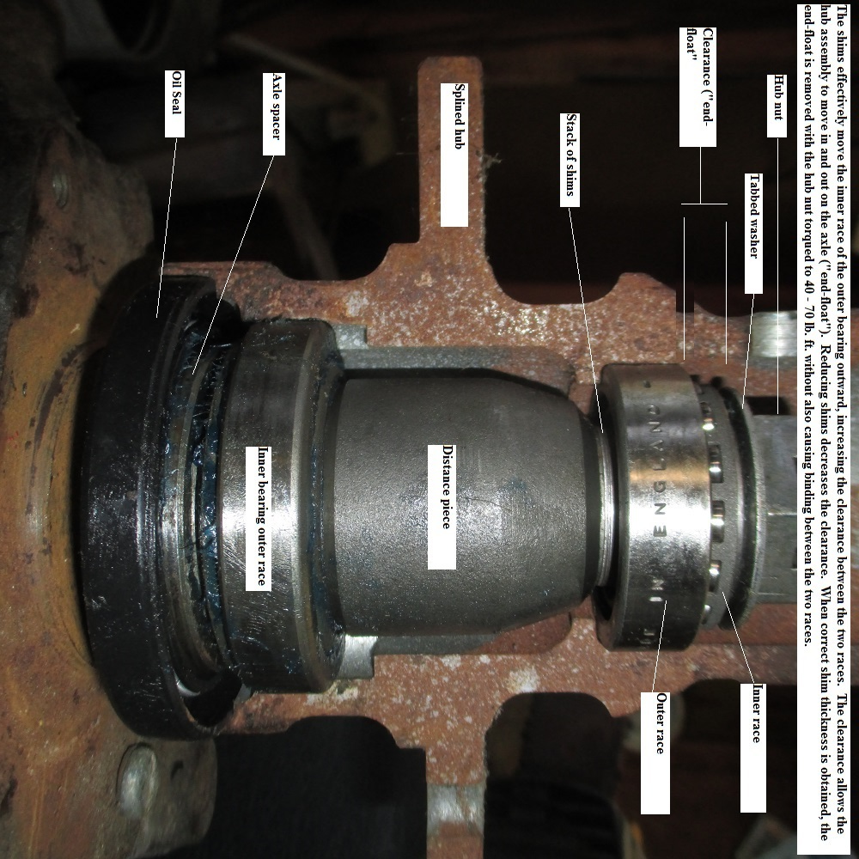

Figure 2

Steve Byers
BJ8 Registry
5 April 2019

