Bigger Front Discs on A 3000 Mk1 or MkII
The only Austin-Healey regarding which I can claim any sort of expertise is my MkII BT7; I’ve got to know that quite well over the years. I am however reasonably sure that the manufacturing step from 100-6s to 3000s saw the introduction of front disc brakes, Girling “Type 14”. Likewise, with further development, these were replaced by the virtually lookalike, but much bigger, “Type 16” after BJ8 chassis 26704. So, if you are a 100-6 or BJ8 owner, read no further. In preparation for taking my car over the Alps and down to the Mediterranean coast I rebuilt or uprated various items in the car. New rear springs, a double ended fuel pump etc; some of these have appeared as articles in this magazine. Anyhow, if BMC felt that bigger brakes were a sensible development, I thought that I’d look into doing it myself.....subject to cost.

The starting point of this conversion is the vital nugget of information relating to the callipers required. BJ8 callipers will not fit. Yes, they are “Type 16”. But, not all “16s” are the same. The crucial point is the distance between the two mounting holes. The BJ8 bolts are 3½” apart; the MkI & II’s bolts are 3¼” apart. Now, one can get so-called kits from our usual suppliers at vast prices, these things plainly being hand crafted out of the purest unobtanium OR one can search the web for callipers off medium sized Fords from the ‘60s through the ‘70s. Capris are a good source. The donor car must have had unvented discs. A further snare is the thread of the brake pipe and brake nipples. These “went metric” at some stage, but that’s not much of a problem....simply swap over. However, the ideal is to find callipers marked:-
64326047 64326673 (RHS)
64326046 64326672 (LHS).
One has to swap discs; going to the bigger/heavier/thicker BJ8 disc is all part of the process. The discs are a straight swap, bolt for bolt, no worries there. The dust or stone shields cannot be reused, but they are often discarded anyhow. (Have you ever seen a disc after a pebble has got stuck in there?)

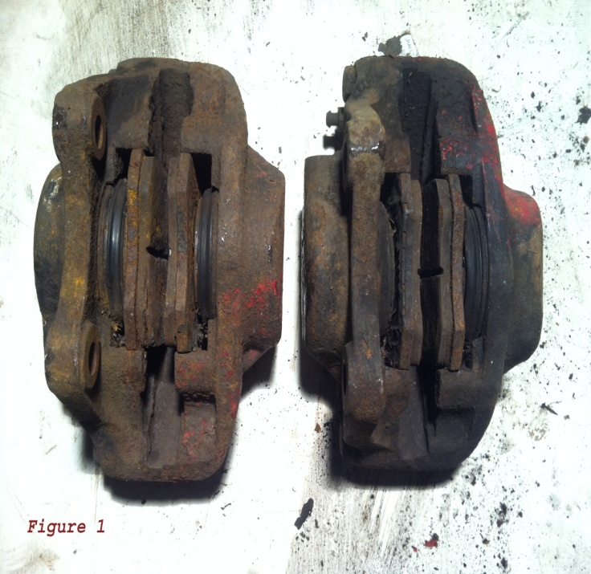
My callipers cost £10:00 plus p&p. They looked fairly awful on arrival, but that was not an issue as I knew that I should have to restore them anyhow. See Figure 1. A calliper comes apart easily enough....two bolts. There used to be a myth to the effect that they should never be split; this was to do with the supposed unavailability of the little square section seal inside which allows the fluid to progress, under pressure from one side to the other. These seals are available and one can split the callipers. (One must.) The callipers will probably arrive with vile old pads seemingly immovably rusted in place. Do not panic; brake fluid is a fairly good lubricant and the callipers’ pistons’ interior bores will most likely be in far better condition than the callipers’ external appearance would suggest.
Extracting the pistons. I do not have an airline in my garage so I cannot blow pistons out. Yes, I usually try to prise them out with screwdrivers which works if the pistons have been in use recently. Otherwise, I put an appropriate bolt into the brake line hole and a grease nipple into the brake bleed nipple’s hole. (Put PTFE tape on the threads to stop leaks). Then, using a lever action grease gun, I pump in grease until the pistons begin to be expelled. A quick tip here.....if you keep pumping at this stage, one piston will probably come right out before the other one moves at all. Disaster......there is no way to get pressure behind the second piston without forcing the first one back into its bore! Clamp the one that has begun to move in situ with a G-clamp and a bit of plywood until the other one eases free. Then it’s easy to get them out in a controlled fashion.
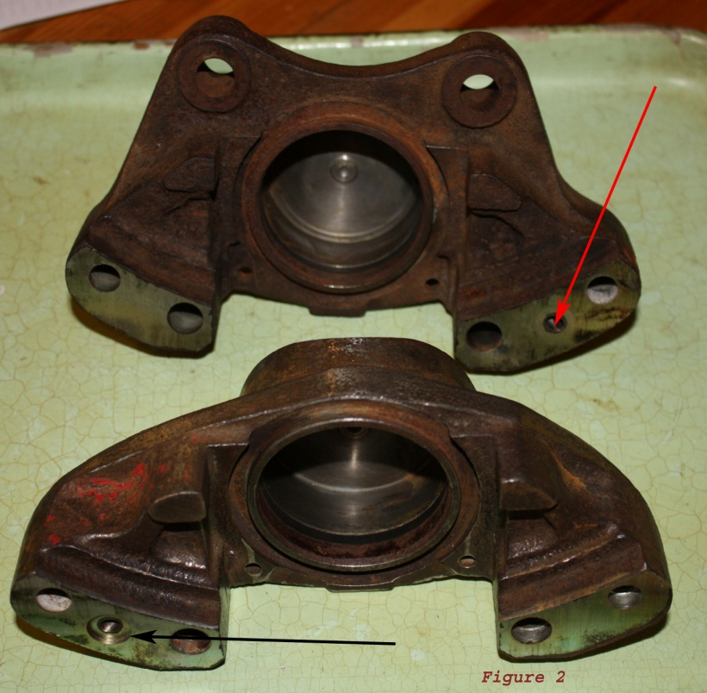
Replacing Seals and pistons
See figure 2, on the left. The black and red arrows show where the square section seal goes and the clean metal surfaces show the likely state of any calliper’s interior upon initial splitting. So, I:-
i] wire brushed the exterior surfaces with an electric drill, cleaned out the grease, old brake fluid etc with petrol then old but clean brake fluid.
ii] cleaned and polished the piston bores.
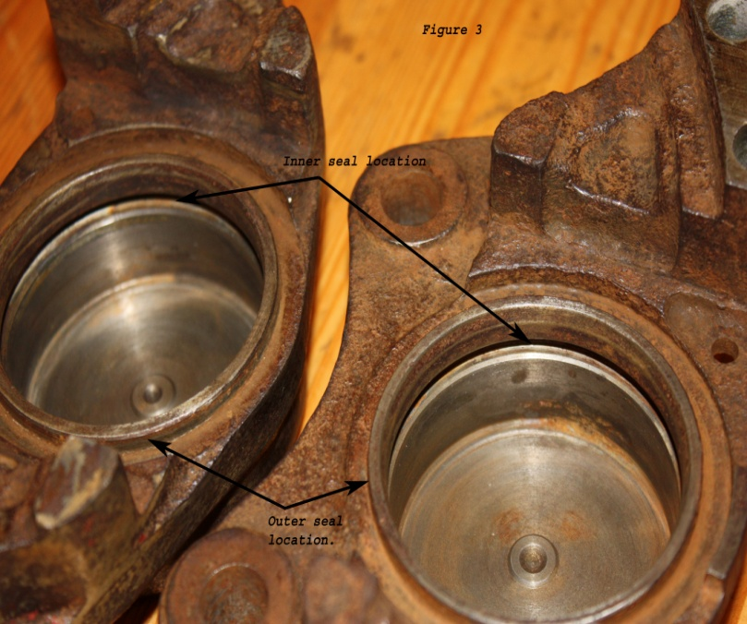
iii] replaced the rubber seals...an inner seal within the bore and an exterior one, rather like a concertina in its action, that attaches to the top of the bore and the top of the piston.

See figure 3, on the left, for the seals’ locations, top arrows for the inner seals; bottom arrows for the outer ones.
When everything is dry and dust free, it is time to spray the calliper halves with the appropriate paint, easily available in virtually any colour.
One might as well take advantage of the callipers being split and put the new pistons in at this stage. Much easier. So:- with the inner seals in place and the parts all clean and flushed out, I was able to push in the new pistons and locate the outer seals. I always fit stainless pistons; they should last forever and represent one less thing to go wrong in the future. Some clean brake fluid in the bore and on the inner seal helps to ease things along at this stage.
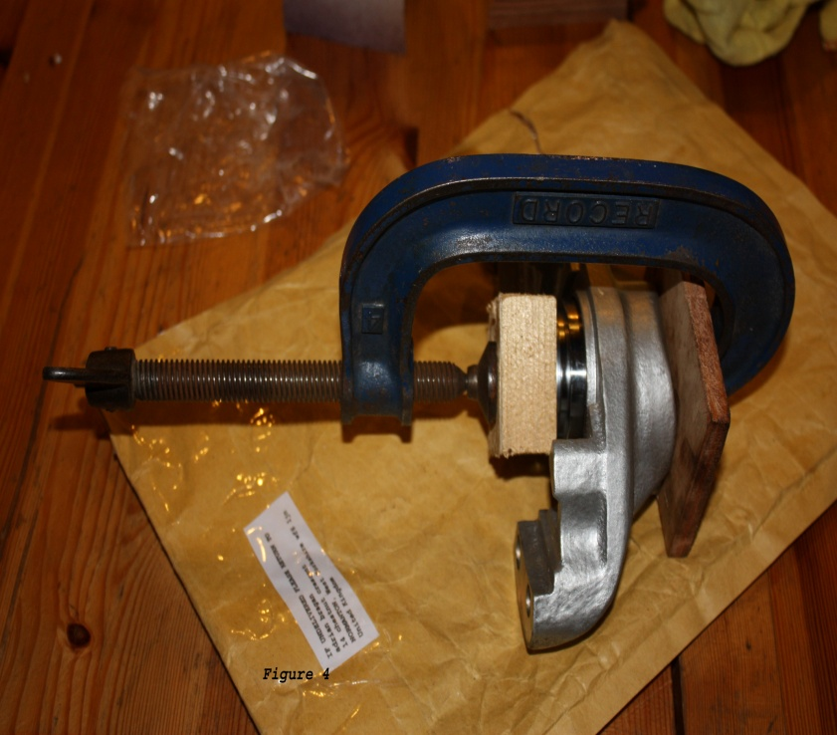
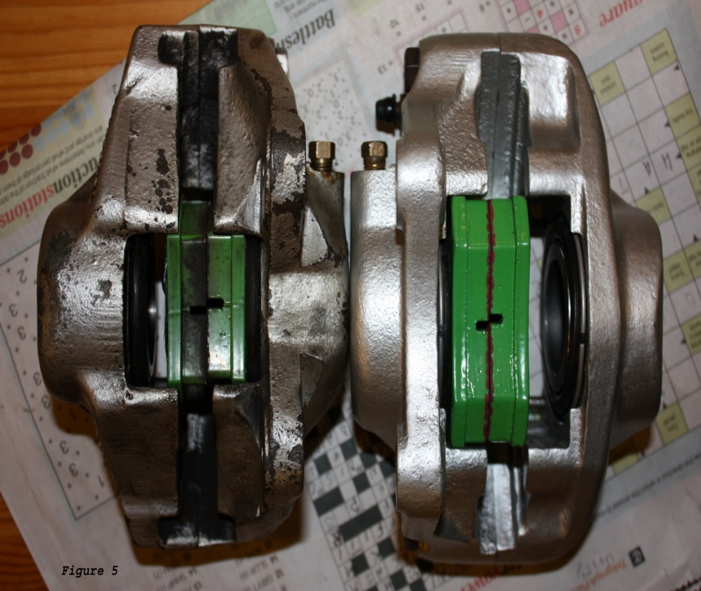
I use a G-clamp to push in the pistons per figure 4, on the left. Once the pistons and the outer seals are in place, it is time to replace the square section seals. I say “replace”, but mine have always seemed as good as new. I do put in new ones but I’m sure that the old ones were serviceable.

Figure 5, on the left, shows a number of things:-
i] an original “14” on the left with the restored and complete “16” on the right.
ii] Note the spring around the outer seal on the “16”, a different setup from the “14”.
iii] Note the bigger gap between the calliper halves permitting the use of a heavier duty disc.
iv] Note the bigger pads on the “16”.
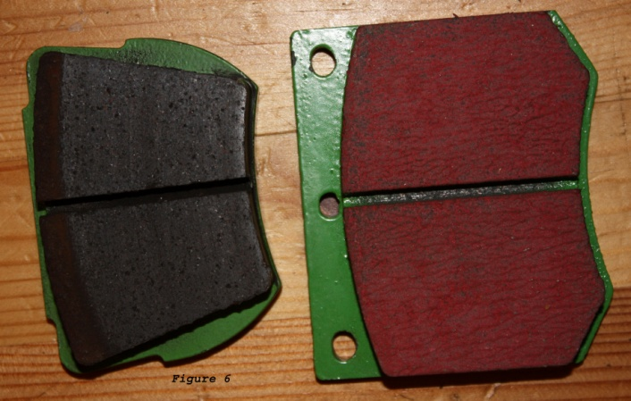
The little picture on the left, figure 6, serves to show how much bigger the “16’s” pads, left, are than the “14’s”, right.

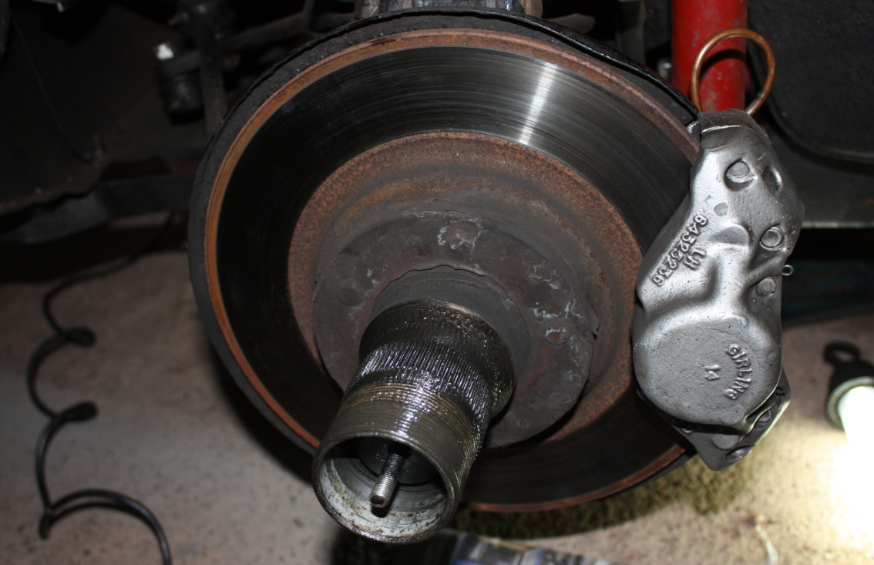
This is the original “14”, prior to the swap.

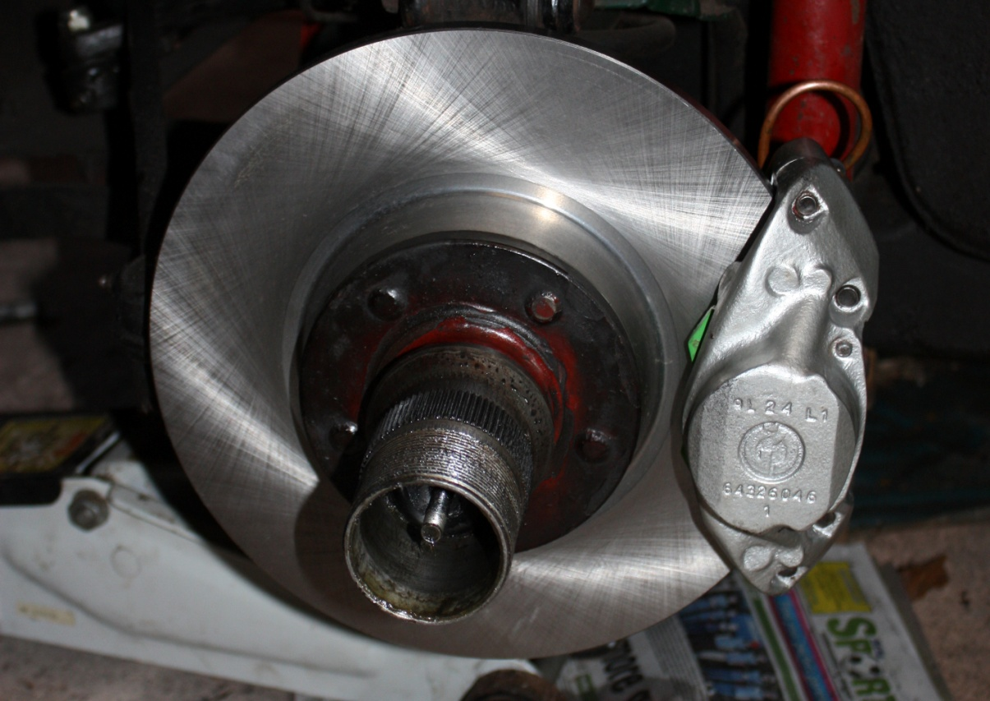
And this is the “16” after the swap. Similar appearance but no dust shield.

. Final question: “Is there an appreciable difference in braking performance?” Yes there is. It’s not noticeable in normal traffic as there should be a comfortable margin there anyhow. However, if one needs to stop in a hurry, then the improvement is very obvious.
Simon Lachlan. August ’13.

