**Lucas 494 Backup Lamp - Original Mounting Bracket & Switch Mounts** *- 1960 BT7 owned by Bob and Barbara Humphries of San Diego, CA*

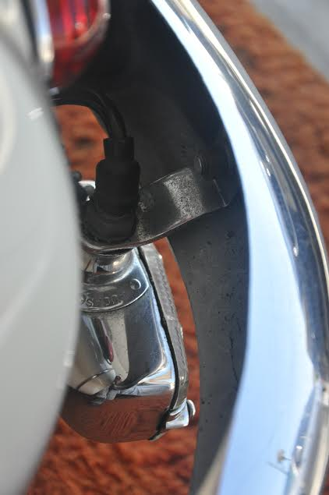 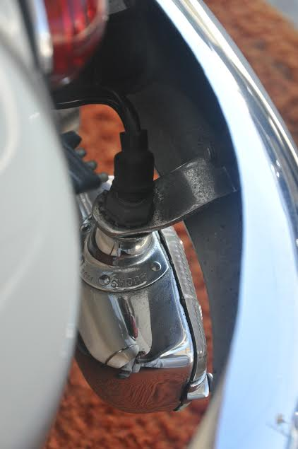

*Original Chrome plated bracket on a 1960 BT7 (courtesy of Bob Humphries).*

