Fuel Pump Issues

For the record, what was originally the AUF 300 series is now referred to as the AZX 1300 series. I doubt that any AUF part numbers are current these days.
In order to approximately understand the pump...it works by creating a vacuum in the pump body which lifts fuel from the tank. This is then pushed up the line to the carburettors on demand. Thus it is vital to stop vacuum leaks on the pump’s inlet side.
You will see the more common SU fuel pump problems below. (This section is partially and shamelessly culled from the net and somewhat abbreviated.)
1) Burned and/or sticking points – causes intermittent fuel starvation and stalling. When this happens, the pump’s tic, tic, tic sound is missing. A sharp rap on the pump or bulkhead may revive it, but the only solution is replacement of the points.
2) Diaphragm stiffens with age – this will usually cause the pump to run slowly or erratically. The only solution for this is to replace the diaphragm.
3) Leakage past valves – pump will seem to run at normal or faster rate, but no fuel is pumped; a vacuum gauge on the input will bounce up and down in time with fuel pump clicking. On the L or HP pumps, this will necessitate new valve disks and/or re-facing the valve seats. On the AUF 300 series, the valve assemblies will have to be replaced.
4) Fuel leak – caused by loose coil housing to body screws, loose inlet/outlet fittings, split diaphragm or cracked pump body. A split diaphragm requires replacement while loose screws or fittings just require tightening. (Try sealant on threads and lock washers).
5) Broken pedestal - usually a problem only on the L and HP pumps and usually owner induced by over tightening the mounting screws. This will stop the pump completely and is corrected with a replacement pedestal.
6) Air leak – usually shows up as fuel starvation at higher speeds. To check for this, disconnect the fuel line from the last carburettor in line and route it into a jar. Turn on the ignition and, as the jar fills, watch for a stream of bubbles. The fix is the same as 4) plus checking the lines and fittings between the pump and the fuel tank.
7) Clogged lines – before or after the pump. Disconnect the line from the pump to the carburettors and replace it with a line into a jar; turn on the ignition and see if fuel is pumped out of the pump. If it is, the output line is clogged between pump and engine. If no fuel is pumped out, disconnect the line from the tank at the pump and turn on the ignition. If the pump runs, the line from the tank is clogged. (Have fun with that one!)
8) Squashed line – per 6) &7), above. Check line between pump and carburettors. Happened to me! Took forever to find out what was wrong.

It seems to me that the only certainty when opening up an SU pump, in this case an AUF 301, is that whatever one finds within will not be 100% identical to what one finds on the diagram in any of the manuals or, more depressing yet, in the rebuild kits. That is due to a mixture of cost cutting and improvements.
The top diagram, below, shows an old(ish) version. There is a condenser (aka capacitor) where, in the very oldest pumps, there would have been nothing (except burnt points). There is a “flow-smoothing device”, and the diaphragm’s “centering pieces” are brass.
The lower diagram’s newer pump has a diode, much better than a condenser and longer lasting. The “flow smoothing device” has been discontinued/much simplified. Sadly, the brass “centering pieces” have been replaced by a nylon moulding which always seems to break. This piece has, in its turn, been replaced by a set of little nylon figure-of-eight shaped thingies which are tricky to press in, but very effective thereafter. See the photo below of the rebuild kit’s contents.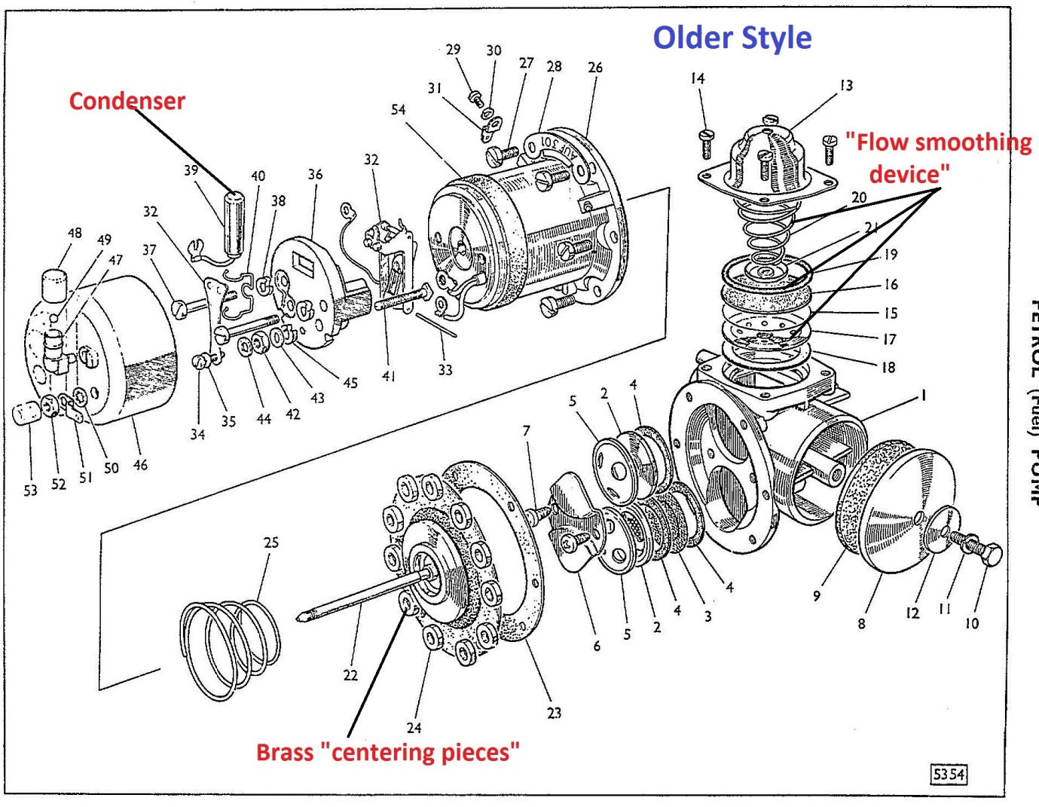
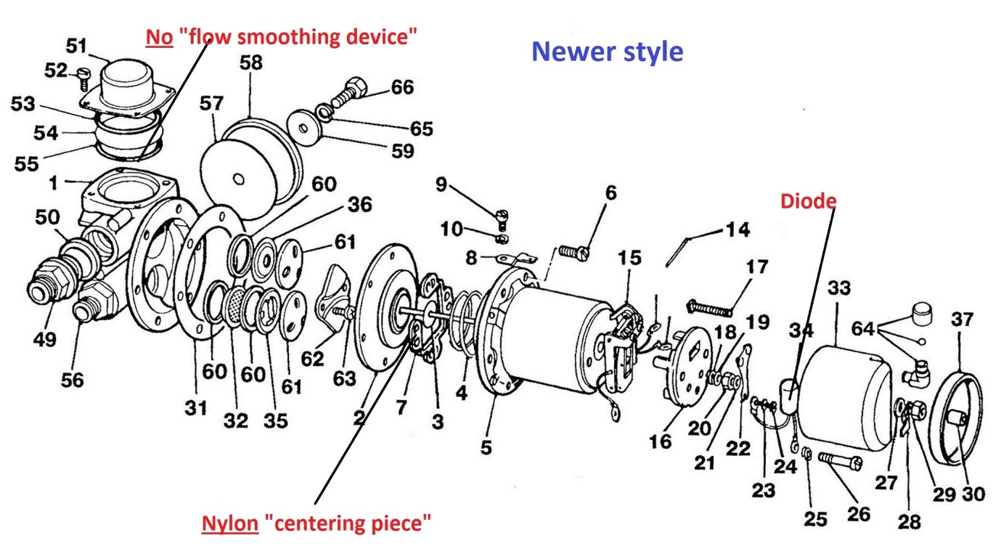
If one looks at the eight common SU fuel pump problems listed above, the latter three problems are fairly self-explanatory and, once alerted as to cause and effect, fairly easy to diagnose and correct. The first five all involve putting the pump on the bench, opening it up and replacing something; in the first four, that something is in a rebuild kit, see below. One might tighten up the coil housing to body bolts in situ to eliminate that possibility, but I’ve never heard of those bolts being loose. Quite the opposite usually.
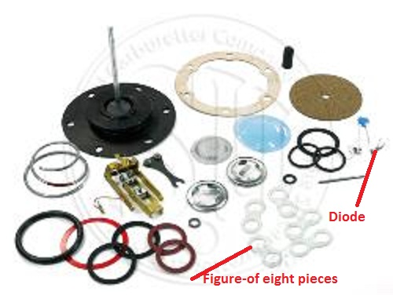
In my opinion, once one opens up the majority of pumps, one will find burnt points, an old condenser and a tired diaphragm. The pump will probably have actually failed because the points were giving up and that may well have been exacerbated by a dead/tired condenser or even by the lack of either condenser or diode. (Condensers and diodes serve to reduce sparking and thus wear at the points). Once one has opened the thing up, one can say fairly confidently that, if faced with an (old) condenser, one is looking at an old diaphragm and that its days are likewise numbered. A rebuild kit, left, costs £29:12 and contains everything one needs to make a pump as good as new, assuming the body’s structural integrity,......diaphragm, points, diode are all in the kit plus valve assemblies, filter and a host of seals and washers. A diaphragm alone costs £17:63. So, it must make sense to buy the kit and replace everything, thus solving most future problems before they arise?? And, as one has to completely dismantle the pump in order to remove the points, why reassemble it with old and potentially failing parts?
So, one buys the kit and confronts the issue of actually doing the rebuild. It is very simple, requiring no unusual tools or skills. Have a manual close at hand and stick to the instructions that come with the kit. If in doubt as to the reassembly stage, take photos as one takes it apart. Note, for example which way up the valve assemblies sit and in which chamber. But even the diagrams above should be sufficient.
1) Assembling the body components, the valves etc, is simple......strip, clean and reassemble with new parts per the instructions, diagrams and your photos.
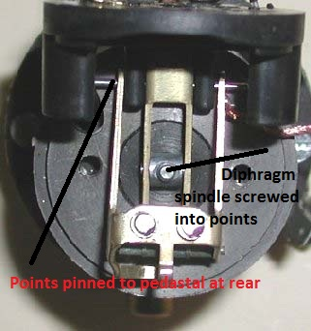
2) The coil half, with the diaphragm, points and diode is easy to take apart and easy to assemble. The usual caveats with reference to having three hands apply, but it all comes together just as it comes apart....allowing for, say, replacing a condenser with a diode. More on which later. There is however one vital setting that needs to be just right or the pump, having maybe worked on the bench, will malfunction in the car under load. This is the points to diaphragm connection. At the tip of the diaphragm’s spindle is a thread which screws into the pivot in the lower half of the points set. The instructions in the kit are adequate here, but the terminology is a little challenging. There is reference to “throw-over” and no explanation as to what that may be. Well, one can see that the lower part of the points must move with the spindle and that, whilst both halves are pinned through the pedestal at the rear, the front halves are only connected to each other by two little springs and a pin; they are not connected to the pedestal. This allows the lower half to pull the top half down thus sliding its points away from those on the blade; it is much like watching that end of a piston which is attached to the driving cog, almost a rotary movement. If the spindle is screwed in too far, the points lock solid. Unscrew the spindle bit by bit. Keep pushing it up and down into the points. When you have unscrewed it enough, the throw-over will happen and the points will part. Go back a little until the points are jammed again and then unscrew carefully to the magic throw-over spot. Mark a bolt hole in the diaphragm against a hole in the case. Now unscrew a further four holes worth, per the kit’s instructions. You will now be informed that “the diaphragm is completely set” and you will carry on without a care in the world. However, it is generally believed nowadays, by the gurus who understand these marvels, that one is well advised to unscrew by a further hole or two, to be sure that it works under load. (I’ve always opted for one extra hole and that has worked fine).
Setting the gaps is simple, per the manual and/or the kit’s instructions. Make sure that the four contacts meet flush ie flat surface to flat surface and that the blade’s points, on top, are correctly aligned with the bottom pair. See the photo on the left where only the bottom right at 5 o’clock has been touching: a problem in the making.
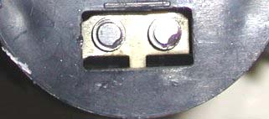
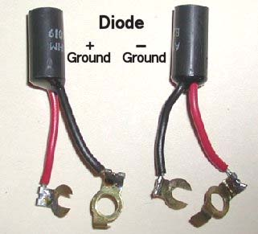
I think that one is entitled to a little confusion on the topic of condensers, diode’s and pumps’ polarity. I know that all our six cylinder cars were originally positive earth and I imagine that the early four cylinder cars were too; I do not know about the later Sprites, but I imagine they were positive earth also. A lot of our cars have been converted to negative earth and so there are traps waiting. A pump with neither condenser nor diode will function in either polarity, but its points will spark and wear quite fast. This was acceptable in the days when chaps in flat hats and cavalry twills took their cars down to the local garage where the ex RAF fitter in brown overalls replaced five sets of SU points per day; it’s not so easy nowadays. With the trend for changing older cars from positive to negative earth – to facilitate the fitting of, say, electronic ignitions – came a need for more negative earth pump choices. Some pumps were quite recently marketed for our cars that claimed to work equally well in either polarity, ie the inference was that these were an improved article which, through clever electronics, worked in either polarity. In fact, these pumps had simply started life as pumps with diodes but these had been removed; if one took off the end cap, one could sometimes see where the diode had been snipped off! So, to be sure, one can either use an old condenser which works for both polarities (not recommended), or one can use the correct diode. Diodes only work one way ie the current will only flow through the diode in a particular direction. Thus all diodes’ internal workings are the same but they have to be connected the right way round. See the picture, above, wherein there are different fittings on the red/black leads thus determining which lead can go where. (The little black can is identical in either polarity).

Simon Lachlan
October 2012

