Brake Fluids
I was getting myself in a muddle over brake fluid just now so I made myself some notes. As I suppose some of you may be as susceptible to muddle as me, I offer them up here:-
- All brake fluid is “synthetic”…it’s not a “natural” product.
- Most synthetic fluids are NOT silicone. They are polyethylene glycol ether based.
- DOT 3 & 4, which can be mixed, are not silicone. They are glycol.
- DOT 5, which cannot be mixed with 3 or 4, is silicone. Can’t be mixed with anything!
- DOT 5.1 is glycol based and cannot be mixed with DOT 5.
- DOT 5.1 can be mixed with DOT 3 or 4, as both are glycol based.

The word “synthetic” began to appear when manufacturers worked out that it made regular brake fluid sound more special ie they could charge us more money for the same old stuff.

DOT stands for Dept. Of Transport and relates to the fluids’ boiling points. If a car brakes at high speed, the brakes get hot. Some heat is carried away from the brakes by the brake fluid. Bad news if the fluid boils! The faster you’re going, the higher DOT you need. Higher DOT numbers indicate higher boiling points for “Dry” fluid (has not absorbed any water) and “Wet” fluids (has absorbed water). ie, the wetter it is, the more problematic it becomes. Mixing 3 with 4 lowers the boiling points and vice verca.

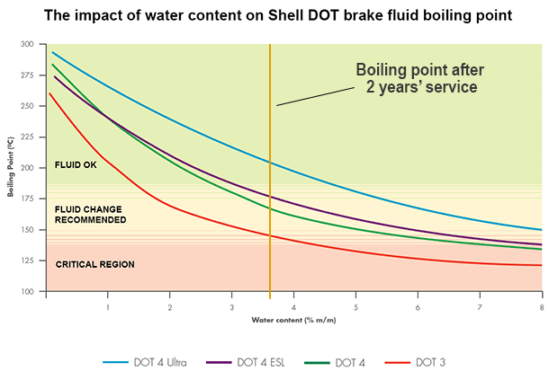
Some purists suggest changing fluid every 18 months to 2 years. I’ve never done that, thinking that moisture and dirt are the main worries. If you keep dirt out of the system and your car out of water ie keep the reservoir cap on tight and don’t top up with old fluid….if, if, if….you should be OK. Personally, I go by the colour of the fluid. If it looks OK, it probably is. If it’s going cloudy, it probably isn’t. An important topic..if in doubt, do your own research!

Simon Lachlan
Feb ’18.

