BLEEDING AUSTIN HEALEY 4 WHEEL DRUM BRAKES
Posted on 21, August2017 by Michael
Adjusting the brakes and getting all the air out of the hydraulic brake system to produce a “hard” pedal can be particularly difficult when dealing with the all drum systems of 100 and 100/6 Austin Healeys.
Here are tips that I have found make the job a little easier.
CHECK THE ARC OF THE BRAKE SHOES.
If new or relined brake shoes are being installed or the brake drums have been turned it is very important to check the curvature of the shoe relative to the drum. Ideally the shoe will contact the drum throughout its entire arc.
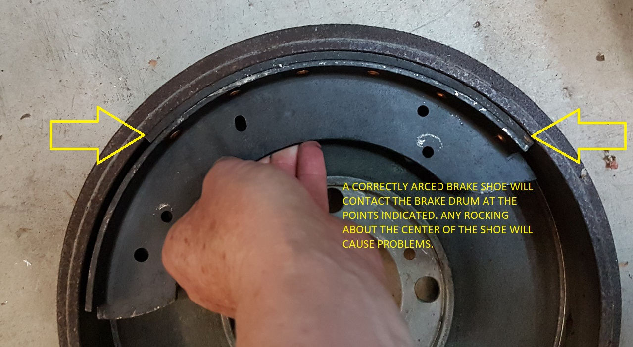
If the shoe can be “rocked” in the drum because the radius of the surface of the friction material is smaller than that of the drum the shoes need to be re-arced to match the drum. If the arc of the shoes is smaller than that of the drum pedal travel will be wasted as the force from the wheel cylinder bends the shoe to shape.
Most companies that reline shoes have a brake shoe grinder to do this job.
SET THE BRAKE SHOE STEADY POSTS CORRECTLY
Behind each of the 8 brake shoes is a “steady” post which is used to tilt the shoe to keep its friction surface parallel to the surface of the drum. These posts have little felt wicks on them to keep them lubricated where they contact the brake shoe.
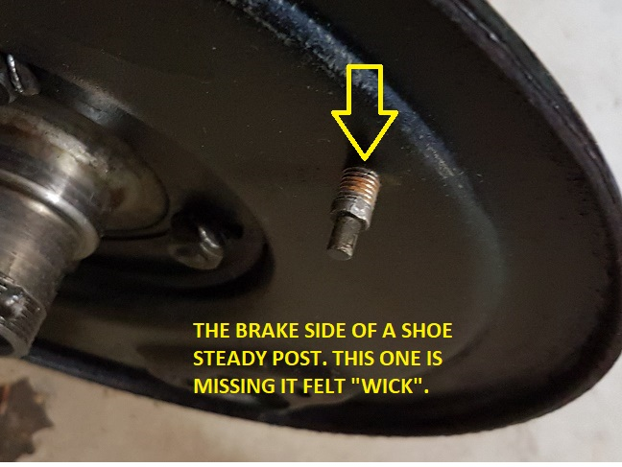If the shoes have been changed or relined or the drums have been turned it is important to re adjust the steady posts which is achieved by turning the post after loosening the lock-nut.
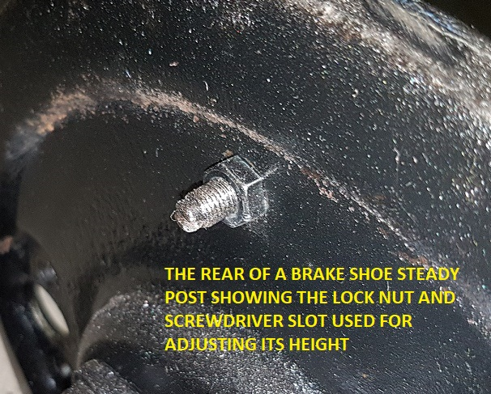I have found that the easiest method is to first unscrew a post until the shoe starts to drag when the wheel is turned then screw the post in until it produces the same amount of drag. Setting the post to the midpoint of these 2 positions will result in correct adjustment.
This adjustment method takes a little practice but is quite simple once mastered.
BACK OFF THE FRONT BRAKE SNAIL ADJUSTERS BEFORE THE INITIAL BLEEDING
I know this sounds counter intuitive but the way the front wheel cylinders are mounted and “plumbed” makes getting all the air out of them very difficult because the port where fluid from the master cylinder enters the cylinder is above the port where it exits on its route to the bleed screw.
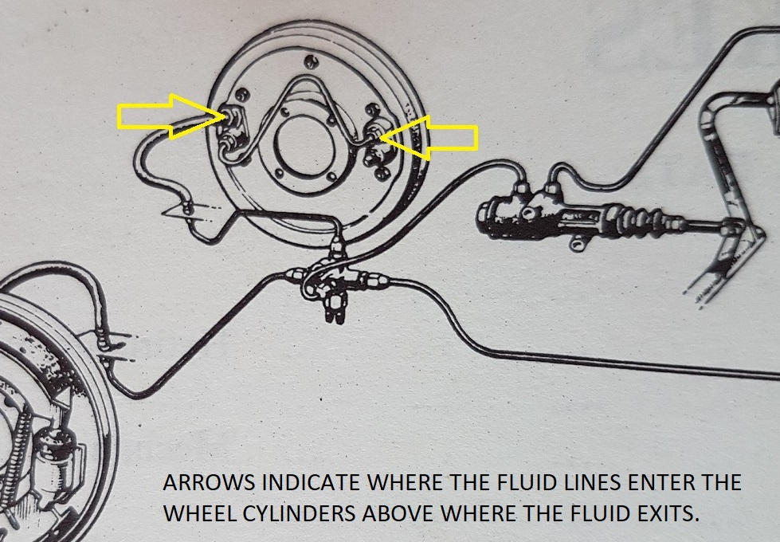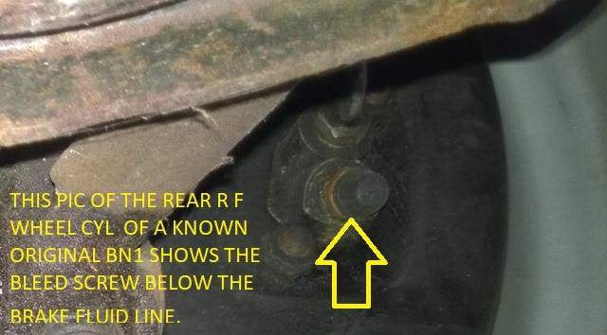I’m sure the Girling engineers had very good reasons for this arrangement but I have no idea what those ideas were however the net result is that as fluid passes through each cylinder during the bleeding process it is very easy for an air “bubble” to remain in the cylinder and, the further the piston is from fully retracted, the larger that bubble tends to be.
By backing off the brake adjusters to fully retract the pistons the amount of air that becomes trapped in each cylinder is minimized, not eliminated but minimized.
BLEED THE SYSTEM BY GRAVITY
Furiously pumping the brake pedal in an attempt to get fluid through the system usually results in aeration of the fluid and serious frustration.
I have had the greatest success by just ensuring that the reservoir is filled and then opening the bleed screws on the cylinders until fluid starts to drip out of them. You can do them all at once or one at a time, you can start with the one furthest from the master cylinder or the one closest it doesn’t matter. All that is important is to ensure that you do not allow the reservoir level to get too low.
Once fluid starts to run out of a bleed screw in a solid stream close the bleed screw and immediately use water to flush away any spilled fluid. When all 4 bleed screws have been gravity bled in this manner then adjust the brakes.
If you have done everything correctly you should have a good “hard” pedal.
ANOTHER TRICK
Occasionally, despite ones best efforts, the brake pedal is still “soft”. When this occurs, it is often useful to try to isolate the source of the problem.
This takes 2 people and a special tool namely a pair of Vicegrip pliers.
There is a special tool for the job but Vicegrips, when used carefully are much better.
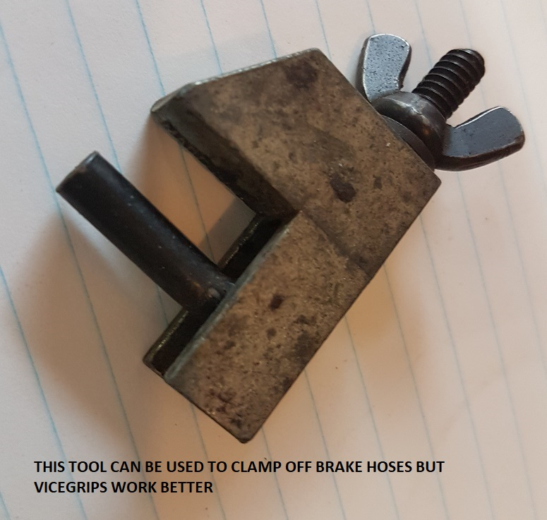Use the Vicegrips to gently clamp off the flow in one of the 3 brake flex hoses. DO NOT SQUEEZE THE HOSE TOO TIGHTLY. Just enough to stop the flow of fluid.
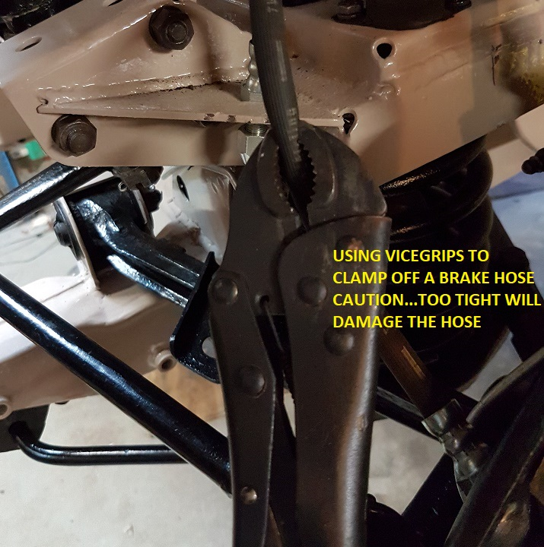Now have your assistant pump the pedal gently until a firm pedal is established and, while the assistant maintains pressure on the pedal, rapidly release the Vicegrips.
As the Vicegrips release the pedal will be felt to drop a little (or a lot). Repeat this procedure on each brake hose. If a more significant drop of the pedal occurs on either of the front brakes or on the rear brakes that is the brake(s) to check for problems.

