Boulton Paul - How Austin Healey body panels made.
C:\British Cars\Austin Healey\Tech\P - Bodywork\Jensenweld\How Austin Healey body panels made.doc
C:\British Cars\History\British Industry\Boulton Paul-How Austin Healey body panels made.doc

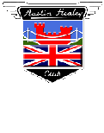 http://www.austinhealeyclub.co.uk

Boulton & Paul Visit [ 2002 ? – JSM ]
On Sunday 15th September, club members paid a visit to the Boulton Paul Association aircraft museum in Wolverhampton to take part in the dedication ceremony for their replica Defiant fighter aircraft and to see how Austin Healey body panels were, and still are made.
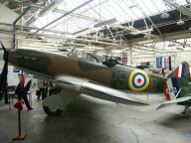 | 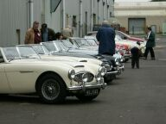 | 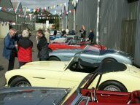
For many years the source of Healey panels, the company has seen several name changes. It started as the Aircraft Department of the old Norwich firm of Boulton & Paul Aircraft Ltd in 1915, became Boulton Paul Aircraft Ltd in 1934 and moved to Wolverhampton in 1936. The construction division of Boulton & Paul remained in Norwich and is known today for it's building products, specifically window and door-frames. In 1961 Boulton Paul Aircraft Ltd became Dowty Boulton Paul Ltd and then traded as Dowty Aerospace Wolverhampton. More recently, it was taken over by TI (Tube Investment Group), and just recently acquired by Smiths Aerospace Actuation Systems.
Initially the company made other people's aircraft, including more Sopwith Camels than anyone else, but opened its own Design Department in 1917, headed by the redoubtable J.D. North, and quickly gained a reputation for innovation. The company became an industry leader in metal construction and a specialist in the manufacture of high performance medium bombers like the famous Sidestrand and Overstrand. Post-war it built the world's first single-engine turboprop the Balliol trainer, and entered the age of the jet with the P.111 and the P.120. After the war, the company diversified to include the manufacture of low to medium volume body panels for cars, including the Austin Healey.
The Boulton Paul Association are a group of people dedicated to the preservation of the companies heritage in aircraft manufacture, and have set up a museum on the site. During the war, the company made the Defiant night fighter. Powered by a Rolls-Royce Merlin V12, the fighter featured a 4-gun turret just behind the pilot's cockpit. Only one of these aircraft remains, and is at the Royal Air Force museum in Hendon. Unable to repatriate this example for restoration, the Boulton Paul Association set about building a replica. The dedication ceremony attracted a wide range of interested people from wartime pilots complete with handlebar-moustaches, to young Air Cadets. Outside a splendid display of our Healeys added to the occasion and provided much interest.
Over in the factory, the panel manufacturing process used is suited to low volume production, the tooling being inexpensive whilst the labour costs are high. It involves placing the sheet steel over a metal buck and pressing it into a large block of rubber. The company has four hydraulic presses, each capable of exerting over 4000 tons. The rubber block is mounted in the upper part of the press and costs about £9,000 to replace. Below floor level are the hydraulics which push the buck up into the rubber block. The male buck for the panel is cast using a low melting point alloy of bismuth and tin called Kirksite. This is cast in a simple mould then hand finished to remove any imperfections. The buck for the Healey O/S rear wing that we witnessed being pressed was one of the originals used in the 60's. On the racks are bucks for many cars including Triumph, MG and Aston Martin. They also make the prototype panels used during crash test development of new cars, and specials such as for Colin McRea's Ford Focus rally car with flared arches. Laid out for us to inspect were all the bucks for AH3000 wings, boot lid and Frog-eye grille.
The pressing takes place in stages with gradually increased pressures and extra rubber padding strategically placed to control the amount of deformation at each stage. To attempt the process in one pressing would result in wrinkles, creases and ruptures around the edges on the panel. The pressures for each stage are 800, 1,200, 2,500, 3,500 and if necessary 4,000 tons. After the first stage, the edges are trimmed to assist the process. Our wing took about an hour to form due to an informative commentary and discussion with Dave and Scott who were giving the demonstration. Normally however, it takes about 1.5 shifts to make a batch of 50 wings.
The next stage in making the wing, i.e. fitting the beading, flanging the edges and punching the fixing holes, is done by others.
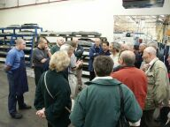 | 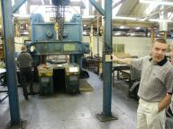 | 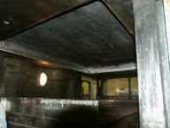
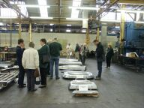 | 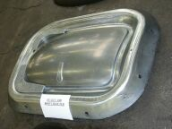 | 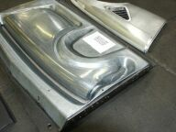
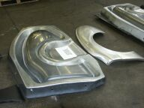 | 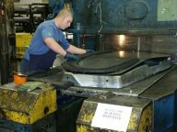 | 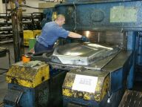
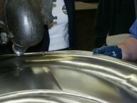 | 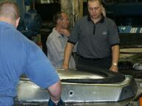 | 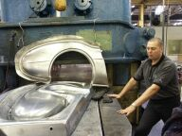
Our thanks go to John Masefield from the AHC Midland Centre for arranging this visit and to David Oakley of Boulton & Paul for showing us around.
More information can be found on the Defiant and the Boulton Paul Association at:-
http://www.localhistory.scit.wlv.ac.uk/Museum/Transport/planes/boultonPaul.htm
http://www.aeroflight.co.uk/types/uk/boulton_paul/defiant/Defiant.htm

