Here’s something I found on the internet. I have edited it somewhat and added two comments with whose opinions I concur.
Any 5.5v Super Capacitor would do. For example, see:-
http://cpc.farnell.com/panasonic-electronic-components/eecf5r5u105/capacitor-1f-5-5v/dp/CA06061?CMP=CPC-PLA
See the pdf Data Sheet on the site for the polarity of the terminals.
Simon Lachlan.

FUEL GAUGE DAMPENER
Slows needle fluctuations in fuel gauge.
Solder two wires to the capacitor, being careful not to overheat it. Put heat shrink tube over the joints. The diagram, below, is for negative earth cars. Simply reverse the connections for positive earth.
Connect the +directly to the tank sender unit and the – to a suitable earth.
When the ignition is switched on, it now takes a while for the needle to rise to the fuel tank level and, when the ignition is switched off, the needle goes up to the full position and then slowly drops to empty.
·
Farad 5.5V

Super Capacitor
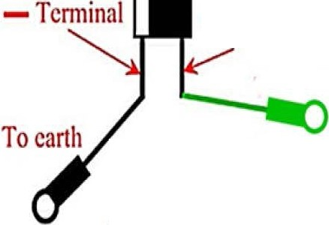+Terminal

To Tank Sender

See the comments, below, wherein two people suggest – very sensibly – that the capacitor should be on the fuel gauge, not on the tank. Either location would work, but putting it on the gauge would be easier, neater and safer.

- This is a simple but clever solution to counteract needle fluctuations caused by the sloshing around of the fuel in the tank. It would probably be easier to solder/connect the capacitor directly over the gauge terminals. One would still adhere to the same diagram.
- I believe that any energy storage device near petrol vapour is extremely dangerous. The original Smiths designers took into consideration the possibility of sparks igniting fuel or vapour. To try to improve of this might be folly.

