Badge on bonnet – Hyphenated or Not
C:\British Cars\Austin Healey\Tech\P - Bodywork\Trim\Badge on bonnet-hypenated or not.doc

2008 Survey Results – per Ed Kaler "Ed's Shop" <shop@justbrits.com>
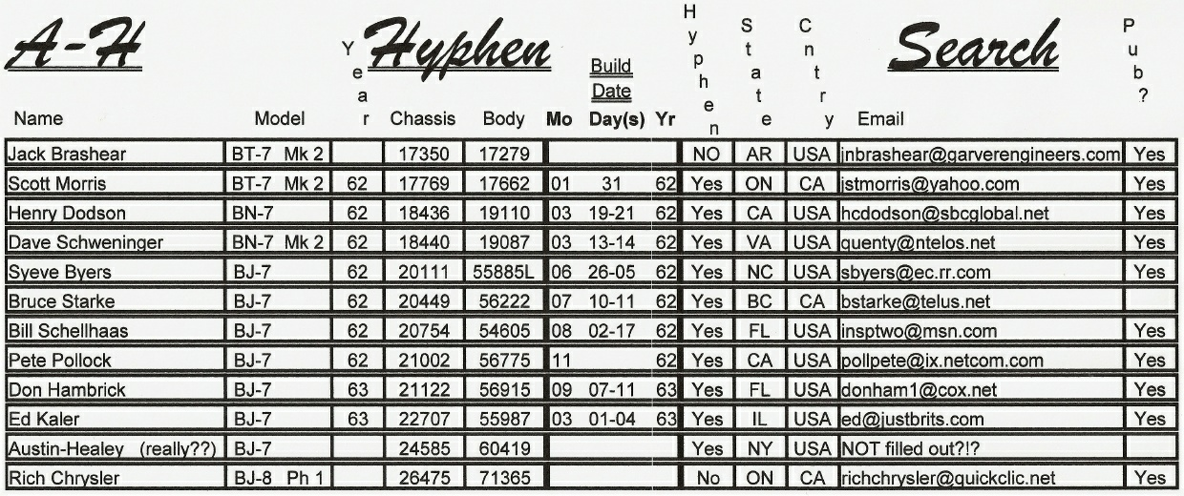
http://www.justbrits.com/Articles.html http://www.justbrits.com/Articles/AHhyphen.htm

Hyphened badge

Re: [Healeys] Badges
From: Michael Oritt michael.oritt@gmail.com
To HealeyRick healeys@autox.team.net
Date: 2015-02-03 at 7:47 PM
Rick -- You might be right about the hyphens although I wonder where they have been stored lo these many years.
Funny, I have parts like that almost every time I R&R a component from any of my cars as well!
Best—Michael
HealeyRick wrote:<< I think I've solved the riddle of the missing hyphen ... "bean counters." ……>>

Re: [Healeys] Badges
From: HealeyRick healeyrik@gmail.com
To healeys@autox.team.net
Date: 2015-02-03 at 1:27 PM
I think I've solved the riddle of the missing hyphen ... "bean counters." I can see the meeting now, "If we save the metal from removing the hyphen from 10,000 badges, we'll have saved a penny." The accountant who came up with that suggestion was then given a 1,000 pound raise and a new Rover. I've always thought I could have saved BMC tons of money. I can't count the number of leftover pieces I have when I make repairs, yet the cars run fine. Clearly they were unnecessary in the first place.

Re: [Healeys] Hyphened badge
From: HealeyRick healeyrik@gmail.com
To Ge AH Mail List
Date: 2015-02-02 at 11:55 AM
A local photograph took this shot of my BJ7 boot badge (HBJ7L-20969) while it was parked in the parking lot at the Misslewood Concours in Beverly, MA this summer (with hyphen)
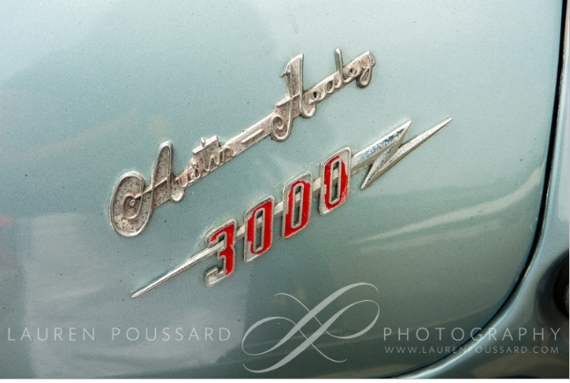 Badge on bonnet-hypenated or not.02.jpg

Re: [Healeys] Hyphened badge
From: Simon Lachlan simon.lachlan@homecall.co.uk
To 'AH Mail List'
Date: 2015-02-02 at 2:07 AM
That got me digging around in my books and pictures. Both my BMC parts book and workshop manual are hyphenated. These books go up to and including MkII BT7. But a pretty early, in AH terms, ad from Healeys at Warwick is unhyphenated.
--Simon
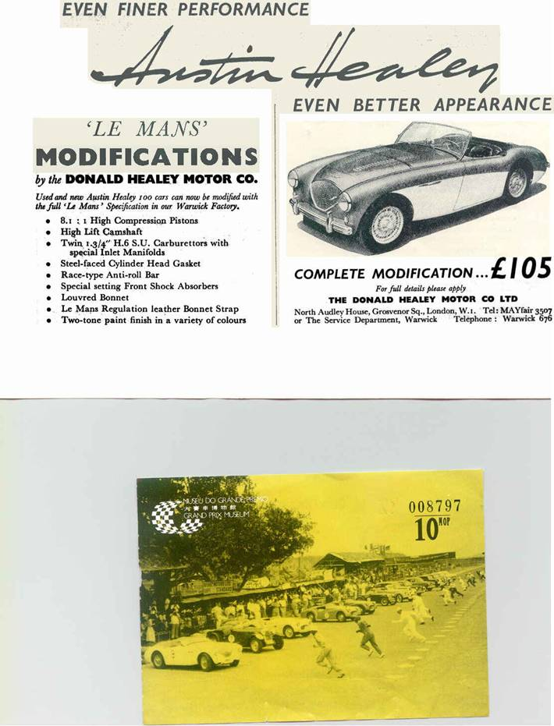
Greg Lemon wrote: << Latest ad I found with a hyphen is 1960, kind of amusing, advertisement for the new 3000, shows a car under a cover, ......>>

Re: [Healeys] Hyphened badge
From: Jean Caron vintage_roadster_restoration@hotmail.com
To healeys@autox.team.net
Date: 2015-02-02 at 12:15 AM
While the front badge was not always hyphenated, the rear one on the trunk (boot)always was if I am not mistaken.
--Jean
Greg Lemon wrote: << Micheal, although it doesn't answer why, it does appear that there was a decision made at Austin/BMC or somewhere to do away with the hyphen, I quick perusal of ebay Austin Healey advertisement shows the hyphen in most of the fifties ads, it is gone in the sixties ads. ......>>

Re: [Healeys] Hyphened badge
From: Greg Lemon glemon@neb.rr.com
To Michael Oritt healeys@autox.team.net
Date: 2015-02-01 at 11:08 PM
Micheal, although it doesn't answer why, it does appear that there was a decision made at Austin/BMC or somewhere to do away with the hyphen, I quick perusal of ebay Austin Healey advertisement shows the hyphen in most of the fifties ads, it is gone in the sixties ads. So it doesn't appear to be just a matter of the supplier forgetting to put it in on later pieces.
--Greg Lemon
Michael Oritt wrote: << I think we have established that there was probably no consistent change point from hyphenated to non-hyphenated which seems to support the idea that after the decision to change was made the stock of hyphenated badges was nevertheless used until exhausted. ......>>

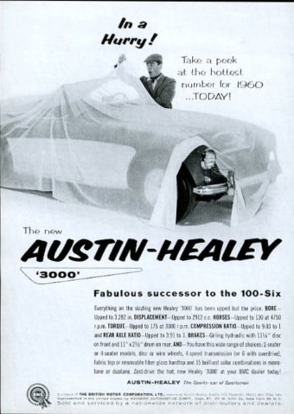
Re: [Healeys] Hyphened badge
From: Greg Lemon glemon@neb.rr.com
To Michael Oritt AH Mail List
Date: 2015-02-01 at 11:01 PM
Latest ad I found with a hyphen is 1960, kind of amusing, advertisement for the new 3000, shows a car under a cover, talks about the "big reveal". Marketing to try to stir up interest and excitement in a new model that looks like just like the old one. http://www.ebay.com/itm/1960-Austin-Healey-3000-car-introduction-photo-vintage-print-ad-/361201874152?pt=LH_DefaultDomain_0&hash=item54194f34e8
--Greg Lemon
Michael Oritt wrote: << I think we have established that there was probably no consistent change point from hyphenated to non-hyphenated which seems to support the idea that after the decision to change was made the stock of hyphenated badges was nevertheless used until exhausted. ......>>

Re: [Healeys] Hyphened badge
From: Michael Oritt michael.oritt@gmail.com
To Ge AH Mail List
Date: 2015-02-01 at 9:17 PM
I think we have established that there was probably no consistent change point from hyphenated to non-hyphenated which seems to support the idea that after the decision to change was made the stock of hyphenated badges was nevertheless used until exhausted. However my original question was not "when" but rather "why" the switch was made. There must have been a reason for making an affirmative decision to do something and I am genuinely surprised that the reason has never been made known, Any thoughts here?
Best --Michael Oritt
Ge Aagten wrote:<< Hi list, 1964 BJ8 MK3 Phase 2. Just checked it. Result: no hyphen >>

Re: [Healeys] Hyphened badge
From: Ge gaagten@gmail.com
To 'Jean Caron' 'AH Mail List'
Date: 2015-02-01 at 12:40 PM
Hi list, 1964 BJ8 MK3 Phase 2. Just checked it. Result: no hyphen
It is an original Dutch car imported by Stokvis in Rotterdam
Regards. --Ge Aagten The Netherlands

Re: [Healeys] Hyphened badge
From: healeymanjim healeymanjim@hansencc.net
To healeys@autox.team.net
Date: 2015-01-30 at 11:07 PM
BJ7 23680 has hyphen

Re: [Healeys] Hyphened badge
From: Elton Schulz
To healeys@autox.team.net
Date: 2015-01-30 at 3:32 PM
My BJ7's original badge has the hyphen. Car # 24585.
--Elton
Per Schoerner wrote:<< Hi; OK, so my nice badge on the shelf would be wrong for my car then, because I have a MkII BT7. ......>>

Re: [Healeys] Hyphened badge
From: Jean Caron <vintage_roadster_restoration@hotmail.com>
To AH Mail List
Date: 2015-01-30 at 1:07 PM
Restoring a 1966 BJ8, no hyphen and the badge on a 1967 I did a few years ago, no hyphen either.
--Jean
Len Hartnett wrote:<< No hyphen! >>

Re: [Healeys] Hyphened badge
From: Len and/or Marge Hartnett thehartnetts@earthlink.net
To AH Mail List
Date: 2015-01-30 at 1:06 AM
No hyphen!
--(The Other) Len Fairfield, CA, USA 1967 AH 3000 MkIII, HBJ8L39031 (199,771 miles)
Per Schoerner wrote: << Hi; OK, so my nice badge on the shelf would be wrong for my car then, because I have a MkII BT7. Let's see if there is anyone with an unhyphened original badge on a BT7, as well as anyone that have a hyphened badge on a BJ8 or BJ7. Please speak up if you feel that your car fits in here. >>

Re: [Healeys] Hyphened badge
From: Per Schoerner per@schoerner.se
To josef-eckert@t-online.de Healeys, Forum
Date: 2015-01-29 at 5:42 PM
Hi; OK, so my nice badge on the shelf would be wrong for my car then, because I have a MkII BT7. Let's see if there is anyone with an unhyphened original badge on a BT7, as well as anyone that have a hyphened badge on a BJ8 or BJ7. Please speak up if you feel that your car fits in here.
Best regards, --Per
Josef Eckert wrote: << Hi Per, I know the hyphen was lost during BJ7 production. But can`t tell you the reason why. My 62 BT7 still has the hyphen in the original badge. >>

Re: [Healeys] Hyphened badge
From: josef-eckert@t-online.de
To Per Schoerner Healeys, Forum
Date: 2015-01-29 at 4:27 PM
Hi Per, I know the hyphen was lost during BJ7 production. But can`t tell you the reason why. My 62 BT7 still has the hyphen in the original badge.
Cheers, --Josef Eckert Konigswinter/Germany
Per Schoerner wrote:<< HI; Well, I think I have seen both MkIIs and MkIIIs with and without hyphen, so ......>>

Re: [Healeys] Hyphened badge
From: Per Schoerner per@schoerner.se
To Michael Oritt Austin Healey
Date: 2015-01-29 3:38 PM
HI; Well, I think I have seen both MkIIs and MkIIIs with and without hyphen, so I'm as curious as anyone to be enlightened as to when the switchover was made. I remember someone made a poll a couple of years ago, everyone was to reply if they had a hyphened or unhyphened badge. Does anyone know what came out of this investigation?
Best regards, --Per
Michael Oritt wrote:<< Per -- Thanks for your reply but I don't think that is it. Certainly at one point A-H was ......>>

Re: [Healeys] Hyphened badge (was: Looking for a 100/4 restoration project)
From: Bob Spidell bspidell@comcast.net
To Michael Oritt healeys
Date: 2015-01-29 at 3:18 PM
Hyphens cost money and the BMC beancounters had them removed.

Re: [Healeys] Hyphened badge (was: Looking for a 100/4 restoration project)
From: Michael Oritt michael.oritt@gmail.com
To Per Schoerner Austin Healey
Date: 2015-01-29 at 2:33 PM
Per -- Thanks for your reply but I don't think that is it. Certainly at one point A-H was correct and somewhere along the way it changed so that all later cars lost the hyphen. I simply wonder why and am quite surprised that there is not a known explanation.
Best--Michael Oritt

Re: [Healeys] Hyphened badge (was: Looking for a 100/4 restoration project)
From: Per Schoerner per@schoerner.se
To healeys@autox.team.net
Date: 2015-01-29 at 8:01 AM
Hi; I have always thought that the unhyphened badges of, at least, MkIIs and MkIIIs, have been aftermarket , but maybe I'm mistaken. I have a worned out original badge on my MkII, with a hyphen, and a brand new unhyphened badge on the shelf. I hesitate to replace it, for origanality sakes. I'm not a 100 percent for originality, I have several things on my car that is not original, but I'm serious when it comes to badges.
--Per
On 2015-01-29 Michael Oritt wrote:<< BTW, I still have never heard a credible explanation as to why the nose badges changed from "Austin-Healey" to "Austin Healey" without the hyphen. Someone once posited that a supplier furnished incorrect badges that were bought at a discount and the rest was history but that does not seem likely to me. >>

From: C:\British Cars\Austin Healey\For Sale-Wanted\Wanted\100 Project-Looking for restoration project 15-01-28.doc

100-6 vs 3000 Badge

Re: [Healeys] Hyphen or no hyphen / 100-6 vs 3000 badging
Date: Thursday, August 14, 2008 6:12 PM
From: "MGTD51" <mgtd51@comcast.net>
To: "62bt7" <62bt7@prodigy.net>, Editorgary@aol.com, healeys@autox.team.net
My car is a 1959 BT7: HBT7-L/2638; it has a 100-6 horn button.
62bt7 wrote: << Since there is so much ink and interest in "hyphen or no hyphen", change point and car number, I have a similar question which I asked several years ago with no defining answer. …… >>

Re: [Healeys] Hyphen or no hyphen / 100-6 vs 3000 badging
Date: Thursday, August 14, 2008 1:23 PM
From: "John Snyder" <helyjohn@cablespeed.com>
To: healeys@autox.team.net
I am doing a ground up restoration on H-BN7-L/605. It was badged as a 100-6, and had the "cones" on the rear reflectors. Re the horn button, my 1962 BT7 has the 100-6 horn button, which I am fairly certain is original to the car. I think that horn button was carried on for a long time.
--John Snyder

Re: [Healeys] Hyphen or no hyphen / 100-6 vs 3000 badging
Date: Thursday, August 14, 2008 1:09 PM
From: "62bt7" <62bt7@prodigy.net>
To: Editorgary@aol.com, healeys@autox.team.net
Since there is so much ink and interest in "hyphen or no hyphen", change point and car number, I have a similar question which I
asked several years ago with no defining answer.
I own 1959/60, 3000, car# H-BN7-L/405, body# 3013BN7/803, built 26-31 March 1959, (first month of production). When the 3000 started production, the cars were still being badged "100-6". ("100-6" grille badge, "100-6" horn button, no "3000" flash on boot lid) The question: What is the change point (car #) from 100-6 to 3000 badging ???.
I have three original 3000 Mk.ll badges, all have hyphen.
--Kirk Kvam
Gary Anderson wrote: << Would anyone with a believed-to-be-original MkII badge where the Austin-Healey is NOT hyphenated please communicate with me directly, I'd like to know the body number and Car No. and, if possible, the assembly date. >>

MkII Badge

Re: [Healeys] MkII Badge
Date: Thursday, August 14, 2008 4:38 PM
From: "insptwo@msn.com" <insptwo@msn.com>
To: "healey help" <healeys@autox.team.net>
There is so much reflection in the photo, is that a cloisonne badge or enamel?
--Bill BJ7

Re: [Healeys] MkII Badge
Date: Thursday, August 14, 2008 2:31 PM
From: "Curt/Nancy Arndt" <cnaarndt@gmail.com>
To: "Dallas Congleton" <dcongleton@embarqmail.com>, "Healey List" <healeys@autox.team.net>
Dallas; No, not necessarily. Just because the Concours guidelines doesn't mention an item, if a knowledgeable judge or team of judges decides to deduct for something they know is incorrect, then so be it. The guidelines are just that, a tool to supplement all of the other documentation and resources that one needs to use when restoring a car. This issue comes up on a regular basis when judging entrants cars. Comments like I gave my restorer the guidelines so therefore if he just follows them I'll win a Gold award. Not necessarily!
There is a reason that all of our telephone and contact information is listed in the guidelines, but I almost never get a call from anyone restoring a car to ask a question. Yet, I talk to fellow members of the Concours Committee on a regular basis to discuss what is right or wrong for a car or component that I'm working on or restoring. Bottom line is it takes a bit more effort than just getting the guidelines to properly restore a Concours car.
However now that this issue has been brought up, the Concours committee will most likely add this to our list of items that will be updated in next years revision.
Cheers, --Curt Arndt Chairman, AH Concours Committee
Dallas Congleton wrote: << Having read this thread for a couple of days, I got out my new Judging Standards and as I read it "the hyphen" isn't mentioned- this would indicate that …… >>

Re: [Healeys] MkII Badge
Date: Thursday, August 14, 2008 12:34 PM
From: "Dallas Congleton" <dcongleton@embarqmail.com>
To: healeys@autox.team.net, "Rich C" <richchrysler@quickclic.net>
Having read this thread for a couple of days, I got out my new Judging Standards and as I read it "the hyphen" isn't mentioned- this would indicate that A National Concours Registry Judge could not deduct for the lack of or addition of a hyphen anyway due to lack of documentation?
"Rich C" <richchrysler@quickclic.net> wrote: << Don't let the fact that a Gold level Concours car that had a non-hyphenated badge mean that it's gospel and correct for that car. …… >>

Re: [Healeys] MkII Badge
Date: Thursday, August 14, 2008 12:59 PM
From: "Ed's Shop" <shop@justbrits.com>
To: jdaggett@dagmarent.com, healeys@autox.team.net
<<Jamie, consider it done. >>
Jamie, can you get he info and add to our survey at: http://www.justbrits.com/survey/hyphen.html
TIA !! --Ed

Re: [Healeys] MkII Badge
Date: Thursday, August 14, 2008 12:15 PM
From: "Rich C" <richchrysler@quickclic.net>
To: Warthodson@aol.com, jdaggett@dagmarent.com, healeys@autox.team.net
Don't let the fact that a Gold level Concours car that had a non-hyphenated badge mean that it's gospel and correct for that car. You don’t know: 1. if there was a deduction for that detail during the judging, or 2. if it was known to the judges whether the hyphen detail was absolutely known at that point in time. The accuracy of known details is continually evolving and being more sharply defined each year. Further, there has been no such thing as a perfect 1000 point Gold level car. Also keep in mind that a car can lose 49 points out of 1000 and still be within Gold.
--Rich Chrysler A National Concours Registry judge

Re: [Healeys] MkII Badge
Date: Thursday, August 14, 2008 11:39 AM
From: "Warthodson@aol.com" <Warthodson@aol.com>
To: jdaggett@dagmarent.com, healeys@autox.team.net
Jamie, consider it done. There are at least three questions:
- It that a verifiably original badge?
- Did the concours judges notice the missing Hyphen?
- How are they treating this issue?
From the recent discussion, it appears to be an unclear area..
--Gary Hodson
Gary, Would you post the following for me: A friend is restoring a 1963 BJ7 and states his MKII badge is hyphenated but the following GOLD LEVEL CONCOURS WINNER HBJ7/24937 built 14AUG1963 appears to have a non-hyphenated badge. _http://www.calabashcattery.com/4images/details.php?image_id=193_

Front Badge: A H or A-H Hyphenated
JSM : 2008-08-14 @~ 12:20 p.m.

Thank you for completing our form.

The following info was sent to shop@justbrits.com:
  Field | Value
  Name: | Scott Morris
  Model: | MkII BT7
  Year: | 1962
  Chassis: | 17769
  Body #: | 17662
  Build info: | 1962-01-31
  Field | Value
  Hyphen: | Yes
  State: | ON
  Country: | Cdn
  mailfrom: | jstmorris@yahoo.com
  Publish | yes
  subject | Hyphen Survey

Re: [Healeys] BJ7 badge
Date: Wednesday, August 13, 2008 9:55 PM
From: "Ed's Shop" <shop@justbrits.com>
To: "Healeys" <healeys@autox.team.net>
Survey IS up-dated and YES I had already remembered to ADD a field for Yes/No - hyphen<VBG>!!
So, NEW test results:
**********************************************
The following info was sent to shop@justbrits.com:
Field Value
Name: Ed Kaler
Model: BJ-7
Year: 1963
Chassis: 22707
Body #: xxxxxxxxx
Build info: 01/01-01/03/63
Hyphen: Yes
State: IL
Country: USA
mailfrom: ed@justbrits.com
Publish Yes
subject Hyphen Survey

Re: [Healeys] to hyphenate or not to hyphenate
Date: Wednesday, August 13, 2008 9:13 PM
From: "Ed's Shop" <shop@justbrits.com>
To: healeys@autox.team.net
Gary Anderson wrote: << Austin-Healey is NOT hyphenated please communicate with me directly,.......>>
How about this, Gary<G>!! BEING a BJ-7 Owner (and curious), I have put together a "survey" for all !!
Results will come to me and I will do a data base of the results and publish for all. I just tested it and it works great and reports as follows:
<quote>
Your BlueMail form has been completed, following are the results:
Field Value
Name Ed Kaler
Model BJ-7
Year 1963
Chassis 22707
State IL
Country USA
mailfrom ed@justbrits.com
subject Hyphen Survey
</quote>
As per Gary's suggestion I will add fields for:
Body Number:
Build Date:
What say you gents?? Gimme an hour or so before going to: http://www.justbrits.com/survey/hyphen.html If you do NOT see those 2 added fields, please just do not fill out<G>!! Also, I will add to "Various Articles" on my main page for those folks that are NOT on this List (you can tell folks) and I will ask the BCF folks about it.
Before 'publishing' I will sort by Chassis # so we can sort of get an idea of where/when the hyphen use changed.
Post to the List to let all know, 1] what you think of it and b] of the idea?!?!
--Ed

Re: [Healeys] to hyphenate or not to hyphenate
Date: Wednesday, August 13, 2008 6:07 PM
From: "Editorgary@aol.com" <Editorgary@aol.com>
To: healeys@autox.team.net
Mal Bruce wrote: << I've seen too many BJ7's with the hyphen to believe it was anytime before late BJ7 production. >>
Would anyone with a believed-to-be-original MkII badge where the Austin-Healey is NOT hyphenated please communicate with me directly, I'd like to know the body number and Car No. and, if possible, the assembly date.
Cheers, --Gary Anderson

Re: [Healeys] BJ7 badge
Date: Wednesday, August 13, 2008 10:14 AM
From: "Warthodson@aol.com" <Warthodson@aol.com>
To: healeys@autox.team.net
Why was the hyphen dropped after such as long history of being used? If it was a supplier error, why would they continue it on the MkIII's? If it were a conscious decision, why wait until near the end of the MkII production? Maybe it was a cost cutting decision. Hyphens are quite expensive, you know.
--Gary Hodson
Mal Bruce wrote: << I've seen too many BJ7's with the hyphen to believe it was anytime before late BJ7 production. >>

Re: [Healeys] BJ7 badge
Date: Tuesday, August 12, 2008 10:30 PM
From: "Andrew Fell Architecture Design" <design@soltec.net>
To: bstarke@telus.net, "Healeys" <healeys@autox.team.net>
I have BJ7 #23155, and my original badge has a hyphen.
--Andrew Fell Urbana, Illinois
Bruce Starke bstarke@telus.net wrote: << My BJ7 # 20449 has the original hyphenated badge. >>

Re: [Healeys] BJ7 badge
Date: Tuesday, August 12, 2008 7:59 PM
From: "Daniel and Diane White" <dwhite4949@wowway.com>
To: "Healey list" <healeys@autox.team.net>
David Schweninger wrote: << Charlie, That would be interesting. We should include the build date. I'm not ...... >>
Dave, My BN7 Mk II was built 13-16 March 1962. I'm thinking some of the lads were across the street at the pub when they should have been wrenching.
--Dan

Re: [Healeys] BJ7 badge (serial number)
Date: Tuesday, August 12, 2008 7:42 PM
From: "Daniel and Diane White" <dwhite4949@wowway.com>
To: "Healey list" <healeys@autox.team.net>
David Schweninger wrote: << I have BN7 II 18440. The original badge says "Austin-Healey MK II. >>
Hello Dave, Just read your post on the list and your serial number sounded familiar so I looked at my Heritage Trust Cert and my number is 18443. My BN7 Mk II was originally white with black interior...just wondering if the factory painted them in groups. What was your original color?
Regards, --Dan

Re: [Healeys] BJ7 badge
Date: Tuesday, August 12, 2008 2:28 PM
From: "bstarke@telus.net" <bstarke@telus.net>
To: "Healeys" <healeys@autox.team.net>
My BJ7 # 20449 has the original hyphenated badge
--Bruce Starke Golden BC

Re: [Healeys] Fwd: BJ7 badge
Date: Tuesday, August 12, 2008 1:07 PM
From: "Bob Poague" <rapoague@comcast.net>
To: "HealeyList" <healeys@autox.team.net>
I have BJ7 22114, built 16-17 January 1963. The badge, which I believe to be original, has the hyphen.
--Bob

Re: [Healeys] BJ7 badge
Date: Tuesday, August 12, 2008 12:57 PM
From: "Simon Lachlan" <simon.lachlan@homecall.co.uk>
To: "'E.A. Driver'" <edriver@sasktel.net>, Josef.Eckert@t-systems.com, Healeys@autox.team.net, eric.frenken@brits-n-pieces.com
I have a latish(?) MkII BT7, centre shift. Original badge, hyphenated.
--Simon

Re: [Healeys] BJ7 badge
Date: Tuesday, August 12, 2008 11:43 AM
From: "Charlie Baldwin" <mgcharlie@comcast.net>
To: "David Schweninger" <quenty@ntelos.net>, "Healey Mail List" <healeys@autox.team.net>
David, It seems that mine is quite a few cars or months before the changeover, so exact dates don't really matter. As I recall, it left the factory in late November or early December of 1961.
--Charlie
David Schweninger wrote: << Charlie, That would be interesting. We should include the build date. I'm not ...... >>

Re: [Healeys] BJ7 badge
Date: Tuesday, August 12, 2008 11:24 AM
From: "David Schweninger" <quenty@ntelos.net>
To: "Charlie Baldwin" <mgcharlie@comcast.net>, "Healey Mail List" <healeys@autox.team.net>
Charlie, That would be interesting. We should include the build date. I'm not sure the car number always tracks the build date.
Daisy was built 13 - 14 March 1962.
As I am nearing completion of a frame up restoration, I can't understand how in hell they put this thing together in two days.
--Dave and Daisy
Charlie Baldwin wrote: << Maybe we can find the change-over point. My BT7 is earlier at 16323. >>

Re: [Healeys] BJ7 badge
Date: Tuesday, August 12, 2008 11:03 AM
From: "David Nock" <healeydoc@sbcglobal.net>
To: eric.frenken@brits-n-pieces.com, "'Healey Mail List'" <healeys@autox.team.net>
I have two original badges sitting here in front of me. The MK111 badge there is no hyphen, the MK 11 badge there is a hyphen.
--David Nock British Car Specialists, Stockton Ca 95205 209-948-8767 www.britishcarspecialists.com

Re: [Healeys] BJ7 badge
Date: Tuesday, August 12, 2008 11:00 AM
From: "Mal Bruce" <mbruce6@cogeco.ca>
To: "E.A. Driver" <edriver@sasktel.net>, Josef.Eckert@t-systems.com, Healeys@autox.team.net, eric.frenken@brits-n-pieces.com
I've seen too many BJ7's with the hyphen to believe it was anytime before late BJ7 production.
--Mal
"E.A. Driver" <edriver@sasktel.net> wrote: << Josef is correct. I was looking at my friends early MK II last evening, hyphenated and in beautiful nick -never been replaced and a very low mileage car. >>

Re: [Healeys] BJ7 badge
Date: Tuesday, August 12, 2008 10:52 AM
From: "E.A. Driver" <edriver@sasktel.net>
To: Josef.Eckert@t-systems.com, Healeys@autox.team.net, eric.frenken@brits-n-pieces.com
Josef is correct. I was looking at my friends early MK II last evening, hyphenated and in beautiful nick -never been replaced and a very low mileage car.
Regards, --Ed Saskatoon, Saskatchewan Historian, AHCUSA 53 BN1 65 BJ8 89 Morgan 4/4
Josef.Eckert@t-systems.com wrote: << On the early MK IIs the original badge was hyphenated. There was a change somewhere late 1962/early 1963. Clausager is wrong on that. ...... >>

Re: [Healeys] BJ7 badge
Date: Tuesday, August 12, 2008 8:21 AM
From: "Charlie Baldwin" <mgcharlie@comcast.net>
To: "David Schweninger" <quenty@ntelos.net>, "Healey Mail List" <healeys@autox.team.net>, eric.frenken@brits-n-pieces.com
Maybe we can find the change-over point. My BT7 is earlier at 16323.
David Schweninger wrote: << I have BN7 II 18440. The original badge says "Austin-Healey MK II.

Re: [Healeys] BJ7 badge
Date: Tuesday, August 12, 2008 8:19 AM
From: "Charlie Baldwin" <mgcharlie@comcast.net>
To: eric.frenken@brits-n-pieces.com, "healey list" <healeys@autox.team.net>
My BT7 Mk.II has the hyphen.
Brits'n'Pieces (Eric Frenken) wrote: << Gary, afaik the hyphen was left off with the MK II. In other words you'll find badges just saying 'Austin-Healey', 'Austin Healey MK II' and 'Austin Healey MK III'. >>

Re: [Healeys] BJ7 badge
Date: Tuesday, August 12, 2008 4:22 AM
From: "Josef.Eckert@t-systems.com" <Josef.Eckert@t-systems.com>
To: eric.frenken@brits-n-pieces.com, Healeys@autox.team.net
On the early MK IIs the original badge was hyphenated. There was a change somewhere late 1962/early 1963. Clausager is wrong on that. All aftermarket MK II badges you can get are not hyphenated. So all hyphenated badges you can see on the cars are original ones. My 1962 BT7 has a hyphenated one, beautifully restored by PAMELA DAVID ENAMELS.
--Josef Eckert Konigswinter/Germany 100BN1, 62BT7, 65Sprite
Brits'n'Pieces (Eric Frenken) wrote: << Quote from Clausager: ...... >>

Re: [Healeys] BJ7 badge
Date: Tuesday, August 12, 2008 2:18 AM
From: "Brits'n'Pieces (Eric Frenken)" <lists@brits-n-pieces.com>
To: "'David Schweninger'" <quenty@ntelos.net>, "'Healey Mail List'" <healeys@autox.team.net>
Quote from Clausager:
"On the Mark II and Mark III models, the grille badge was deleted, and a new badge was fitted above the grille, with the 'Austin Healey' script on a red background and a winged surround, and a smaller badge below reading '3000 MKII' or '3000 MKIII'. On this later style of badge, 'Austin Healey' was not hyphenated."
Best regards, --Eric http://brits-n-pieces.com
David Schweninger wrote: << I have BN7 II 18440. The original badge says "Austin-Healey MK II. >>

Re: [Healeys] BJ7 badge
Date: Monday, August 11, 2008 10:21 PM
From: "insptwo@msn.com" <insptwo@msn.com>
To: "healey help" <healeys@autox.team.net>
My BJ7 built between August 2-17th 1962 has the original front badge which reads Austin-Healey 3000 MKII
--Bill BJ7 (what else!)
Brits'n'Pieces (Eric Frenken) wrote: << Gary, afaik the hyphen was left off with the MK II. In other words you'll find badges just saying 'Austin-Healey', 'Austin Healey MK II' and 'Austin Healey MK III'. >>

Re: [Healeys] BJ7 badge
Date: Monday, August 11, 2008 6:29 PM
From: "David Schweninger" <quenty@ntelos.net>
To: eric.frenken@brits-n-pieces.com, "Healey Mail List" <healeys@autox.team.net>
I have BN7 II 18440. The original badge says "Austin-Healey MK II.
--Dave and Daisy
Brits'n'Pieces (Eric Frenken) wrote: << Gary, afaik the hyphen was left off with the MK II. In other words you'll find badges just saying 'Austin-Healey', 'Austin Healey MK II' and 'Austin Healey MK III'. >>

Re: [Healeys] BJ7 badge
Date: Monday, August 11, 2008 5:45 PM
From: "BJ8Healeys" <sbyers@ec.rr.com>
To: healeys@autox.team.net
I have a BJ7, chassis number 20111, that I rescued from some woods in Virginia and that has been in storage for the last 25 years. It's nose badge (original, I would say) does have the hyphen. It reads "Austin-Healey Mk II"
--Steve Byers HBJ8L/36666 BJ8 Registry Havelock, NC USA
Brits'n'Pieces (Eric Frenken) wrote: << Gary, afaik the hyphen was left off with the MK II. In other words you'll find badges just saying 'Austin-Healey', 'Austin Healey MK II' and 'Austin Healey MK III'. >>

Re: [Healeys] BJ7 badge
Date: Monday, August 11, 2008 5:13 PM
From: "Brits'n'Pieces (Eric Frenken)" <lists@brits-n-pieces.com>
To: Warthodson@aol.com, healeys@autox.team.net
Gary, afaik the hyphen was left off with the MK II. In other words you'll find badges just saying 'Austin-Healey', 'Austin Healey MK II' and 'Austin Healey MK III'.
Best regards, --Eric http://brits-n-pieces.com

Re: [Healeys] BJ7 badge
Date: Monday, August 11, 2008 2:15 PM
From: "Mal Bruce" <mbruce6@cogeco.ca>
To: Warthodson@aol.com, healeys@autox.team.net
Gary, You sent me looking for my new MK2 badge where I discovered it had no hyphen. I checked 4 used that I have and one had no hyphen while 3 did, the one without came from car #208xx built in 08/62. However, the other 2 that I know the origin of came from later cars including my current project 238xx built in 04/63. With all the possibilities for replacement over a 40 odd year history, I inclined to ignore the early replacement but will start to watch for the missing hyphen from now on.
--Mal

Re: [Healeys] BJ7 badge
Date: Monday, August 11, 2008 12:37 PM
From: "Warthodson@aol.com" <Warthodson@aol.com>
To: healeys@autox.team.net
A friend recently received a repro. MKII badge for his BJ7 from Dennis Welch that does not have the hyphen between Austin Healey. He asked if this is correct. I told him I would check it out on this list. When did they begin leaving off the hyphen?
--Gary Hodson

