Subj: Mounting BJ7 grill, surround and grill hood
Date: 09/11/2003 05:25:24 GMT Standard Time
From: enmcate@comcast.net
To: healeys@autox.team.net
Sent from the Internet (Details)

(1) A brief description of installing a BJ7 grill surround.
The front end should be jacked up (on jack stands) with one wheel and its splash panel and steady bracket removed. The air deflectors should be out or at least loosened. The surround has six tabs that will be used to fix it to the body and other parts. Do not attempt to bend these tabs. The straight tabs are down. The lip of the surround will eventually fit outside of the edge of the body opening.
- The surround goes in from the front, turning it and jockeying it up and down to slip the entire unit inside the opening (this requires some space inside which is why the air deflectors have to be at least loosened).
- Now the trick is to get the lip outside the opening edge by shifting it right and left. First, drop the surround slightly and bring its top forward so that the lip is outside the top part of the opening (where the opening edge has three extensions down for the top surround fasteners). Then shift it to the right (or left, whichever appeals to you), and pull the other end forward, outside the opening edge. As you shift it back to the center, most of the lower lip will come forward, leaving only the right end to be done. Pull the left end of the surround well forward and shift the surround to the left. There is enough play to get the surround left lip well outside the whole body at the left end of the opening so that the surround will shift about an inch left of center. Then the right end can be brought through and the surround shifted back to center. Voila, the surround is in.
- Here it is worth suggesting that two people work together on this step. The left lip should be held well forward so that it does not scrape the paint while shifting the surround left and right and pulling the right end out. The grill hood is slipped onto the surround ends by pulling the surround forward. Again, two sets of hands will help avoid paint scrapes. Hold off putting nuts on the fixed bolts on the ends of the grill hood until the top studs are in.
- Now before inserting the grill slats piece, install the studs, top and bottom. The top studs are not available from Moss but can be created by cutting off about an inch and a half from a quarter inch fine thread bolt. Using studs for the top fasteners allows them to be installed at this point in the process and still be able to slip the grill tabs on. It would be nearly impossible to insert bolts in those top positions after the grill is in place. The surround and grill hood may need to be jockeyed a bit to get the holes to line up so the top studs can be threaded in. To assist, you can lock two nuts onto the stud to give purchase and the ability to use a wrench on the stud. Insert the stud enough that you can feel that the stud is all the way through the fixed nut on the grill hood. The bottom two studs are available from Moss and after inserted, install nuts on the forward end and tighten these up. After the studs are in place, the top center one can have the inside nut added and tightened up. Also, the short bolt for the bottom surround bracket can be installed and the two small fixed bolts on the grill hood can have nuts installed and tightened. The two spire nuts can be put in place on the center surround tabs for later attaching the grill center tabs.
- If working alone, the air deflectors should be set in place now and the top fasteners installed (while you can reach both ends at the same time). They can be left out till the grill is in place and the top grill tabs finished if you have two sets of hands.
- The grill slats piece is then inserted from the side that has the wheel and splash panel removed. The top grill tabs are slotted while the bottom, outside two are holes. Once on the studs, finish the top tabs first (a classic bad location for tightening these nuts). The bottom two studs also handle the bottoms of the air deflectors and the splash panel steady brackets. The two center grill tabs are fastened with bolts into the spire nuts previously discussed.
Now, sit back and admire your work (and hope you never have to do it again).
Esko
BJ7

(2) There is a sequence of grille component installations that makes it go a bit easier. As you follow the steps, leave each fastener a bit loose until all are installed and then tighten.
1) Slide the horizontal grille bar section up behind the opening and insert one hex ¼” bolt, lock washer and flat washer through the bottom of the central support to which the bars are riveted, screwing it into the captive nut in the centre bottom tang of the shroud.
2) Position the polished stainless steel brow against the flange of the top of the grille opening in the shroud and insert a similar bolt and washer set through the top of the centre support, through the hole in the top of the grille opening of the shroud and into the captive hut at the centre of the brow. Install the left and right bolt and washer sets into the other (left and right) captive nuts in the brow.
3) Position one of the air deflectors that goes between the back of the grille and radiator and attach its top flange to the upper cross bar running in front of the radiator.
4) Using one of the lower grille bolt and washer combinations, insert it through the lower front tab of the air deflector, through the outer grill support bar and into the captive nut in the outer tab of the shroud.
5) Repeat this installation of the other air deflector.
6) Tie the bottom-rear corners of the air deflector together using the angle strap and 10-32 screws, washers and nuts.
7) Very carefully flex the bottom chrome finisher as you slide it over the bottom lip of the grille opening in the shroud. The ends of this chrome piece should be “opened” up a bit so that they will overlap the combined thickness of the shroud grille opening and the bottom corner of the upper stainless brow.

Roger.
From: Rich C [richchrysler@quickclic.net]
Sent: 16 January 2010 16:56
To: Simon Lachlan
Subject: Re: [Healeys] Grille surround and top cowl MkII BT7
Attachments: Oct08 016.jpg; Oct08 018.jpg

Simon,
(4)I understand what you’re saying. I just did all this last week on a customer’s ‘65 BJ8 so it’s relatively fresh in my foggy brain!.
The upper tabs sit outside and up against the aperture lip, the lower brackets go inside and up against the back sides of the riveted brackets.
Here’s a couple of pictures I took during assembly, sorry for the out of focus on the lower one.
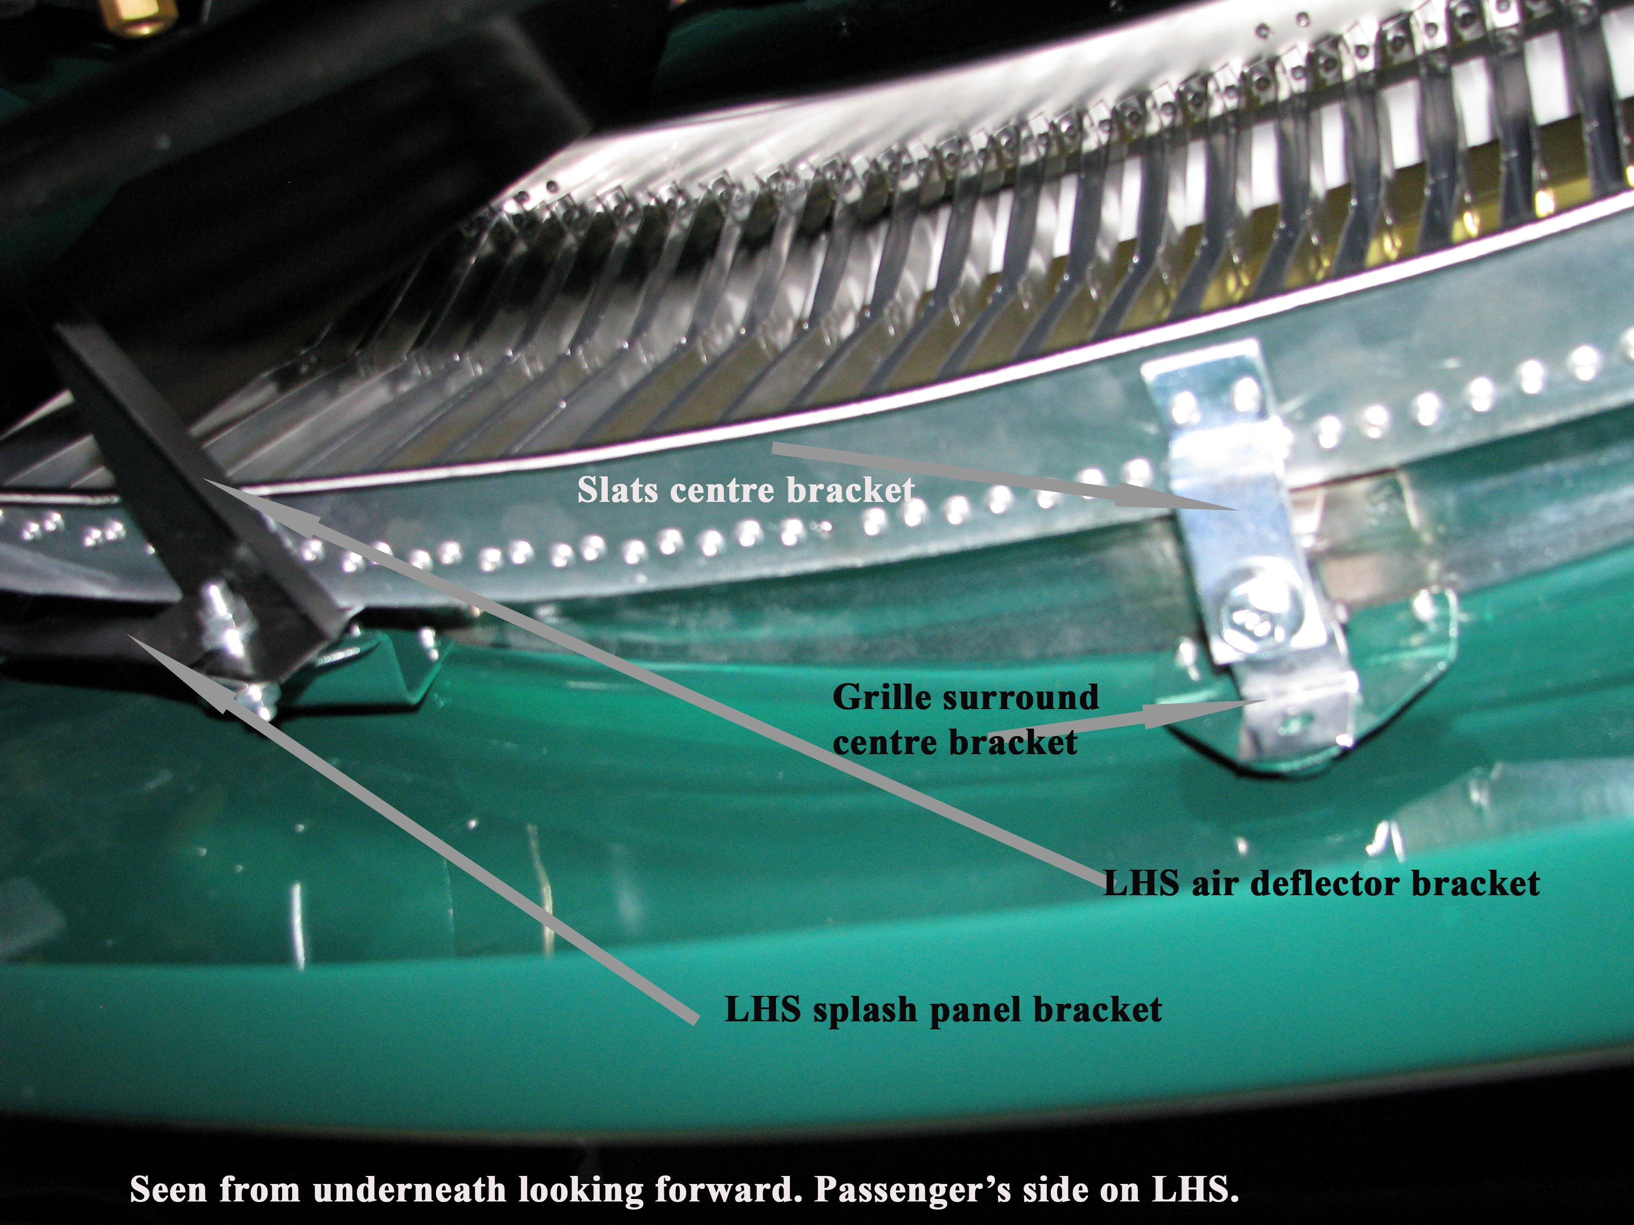
One more pair of fasteners I forgot about....on the extreme left and right ends of the upper brow there should be small studs that pass through small holes in the shroud, with flats, locks and nuts to secure them. These little studs are about a #4 thread and are often missing. In fact they aren’t in new replacement brows at all.
Rich
----- Original Message -----
From: “Simon Lachlan” <simon.lachlan@homecall.co.uk
To: “’Rich C’” <richchrysler@quickclic.net
Sent: Saturday, January 16, 2010 11:06 AM
Subject: RE: [Healeys] Grille surround and top cowl MkII BT7

Thanks for this Rich.
I’ve had another think. Maybe I’ve been interpreting the article to which I referred too literally. Are all the tabs of the grille surround located inside the aperture or, as the article implies, the top ones outside and the bottom ones inside?? If you see what I mean!
It’s one of those jobs that’ll become plainer as one actually does it.
Trick is to do without too many tears?
Simon
-----Original Message-----
From: Rich C [mailto:richchrysler@quickclic.net]
Sent: 16 January 2010 15:03
To: Simon Lachlan; healeys@autox.team.net
Subject: Re: [Healeys] Grille surround and top cowl MkII BT7
Simon,
(3)
1) On the later grille assembly, the upper brow is preassembled into the upper portion of the oval surround, so that the oval lip is exposed all the way around and the 3 upper tabs are lined up with and immediately behind the 3 captive nuts of the brow.
2) This assembly is carefully inserted into the shroud aperture, and then working from behind the grille opening, 4 special ¼” NF studs with a hex surface half way along the stud are run forward into the two outer upper captive nuts in the brow, and into the two captive nuts in the lower left and right brackets riveted to the shroud.
3) There is an additional small lag bolt in the top and bottom middle mounting flange that runs through a fender mounting style captive clip.
4) At this point you should have the surround and brow assembly nicely set into the aperture and the back ends of the four special studs facing toward the rear of the car. The vertical teeth assembly is brought in carefully behind the aperture from the side.
5) The outer upper tabs fit onto the studs, as well as the lower outer tabs to the lower studs. The upper ones can now have flat washers, lock washers and nuts installed and run up, securing the upper portion of the teeth assembly.
6) The lower studs now must also have the lower brackets of the radiator air deflector panels installed onto the lower studs, along with the left and right steady straps for the inner wheel arch splash plates.
7) With all this lot run onto the lower studs, flat washers, lock washers and nuts can be installed and run home.
8) Last, there is a middle lag screw on the top and bottom of the teeth assembly that installs into the bracket on the oval surround.
Rich Chrysler

(5)
The grille assembly needs to have the upper brow snapped into the oval surround, then the assembly pressed carefully into place in the aperture, lower brackets into the aperture first. Have fun not gouging paint. Then the fasteners can be introduced into the assembly as follows. According to the original Parts Book, the studs with the hex in the middle were only fitted to the 2 bottom grille mounting positions (left and right). The upper ones used 3 plain studs (no hex surface) that screwed forward into the captive brow nuts. Then the remainder of the stud shank cleared through the upper brackets of the oval surround and through the shroud holes, with flats, locks and nuts running onto the stud shanks to tighten things in place. Meanwhile the left and right lower outer hexed studs ran forward through the lower grille surround tabs and into the captive nuts on the riveted brackets on the shroud. A spire bolt ran through the centre lower shroud bracket with its head toward the front of the car, through the surround and into a captive fender style clip on the grille teeth centre bracket.
The rest of the lower left and right hexed studs received the slotted tabs of the grille teeth assembly and the lower flange of the radiator air intake deflector, and the strap type steady bracket for the inner wing splash shields, held there with flat, lock and nut. There were two studs on the extreme ends of the upper brow that pass through the little holes in the shroud flange at 3 and 9 o’clock, and draw the ends of the brow securely into place with locks and nuts on the back side.
There was another captive fender style short clip on the surround bracket at 12 o’clock with spire bolt that further held the surround and teeth assembly together.
Rather a complicated assembly to say the least!

Rich Chrysler

(6)
Hi Bill,
The upper brow and oval attach in front of the shroud opening with the double ended studs with the hex nut surface halfway along the stud length.
Then with these studs screwed into place, the slat assembly mounting tabs run onto the back side of the studs, held with flats, locks and nuts.
On the lower outboard ones, the lower mounting of the inner radiator shrouding panels and the steady legs from the outer splash shields also fit onto the studs, again held with flats, locks and nuts.
Rich Chrysler

(7)
Hi Guys,
The Mk 2 and Mk3 3000 grille has an upper brow, continuous oval surround and teeth made of vertical slats.
When assembled in the car a conscious decision was made to dull the chromed finish of the surround in from the slightly raised contour part way into the oval lip. This dull silver gray paint application was done for two reasons.
First there are dimples formed in this area where the inner mounting tabs are spot welded inside. The dull gray would hide this. Second, they did not want the vertical teeth to be reflecting back into the surround. The dulling of this inner bit would leave a much cleaner and less distorted look to the
assembly.
This does not apply to the earlier 100/6 and early 3000 grille assembly which comprised of the chromed upper brow, chromed lower thin strip, and the chromed horizontal wavy teeth.
Rich Chrysler
(8)

Thank you all for your advice. Most of it was very clear and quite a bit of was contradictory!
I know that I remain unsure on two points which we could probably all do with having cleared up once and for all. (There are constant questions on these points in the archives).
Question 1) Do the top tabs of the grille of the grill surround go on top of or behind the shroud? Mine were on top.
Answer:- “On top of (outside)”.
Question 2) Does the top cowl lip go behind the grill surround or on top of it? As I said in my first mail, the cowl’s 3 captive nuts would seem to be redundant if the cowl was between the surround and the shroud.
Answer:- “The top cowl is sandwiched by the grille surround and the top grill surround fixings. So the top cowl lip goes behind the grille surround and between the captive nuts and the shroud are the top fixing stays.
So it’s from the front to the back: grille surround - top cowl - top grille surround stays - shroud.”

