1952 Healey Road Test Revs Institute
C:\British Cars\Austin Healey\History\Road tests\1952 Revs Institute Pics-Healey Road Test.doc

Photographer: George Phillips (Photographer)
Date created: 1952
Type of resource: Still image
Genre: Digital image
Collection: The Revs Institute for Automotive Research, Inc., The George Phillips Collection of the Revs Institute
Subject: Automobile > History
Marque: Austin-Healey
Model: Austin-Healey 100
Revs ID: 2006-001PHIL-1952-b1_36.0_0001

- 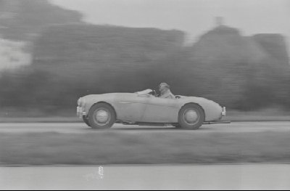

Healey Road Test
- 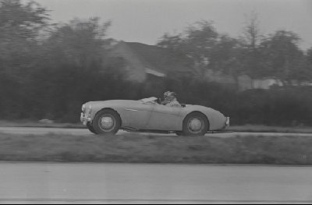

Healey Road Test
- 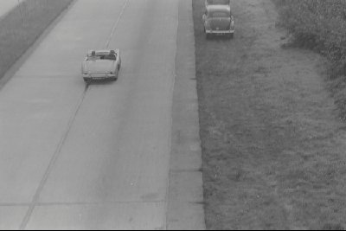

Healey Road Test
- 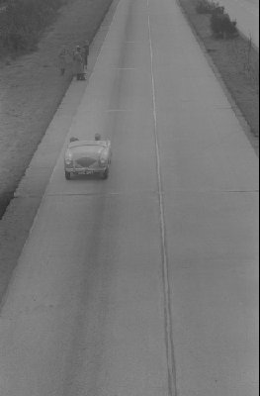

Healey Road Test
- 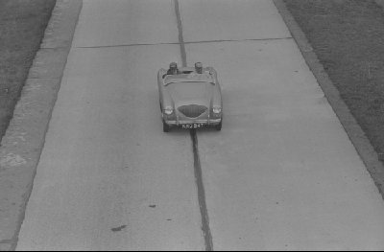

Healey Road Test
- 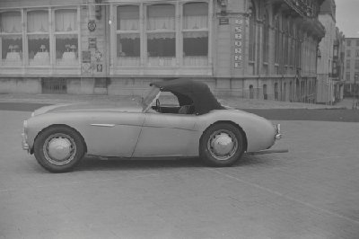

Healey Road Test
- 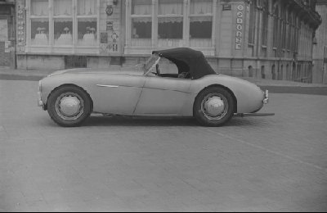

Healey Road Test
- 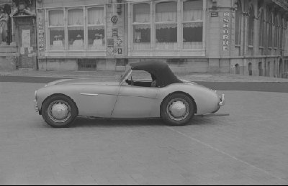

Healey Road Test
- 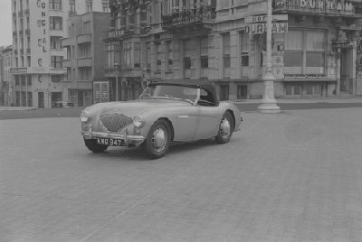

Healey Road Test
- 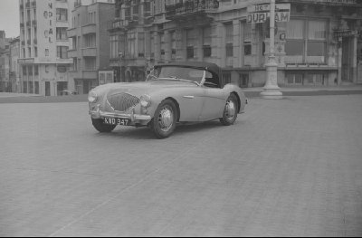

Healey Road Test
- 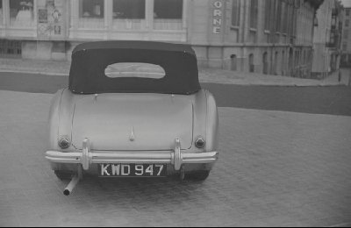

Healey Road Test
- 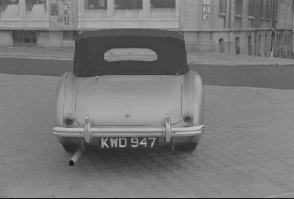

Healey Road Test
- 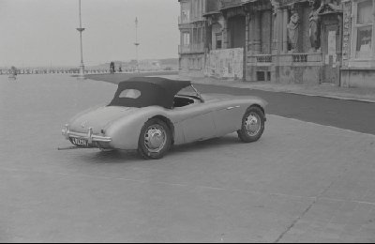

Healey Road Test
- 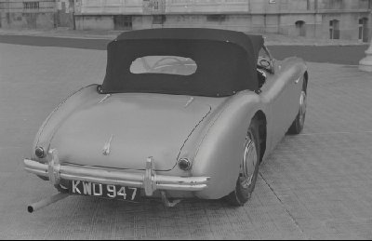

Healey Road Test
- 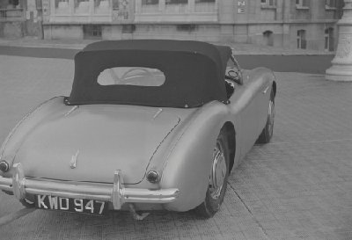

Healey Road Test
- 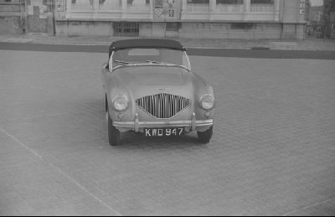

Healey Road Test
- 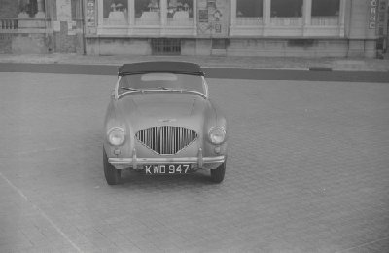

Healey Road Test
- 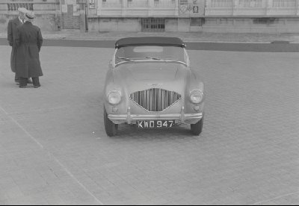

Healey Road Test
- 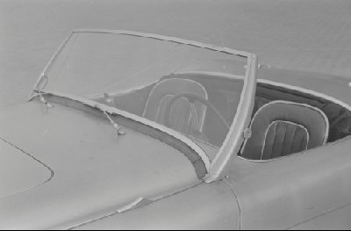

Healey Road Test
- 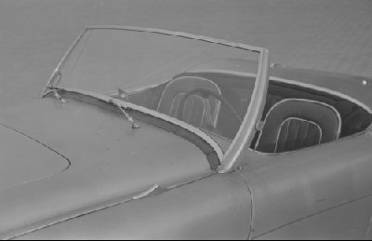

Healey Road Test
- 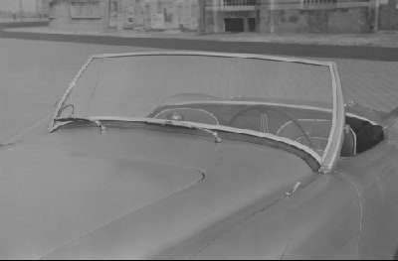

Healey Road Test
- 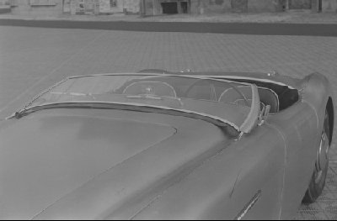

Healey Road Test
- 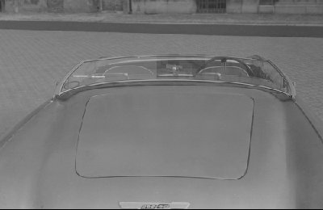

Healey Road Test
- 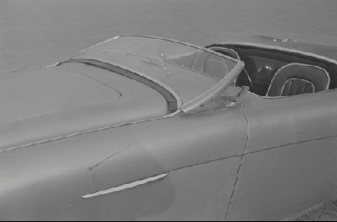

Healey Road Test
- 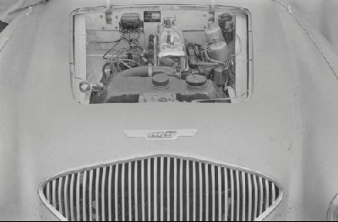

Healey Road Test
- 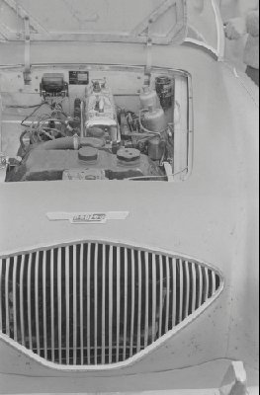

Healey Road Test
- 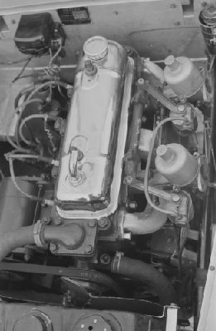

Healey Road Test
- 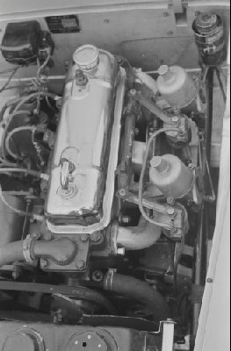

Healey Road Test
- 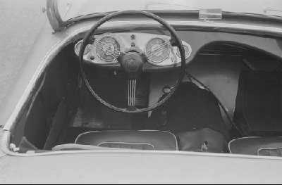

Healey Road Test
- 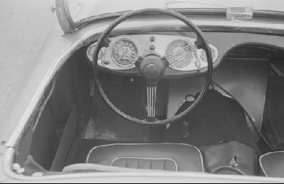

Healey Road Test
- 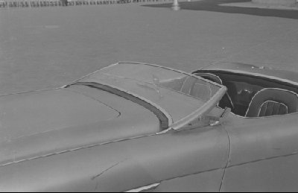

Healey Road Test
- 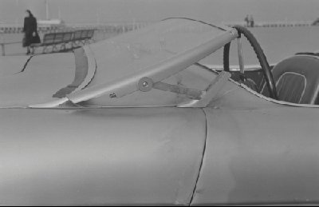

Healey Road Test
- 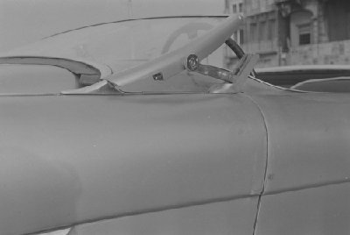

Healey Road Test
- 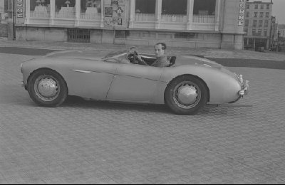

Healey Road Test
- 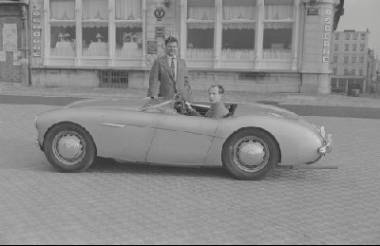

Healey Road Test
- 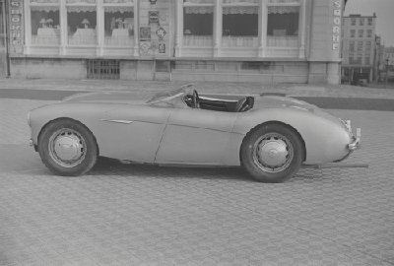

Healey Road Test
- 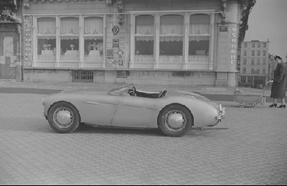

Healey Road Test
- 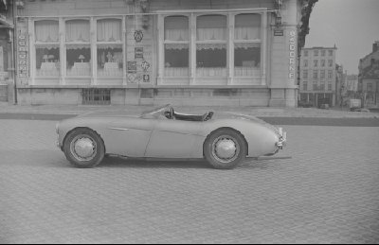

Healey Road Test
- 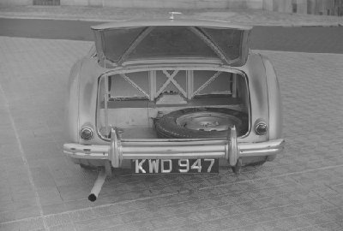

Healey Road Test
- 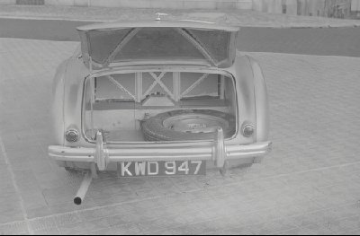

Healey Road Test
- 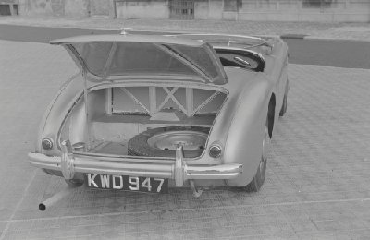

Healey Road Test

