**Coating headers versus Wrapping exhausts versus Doing Nothing**

In the automotive industry, it’s almost a lost cause attempting to come to a conclusion by searching on the internet for a definite answer on something as debatable as header wrap vs. ceramic coating vs. leaving the header naked as it was the day it left the factory.

I said *almost* a lost cause*.*

Today, what I’m going to examine are the differences between the options above, and speak to a couple of different reputable companies to get their take on which method(s) should or should not be implemented; and in the most unbiased manner possible, try to discern the best way to protect your investment while keeping it cool and making it the most efficient. The companies I have selected to talk to for this article are American Racing Headers, Jet Hot, and Kooks Headers. This way I can get a few different takes on the whole situation. American Racing Headers is a company based out of New York (most of you are probably familiar with) that specializes in 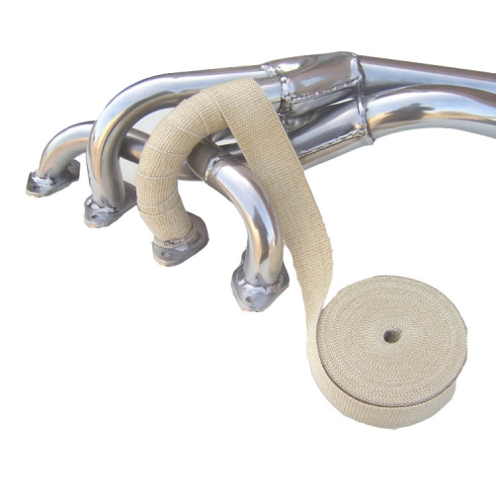crafting headers for American cars. Jet Hot, based in North Carolina, is a company that specializes in ceramic coatings for exhaust pieces for just about anything that has an engine. And last but certainly not least is Kooks Headers, also out of North Carolina, who specialize in custom exhaust pieces for domestics. These companies have one thing in common: exhaust is the driving force behind each of their businesses, as so they are commonly considered to be experts in the field. These companies have spent countless hours and lots of money researching and developing their products and services, so I figured- who better to ask?

The first of these companies I had an opportunity to interview with was American Racing Headers. I spoke with Anthony, who put me in touch with the owner of the company- Nick. These guys have been in the exhaust business for twenty some odd years but the company itself has only been around for the last five and a half. Talking with Nick, he informed me that all of their systems are made out of SS304 Stainless Steel, which is 200% better at retaining heat than mild steel. “The issue with wrapping a header is that by wrapping something around it, it insulates it [the header] but retains moisture and dirt against the steel itself. This leads to rust and cracking prematurely and also prevents the naked eye from seeing any damage caused until it’s too late. By wrapping the system,” he explained, “it’s almost a guaranteed early death to the component.” We went on to talk about ceramic coatings on a header. “We don’t recommend coating our headers unless it’s for an extremely high horsepower application, there’s just really no need. As far as coating a header, unless you intend to use the car for a lot of high abuse racing- like road racing, or have a forced induction system it’s just overkill.”

Bottom of the third: Coating: 0. Wrapping: 0. Naked: 1, according to American Racing Headers.

The next company that I was able to get a hold of was Kooks Custom Headers. These guys have been in the exhaust industry for 48 years, so needless to say they’ve been around the block a few times. I spoke with George R. there, and he was very to the point about wrapping headers: “It’s a thing of the past. Originally it was used to retain heat in the primaries, but that’s not necessary anymore.” When I brought up the notion of ceramic coatings, he shot that down almost immediately as well, “There’s no need, its overkill for anything but a 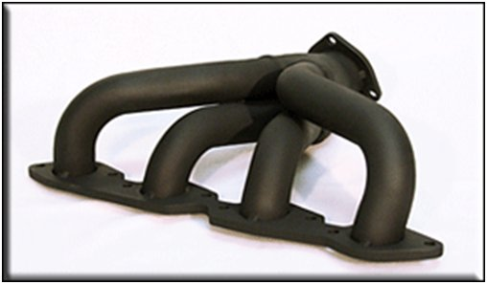racecar. You could do it for looks, but it’s really kind of pointless.” So, that’s two in the books that have shot down the notion of coating or wrapping headers for anything but a fully fledged racecar. These also happen to be two of the most respected names in the business.

Top of the sixth: Coating: 0. Wrapping: 0. Naked: 2.

So far, the top two names in headers have said not to do anything to your headers unless you’re running an absurd amount of power, forced induction of some sort, or unless your car is a true bred race car (and as much as I know we all hate to admit it, but unless you trailer your car to the track, it has at least a 6 point cage, 5 point harnesses, is not registered, and has no interior- it does not qualify as a race car). I know this goes against everything we’ve all read on the forums, and against what we’ve all been raised/taught through the years. I certainly used to think that ceramic coating headers and then heat wrapping them was the only way to go. Interestingly enough, however, when you break it down past it being an overkill move, the engineering behind both of the previous two notions is not without thought. The cooler an engine runs, generally the better, but when you start changing the way that exhaust is pulled out of the engine ([scavenging](http://en.wikipedia.org/wiki/Scavenging_%28automotive%29)), you start to change the way the engine behaves. It is possible to change the dynamics of the engine in such a way that you actually *lose* power. The concept of over-scavenging is what happens when an improperly tuned exhaust pulls too much air through the engine and you end up with a flat spot in the RPM range.

I know what you’re thinking- “But wait! He hasn’t said anything about Jet Hot yet!”

So, last but not least I got a call back from Jet Hot, and much to my surprise it was from David Burton, the head of engineering for Jet Hot. David was very patient with me and my lack of an engineering background, and broke it down very simply. In essence, when you coat something, you prevent corrosion. This is true with the Jet Hot coatings, but unlike header wrap their coatings provide a completely uniform dispersion of heat, and do not trap moisture, but prolong the corrosion resistance process. When asked about corrosion he said, “It really depends on the alloy and what kind of metal the headers are made of. Different metals will oxidize and rust at different rates. Mild steel is prone to rusting quickly, where as stainless steel is more corrosion resistant, even cast iron is prone to pitting- just at a much slower rate. Wraps and coating both improve the thermal qualities by acting as insulators, but wraps will burn and sometimes even etch themselves into the metal or alloy they cover as they heat and cool. They also trap dirt, debris, and water against the metals they are insulating. The thermal cycle burns the carbon out of steel as it goes from extremely hot, to cool, and then repeats. When this happens, the metal begins to rust under normal conditions. What the ceramic coating does is act as an insulator, and a corrosion inhibitor.”

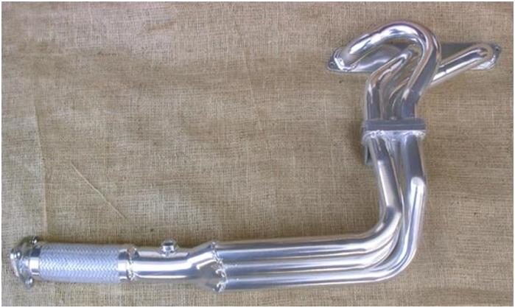

So, top of the ninth, Coating: 1. Wrapping: 0. Naked: 2.

Basically, what I can deduce from all of these interviews is that the first singular issue that should be addressed is that we should NOT be wrapping headers. It’s a thing of the past, passed down from the generations before. Ceramic coating is a great tool in preventing corrosion, but not entirely necessary for an everyday driver. The bottom line is if you want to spend the extra money on corrosion resistance, and heat insulation, it’s not a bad idea- but the headers will perform just as well without them. So, if you happen to be running a beast of a Corvette with a small mountain of power underneath the hood – either by way of forced induction, or just an astronomically built N/A set up – then it might be a good idea to get a ceramic coating on your headers. But, for the rest of us, while it does look nice, and provide an insulator to our headers, those beautifully crafted bends of steel sucking out the hot gases inside our motors, can be left just as naked as the day they were born.