Austin-Healey Club Black Forest Week 2016, see http://www.ahcbf.org/index.html

More to take with you for the Black Forest Week 2016. Josef Eckert

City of Freiburg, the Gate to the Black Forest
The city of Freiburg with a population of about 230,000, capital of the Black Forest, lies in the West of the Southern part of the Black Forest and builds the bridge to the valley of the river Rhine. A famous old German university town, Freiburg was incorporated in the early twelfth century and developed into a major commercial, intellectual, and ecclesiastical center of the upper Rhine region. The city is known for its medieval cathedral and Renaissance university, as well as for its high standard of living and advanced environmental practices. The city is situated in the heart of the major Baden wine-growing region and serves as the primary tourist entry point to the scenic beauty of the Black Forest. According to meteorological statistics, the city is the sunniest and warmest in Germany.
Freiburg was founded by Konrad and Duke Bertold III of Zähringen in 1120 as a free market town; hence its name, which translates to "free (or independent) town of this place means a "fortified town of free citizens".
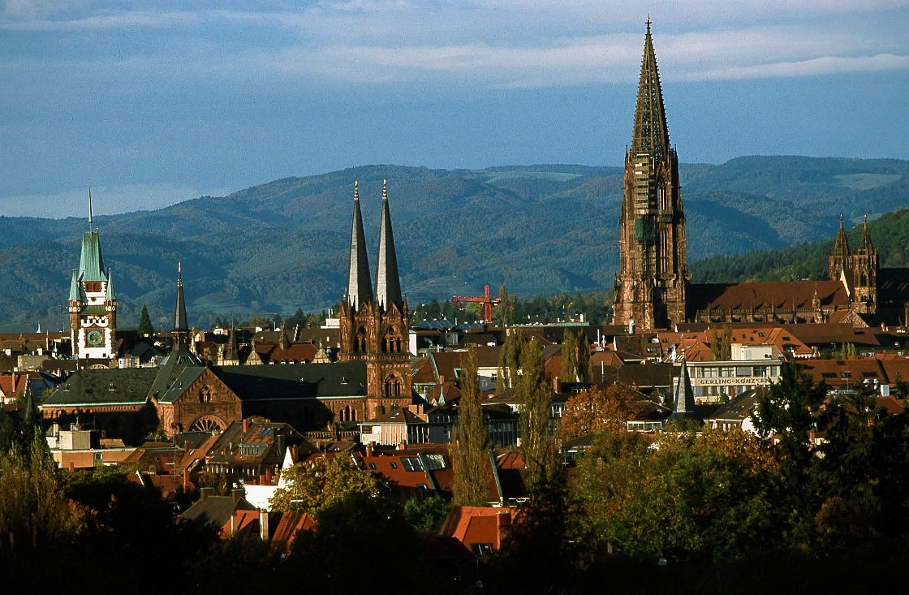View of Freiburg, Freiburg Münster and Martinstor

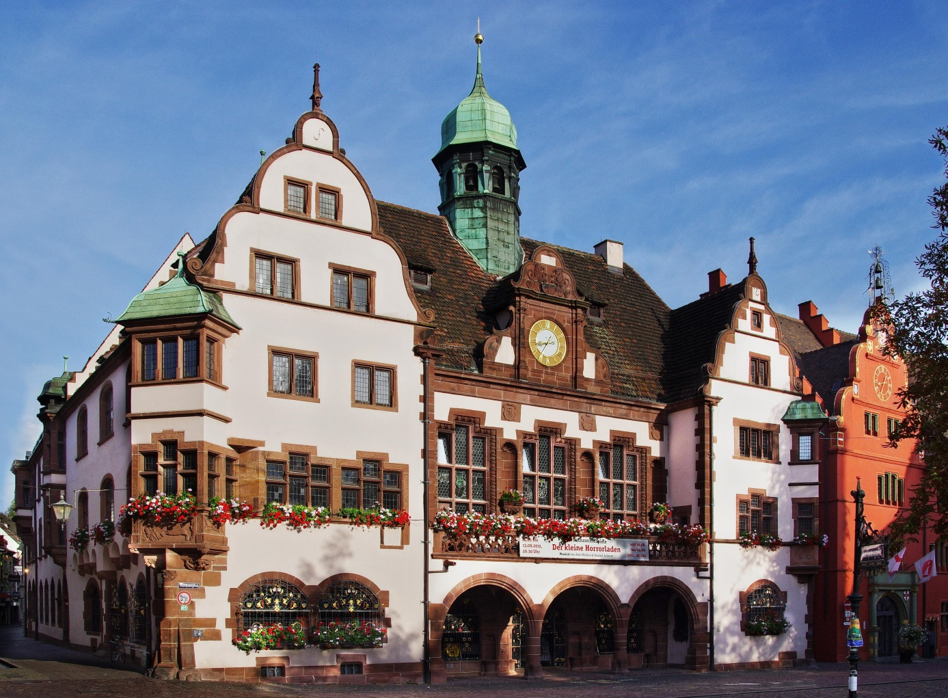
Freiburg City Hall (Rathaus)
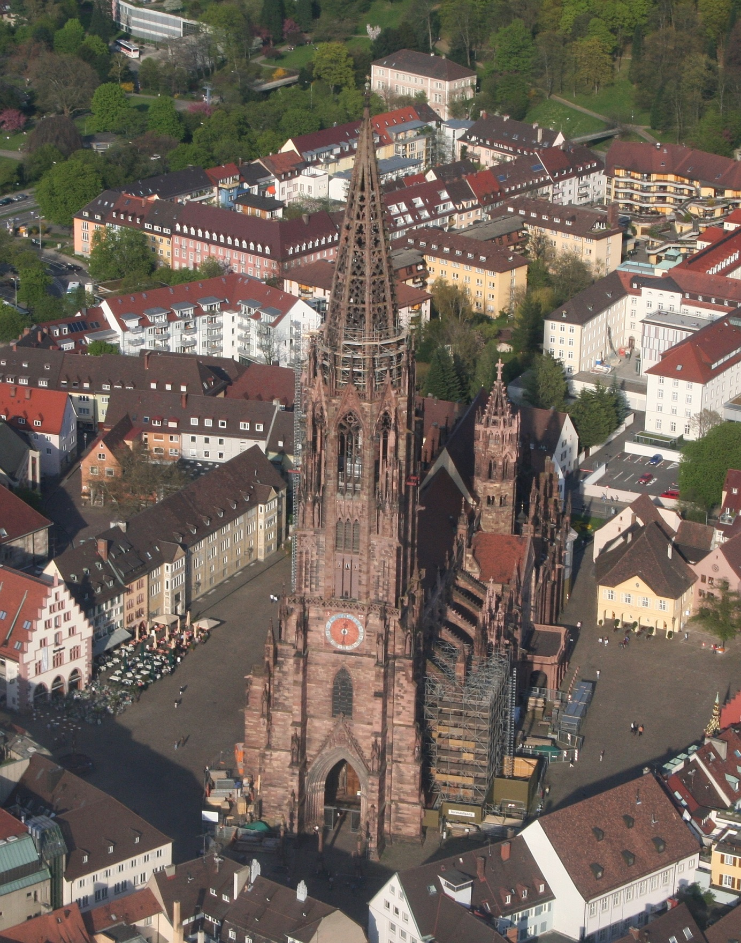

Freiburg Münster medieval cathedral

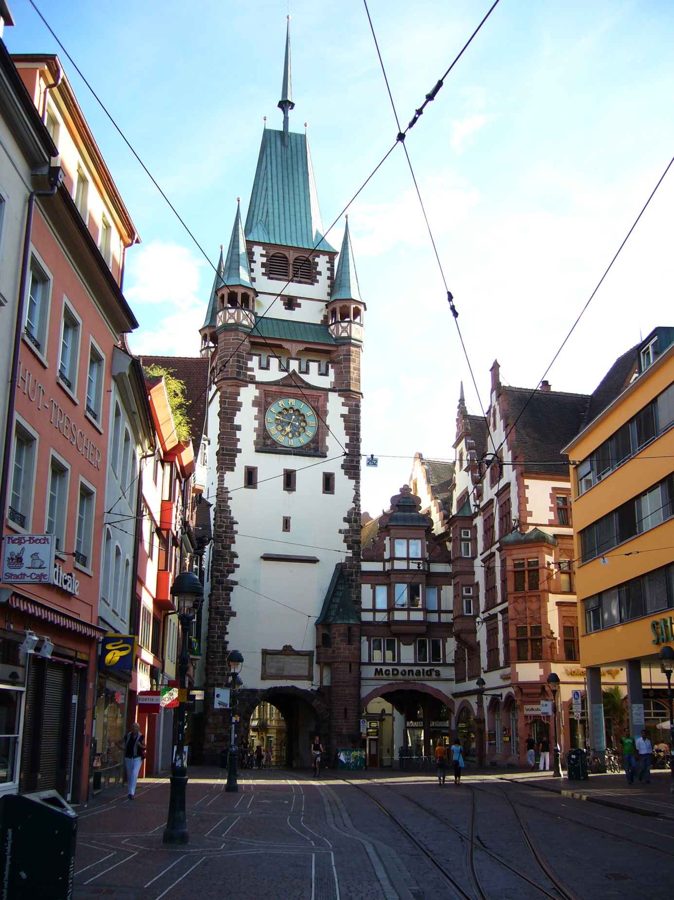
The Martinstor (Raised Martin Gate), one of the two still existing original city gates in Freiburg.

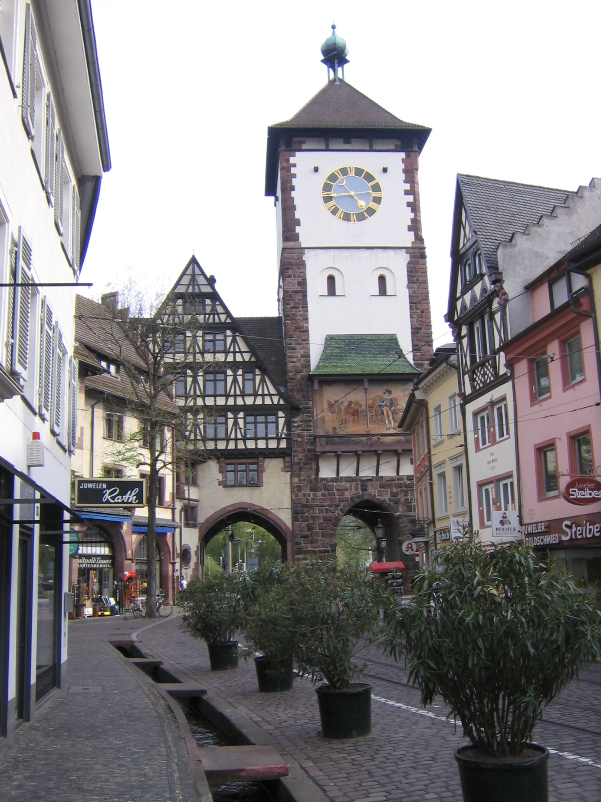

The Schwabentor Swabian Gate and Bächle (gutters)

Freiburg was heavily bombed during World War II. A raid by more than 300 bombers of the RAF Bomber Command on 27 November 1944 (Operation Tigerfish) destroyed a large portion of the city centre, with the notable exception of the cathedral, which was only lightly damaged. After the war, the city was rebuilt on its medieval plan.
Because of its scenic beauty, relatively warm and sunny climate, and easy access to the Black Forest, Freiburg is a hub for regional tourism. The longest cable car run in Germany, which is 3.6 kilometres (2.2 mi) long, runs from Freiburg-Günterstal up to a nearby mountain called Schauinsland. The city has an unusual system of gutters (called Bächle) that run throughout its centre. These Bächle, once used to provide water to fight fires and feed livestock, are constantly flowing with water diverted from the river Dreisam. They were never intended to be used for sewage, and even in the Middle Ages such use could lead to harsh penalties. It is said that if one accidentally falls or steps into a Bächle, they will marry a Freiburger.
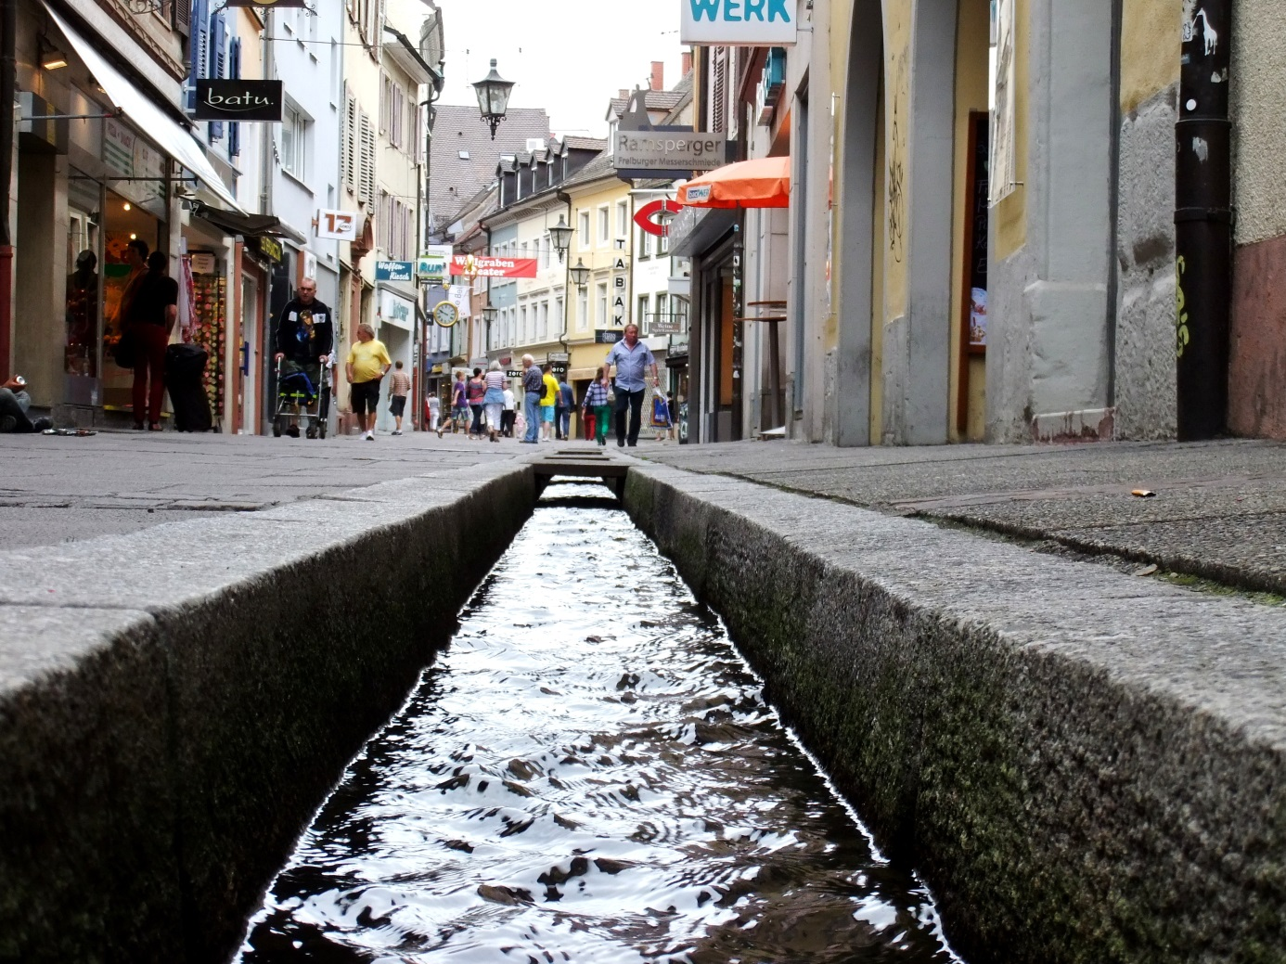Bächle
At the centre of the old city is the Münsterplatz or Cathedral Square, Freiburg's largest square. A farmers market is held here in the mornings every day except Sundays. This is the site of Freiburg's Münster, a gothic minster cathedral constructed of red sandstone, built between 1200 and 1530 and noted for its gothic church spire, which is said to be the most beautiful spire on earth. Around the cathedral´s roof there are plenty of gargoyles which are all different. Right to the spire there is one not facing but showing his back with the bugger as a water shoot to the archiepiscopal residence. An anecdote says the stonecutters were not well paid by the archbishop.

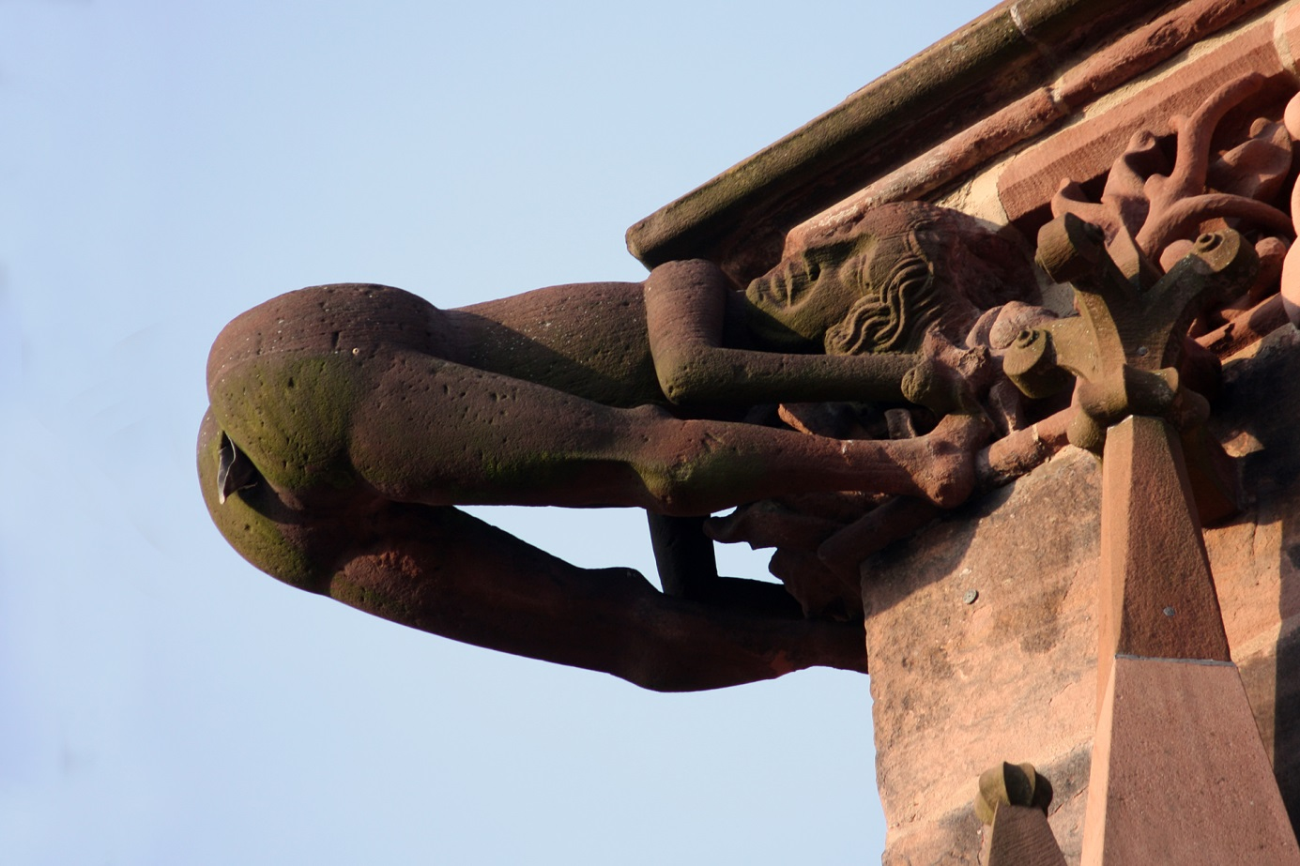
Gargoyle Freiburg Münster

The view from the top of the spire of the Münster.over the old city centre is worth the over 300 stairs of the spiral staircase to climb.

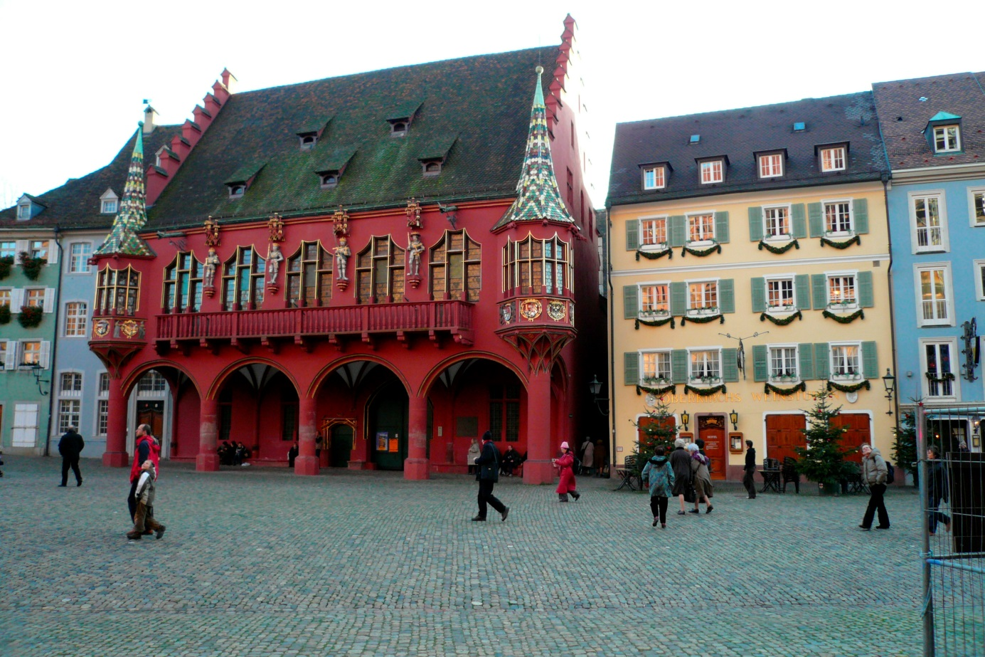The Historical Merchants Hall of 1520-21
The Historisches Kaufhaus, or Historical Merchants Hall, is a Late Gothic building on the south side of Freiburg's Münsterplatz. Built between 1520 and 1530, it was once the center of the financial life of the region
Zum Roten Bären, the oldest hotel in Germany, is located along Oberlinden near the Swabian Gate.
To the east of the city centre, the Schlossberg hill provides extensive views over the city and surrounding region. The castle (Schloss) from which the hill takes its name was demolished in the 1740s, and only ruins remain. Schlossberg retained its importance to the city, however, and 150 years ago the city leaders opened up walks and views to make the mountain available to the public. Today, the Schlossbergbahn funicular railway connects the city centre to the hill.
Freiburg has an extensive pedestrian zone in the city centre where no motor cars are allowed. There are plenty department stores, many boutiques and shops for shopping and there is a food hall “Markthalle” with plenty of food stands, restaurants and I shouldn´t forget to mention the Bratwurst Stände (sausage stands) on the Münsterplatz (Cathedral Square), surrounded by lots of pottery, woodcarvings or food stands for cheese, mushrooms, olives, spices, fruit and vegetables. There is plenty to see and enjoy for one day.
Within your Black Forest Week package you will find a map of the city centre to explore Freiburg on your own. There is so much to see, we can´t mention all.
But please don´t take your car for visiting Freiburg. Parking prices are horrendous and parking is mainly on underground car decks. Much better and more relaxing, you take the direct train from Schluchsee station (close to our hotel) through the picturesque Höllental (hell´s valley) to Freiburg. The train goes through more than 30 tunnels and over some viaducts on its route. Its an impressive train ride you shouldn´t miss. Train fare is included in the Black Forest event package.

