1952 London Automobile Show
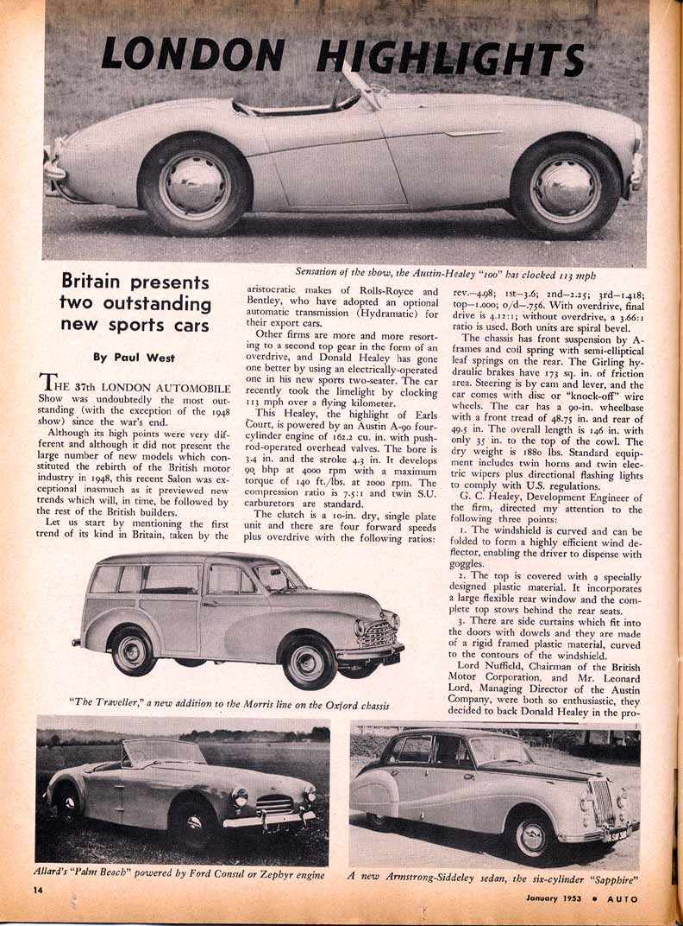
". . . (pro-)duction of this new Sports car; And the Austin factory may be able to bring out as many as 10,000 a year, of which about 90 per cent would be marked for export. The price in Britain has been fixed at £850 ($2380)."

Here is a page from the January, 1953, issue of Auto Speed and Sport magazine. The caption refers to the --New! New! New!-- Austin-Healey "100" sports two-seater shown in profile, with -- Ack! Ack! Ack! --DISC wheels and hubcaps: "Sensation of the show . . ." Further in the text you will find specifications that may differ from what we (some of us) (not I) know of the production versions.
The text continues on the next page: ". . . (pro-)duction of this new Sports car; And the Austin factory may be able to bring out as many as 10,000 a year, of which about 90 per cent would be marked for export. The price in Britain has been fixed at £850 ($2380)."

http://home.roadrunner.com/~fsheff/photo022.htm

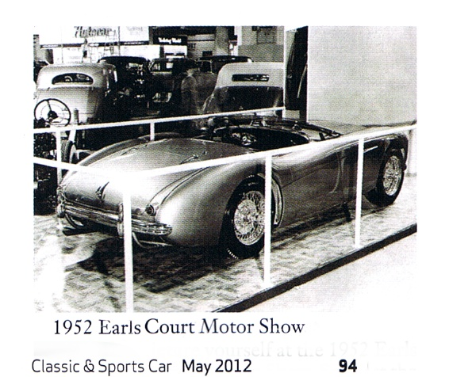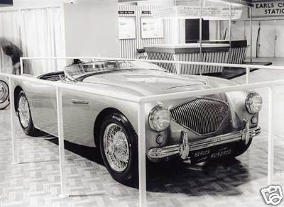
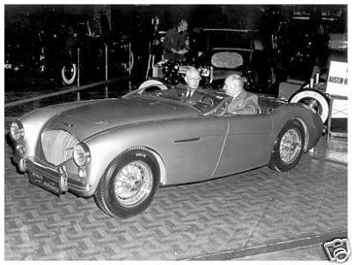

C:\British Cars\Austin Healey\History\Motor Shows\Earls Court-1952 London Automobile Show.doc

