Bumperettes [ Overriders ]
/tmp/in/input.doc

Cape International www.cape-international.com (Steve Norton)

Denis Welsh Motorsport www.bighealey.co.uk (Dennis Welch)

Triple S Motors www.tripleSmotors.com (Fred & Andy) [no longer available]

eBay Item : 230051971647 Ends : Nov-21-06 REAR OVERRIDER CONVERSION KIT
COMPLETE KIT FOR CONVERTING TO REAR OVERRIDERS LIKE THE WORKS RALLY CARS. THIS KIT INCLUDES ALL MOUNTING HARDWARE. THE BRACKETS ARE POWDER COATED BLACK. THE OVERRIDERS ARE BEAUTIFULLY CHROMED. ALSO INCLUDES THE RUBBER BOOTS FOR THE HOLES WHERE THE BRACKETS PASS THROUGH THE BODYWORK. CONTACT FRED & ANDY
www.tripleSmotors.com
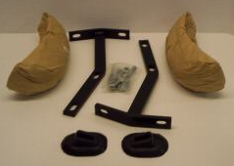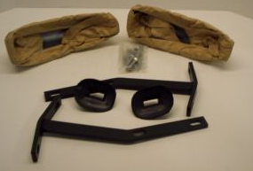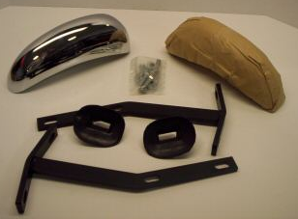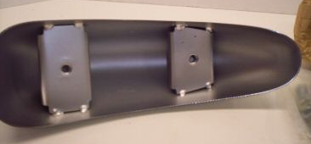

Rear Bumperetts
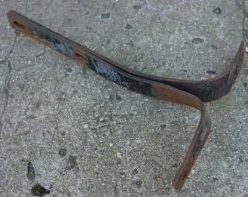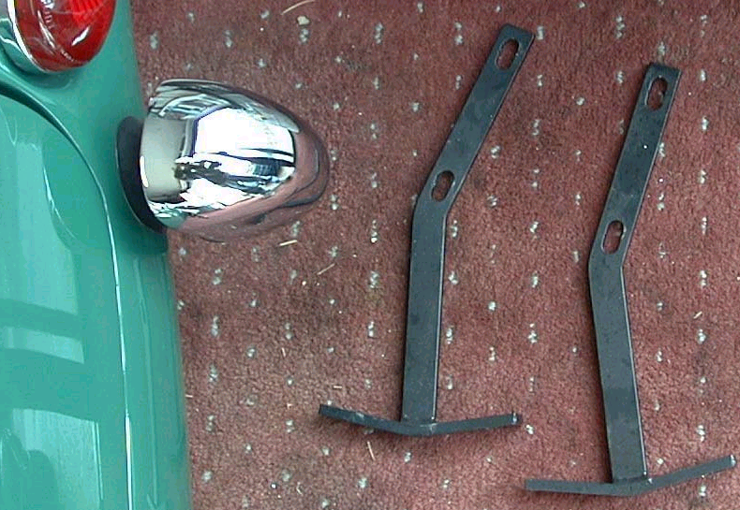
Normal Bumperette
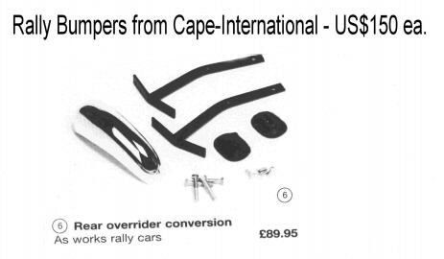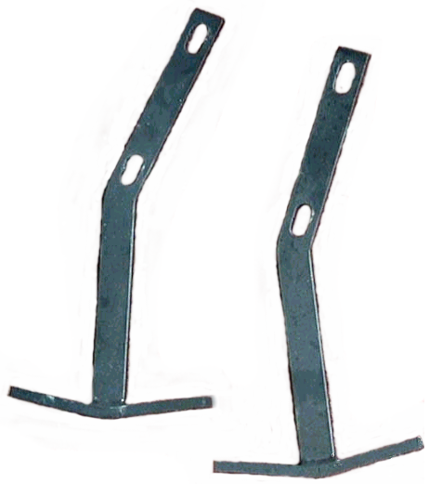

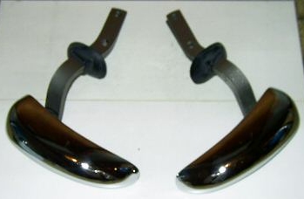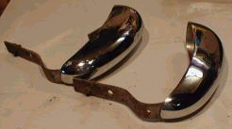

Big Healey Bumperettes - Sources

Re: [Healeys] bumperettes
From: John Spaur <jmsdarch@sbcglobal.net>
To healeys@autox.team.net
Date: 2015-08-13 at 10:25 PM
Someone sent me some links to companies that sell sprite bumperettes for the big healey. Would whomever sent them please resend them?
TIA, --John San Jose, CA

BT7 bumpers

Re: [Healeys] BT7 bumpers
From: Kimo Briske <kimobriske@gmail.com>;
To Healeys
Date: 2015-03-18 at 9:03 PM
Here's a photo of an original on my BT7. I’s been re-chromed.
Aloha, --Jim
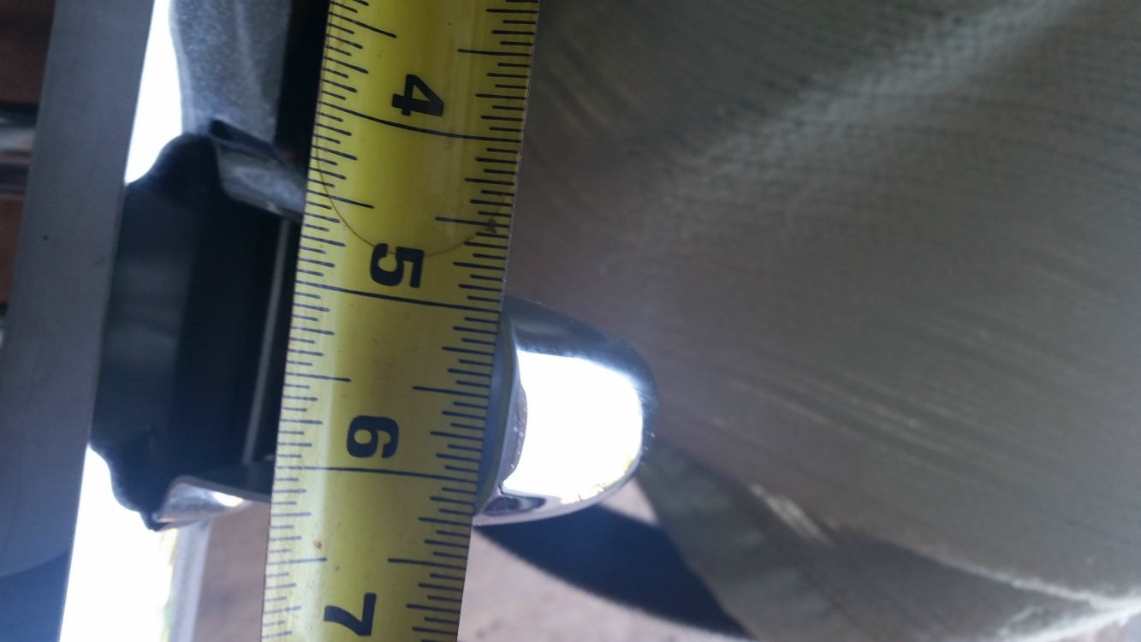

Re: [Healeys] BT7 bumpers
From: John Spaur <jmsdarch@sbcglobal.net>;
To healeys@autox.team.net
Date: 2015-03-16 at 9:23 PM
Would some send a picture of the BT7 over-rider? I am trying to figure out if my bumpers are original. I know the original over-rider is flatter and thicker on the top but I have nothing to compare mine with. TIA
--John Spaur ’62 BT7

Bumper Overrider

From: | "John Snyder" <johnahsn@olypen.com>
To: | healeys@autox.team.net, "Jerry Wall" <jwbn6@iopener.net>
CC: | "Douglas W. Flagg" <dwflagg@juno.com>
Subject: | Re: Bumper Overrider
Date: | Fri, 21 Feb 2003 22:30:36 -0800
Jerry, I think you may have the correct answer to my question. This overrider came w/ a completely disassembled 3000 BT7 MK2 that I bought around 15 years ago which I'm finally getting around to restoring. The PO was not very knowledgeable about Healeys, and I inherited a bunch of stuff that was not correct for the car. Unless I hear otherwise, I will assume this particular overrider is worthless.
--John Snyder
Jerry Wall wrote: << John, Some years ago, there were some reproduction overriders which were ......>>

To: | johnahsn@olypen.com, healeys@autox.team.net
Date: | Fri, 21 Feb 2003 20:15:12 -0600
From: | "Jerry Wall" <jwbn6@iopener.net>
Subject: | Re: Bumper Overrider
John, Some years ago, there were some reproduction overriders which were horribly obese. You could lay one on top of an original overrider as if the original one was the mold for the reproduction. 6 cylinder overrider have indentions on the backside which conform to the bumper.
--Jerry

From: | "John Snyder" <johnahsn@olypen.com>
To: | healeys@autox.team.net
Subject: | Bumper Overrider
Date: | Fri, 21 Feb 2003 01:53:52 -0800
Hello List, I have a brand new bumper overrider that came in the boxes w/ one of my Healeys. As first glance, it looks just the overriders used on 100-6s and 3000s, but upon actual comparison, the portion that is above the bumper is wider. Could this part be for a 100-4 (I don't know much about the 100-4s)?

Does this part have some value to anyone on the List? I suppose first, I need help to figure what make/model of car this thing is for. Maybe it is for some other British car.
--John Snyder 4 3000s

BJ8 front bumperette

Date: | Tue, 26 Nov 2002 17:28:29 -0800 (PST)
From: | "Blue One Hundred" <international_investor@yahoo.com>
Subject: | Re: BJ8 front bumperette
To: | "Rick Swain" <grain@auracom.com>, RLoosigian@aol.com, healeys@autox.team.net
Rick - both Dennis Welch and Steve Norton in the UK make rear bumperette rally kits:
www.bighealey.co.uk (Dennis Welch) www.cape-international.com (Steve Norton)

In general, Steve Norton at Cape is a great guy, but you may or may not have to work with his bumperette kit - I think a couple listers mentioned there were some fitting problems (not long enough to mount). Knowing Steve, however, if you tell this to him on the phone when ordering, he will make sure it fits correctly before shipping it.

Dennis Welch - don't know anything about their bumperette kit.

--Alan '53 BN1 '66 BJ8
"Rick Swain" <grain@auracom.com> wrote: << [[ On 11/25/02 4:21 PM, RLoosigian@aol.com wrote: << …….. I know that there are several sources for mounting brackets for the rear but have never seen front brackets advertised. >>]] Unlike Ralph, I have not seen sources for mounting brackets for the rear. …….. >>

From: | WilKo@aol.com
Date: | Tue, 26 Nov 2002 12:21:18 EST
Subject: | Re: BJ8 front bumperette
To: | healeys@autox.team.net
On 11/26/02 4:32:06, grain@auracom.com writes: << … Can anyone point me in the right direction? Thanks, --Rick Swain >>

I got mine from Cape International. They can be seen installed at: http://members.aol.com/wilko/Overriders.html

Rally Style Bumperettes
The works team used these sprite bumperettes on the Big Healeys as a weight saving measure. They look real smart and don't clutter the lines of the car.

and lamps at: http://members.aol.com/wilko/lamps.html

Lucas Lamps/Works Style Brackets

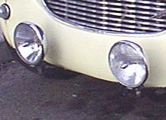
The Lucas Flamethrowers were a popular addition to the works Healeys and most had brackets simlar to these holding them. The bracket shown here is from Cape-International in Coventry, UK. The lamps pictured are (from left) a Lucas SLR 700 and an SFT 700. Long range spot and wide flat fog light respectively. Both are 7" and loaded with halogen goodness.

From: | "AH102" <bluechipracing@snet.net>
To: | "Rick Swain" <grain@auracom.com>, RLoosigian@aol.com, healeys@autox.team.net
Subject: | Re: BJ8 front bumperette
Date: | Tue, 26 Nov 2002 08:30:09 -0500
Rick: Cape International www.cape-international.com has the rear brackets. They also have front brackets for driving lights. They could possibly be modified for overriders.
--Jim
Rick Swain wrote: << Unlike Ralph, I have not seen sources for mounting brackets for the rear. …….. >>

Date: | Tue, 26 Nov 2002 08:28:47 -0400
Subject: | Re: BJ8 front bumperette
From: | "Rick Swain" <grain@auracom.com>
To: | RLoosigian@aol.com, healeys@autox.team.net
On 11/25/02 4:21 PM, RLoosigian@aol.com wrote: << …… I know that there are several sources for mounting brackets for the rear but have never seen front brackets advertised. >>

Unlike Ralph, I have not seen sources for mounting brackets for the rear. I'm considering mounting bumperettes at the rear of my BN4 and am also interested in mounting driving lights in the front w/o a bumper as on some of the rally cars. I suppose I could organize something myself but if ready-made brackets, which match the look of the rally cars, are available, it might save me some work. Can anyone point me in the right direction? Thanks
--Rick Swain '59 BN4

Date: | Mon, 25 Nov 2002 18:09:02 -0800 (PST)
From: | "Blue One Hundred" <international_investor@yahoo.com>
Subject: | Re: BJ8 front bumperette
To: | RLoosigian@aol.com, healeys@autox.team.net
Ralph - Front bumperettes were never mounted on the rally cars (at least not that I'm aware of), that's why no one sells them. You can probably have your local metal shop or body shop make up a pair of mounts for about a Hundred bucks, or frankly even less if they use your current bumper irons and modify them. Good Luck,
--Alan

From: | "Steve Byers" <byers@cconnect.net>
To: | healeys@autox.team.net
Subject: | Re: BJ8 front bumperette
Date: | Mon, 25 Nov 2002 18:20:24 -0500
Hi, Ralph - The owner of this car should be in touch with you shortly.
Another fine service of the BJ8 Registry.
--Steve Byers HBJ8L/36666 BJ8 Registry Havelock, NC

From: | RLoosigian@aol.com
Date: | Mon, 25 Nov 2002 15:21:37 EST
Subject: | BJ8 front bumperette
To: | healeys@autox.team.net
Reference the Moss Motors, British Motoring Magazine, Winter 2000, Volume 21, Number 4, which was just received. On page 8 is the photo of a green BJ8 that appears to have Sprite bumperettes on the front. I am wondering whether anyone knows who the owner of the car is, or whether the owner is on the list. I would like more info on how they were mounted, where the brackets came from, etc. I know that there are several sources for mounting brackets for the rear but have never seen front brackets advertised. Thanks
--Ralph Loosigian

