Reach your target audience,

make an everlasting impression:

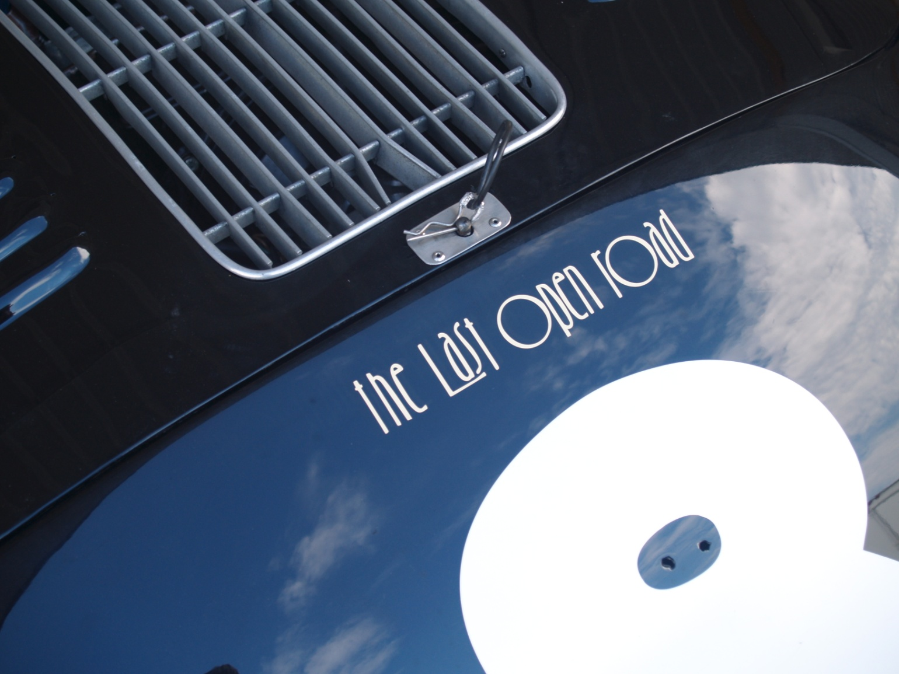

Why do the owners of over 200,000 cherished racecars, sports cars, classic cars, hot rods, collector cars, tow cars, motorcycles, motor homes and daily drivers proudly display *“The Last Open Road”* decals?

Because they flat-out **LOVE** Burt Levy’s *The Last Open Road* book series and believe in the brand.

And here’s an opportunity to reach out to that passsionate, involved and enthusiastic audience!

**THE STORY of *THE LAST OPEN ROAD* SERIES**

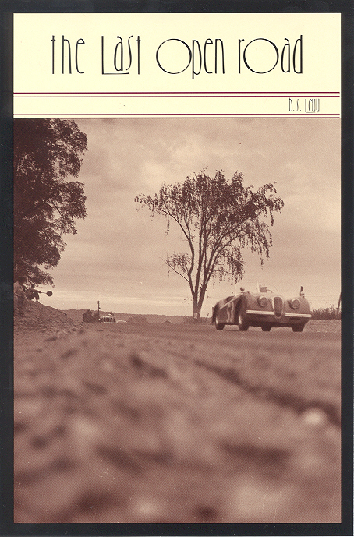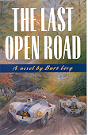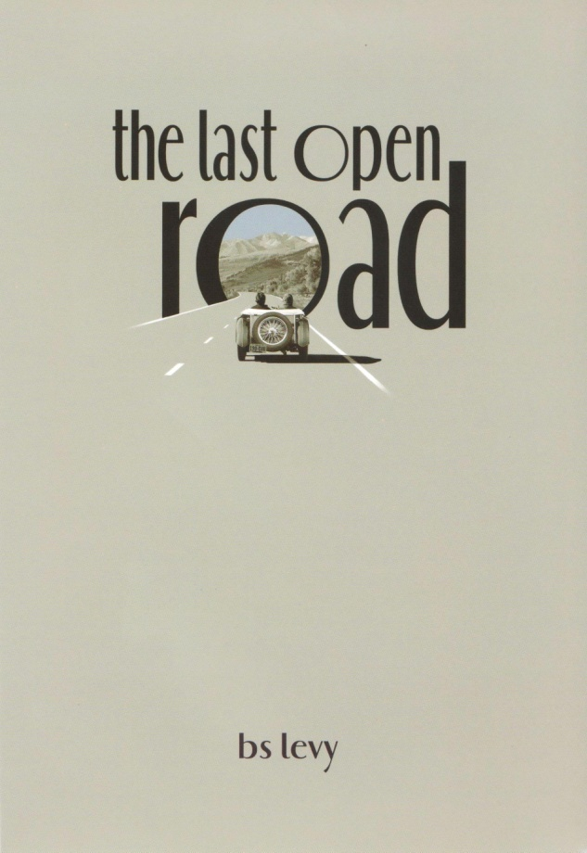

1994-1997 1998 (St. Martin’s Press) 2001-2018

Burt Levy’s *The Last Open Road* has become both a cult classic and a publishing phenomenon since it first debuted under a pop-up awning at the big Road America vintage meet in July of 1994. Now in its 26th year and 10th hardcover printing, *The Last Open Road* continues to find new fans and friends world-wide. Quite an accomplishment for a book that was turned down by almost every major fiction publisher in the country. Some of them liked it, but felt that there was “no market for ‘car’ fiction.” Or, as one particularly snotty and arrogant New York publishing executive said: *“It’s a wonderful story, but there’s no market. THOSE people don’t read…”*

Burt and wife Carol thought otherwise, took out a second mortgage on their home, formed their own publishing company, Think Fast Ink L.L.C., and published it themselves. Thanks to universally rave reviews in both the mainstream and motoring press and unbelievable word-of-mouth support on the motorsports and collector-car scenes, it sold out two printings and was picked up by major New York publisher St. Martin’s Press. But they didn’t do much to promote it—Burt and Carol were selling more copies at racetrack, museum and car-show book signings, through their website and in cooperation with motorsports- and car hobbyist-oriented shops, websites and specialty retailers than St. Martin’s were selling through the traditional bookstore market!

So for the initial sequel, *Montezuma’s Ferrari,* Burt and Carol decided to go it on their own again. But Burt had an idea. Why not fund the project the same way his racing was funded: with sponsorship and advertising? And it worked! In eight weeks, Burt generated over $30,000 in ads and sponsorships for a 32-page, full-color, between-chapter insert disguised as a period motorsports magazine *(“AutoWeak”)* from the same era as the story. It included ads from major brands like Mercedes-Benz and Castrol (see pictures below). That “novel” idea won *Montezuma’s Ferrari* the 2000 Benjamin Franklin “Book of the Year” award for innovation in publishing.

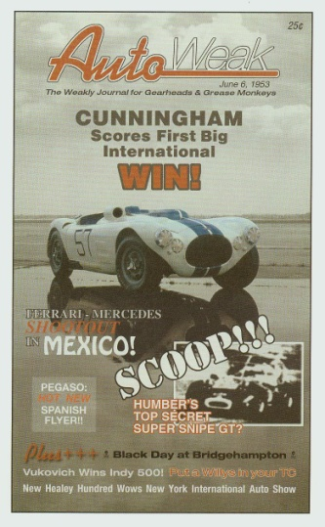 Scan0004.tif Scan0007.tif 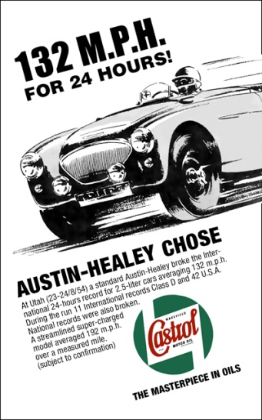

Burt and Carol not only printed the new book, but bought back the rights and remaining copies of *The Last Open Road* from St. Martin’s Press as well. And they’ve successfully continued that approach for all the subsequent sequels (there are currently six novels in *The Last Open Road* series—plus a short-story anthology—with a seventh and last on the way) and each ad/sponsorship section has its own unique theme and features real ads, period ads and pictures of cars and historic events appropriate to the story and funny “fake” ads to keep the reader’s interest and attention:

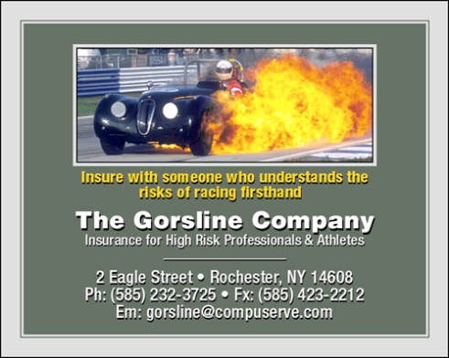 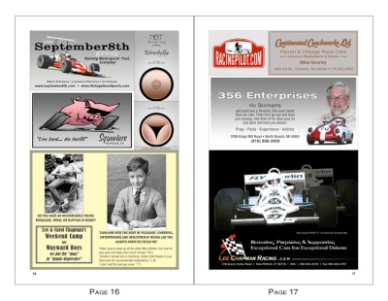 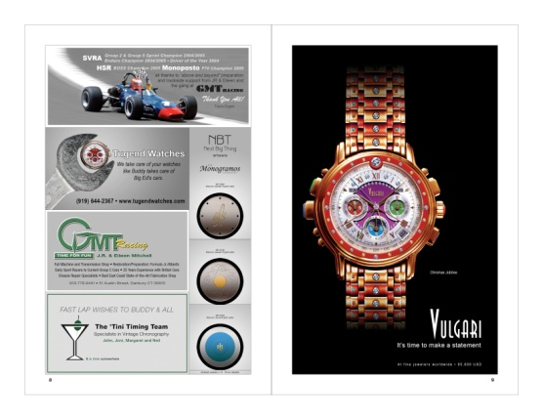

The enthusiastic following for *The Last Open Road* series has continued through all five sequels:

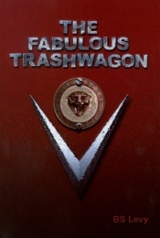 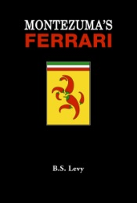 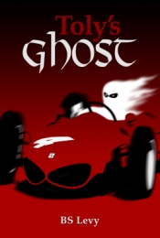 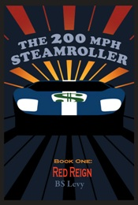 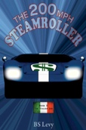

The eagerly awaited *The 200mph Steamroller Book III: Assault on Four O’clock* will be the latest book in *The Last Open Road* series, and a special chance to be a part of the project and reach out to that audience with a message that will endure for years to come. Unlike periodicals that are often put on a shelf or into the wastebasket after a single thumb-through, *The Last Open Road* novels are typically read and re-read over many sittings and are often passed on to friends. So at pricing competitive with a single insertion in a print magazine, your advertising message will have a near unlimited shelf-life and reach an involved, high-demographic, enthusiastic and brand-loyal audience.

*The Last Open Road* book series has developed an incredibly large and enthusiastic following world-wide in the motorsports, car hobbyist and collector-car worlds:

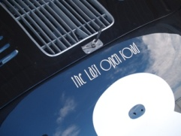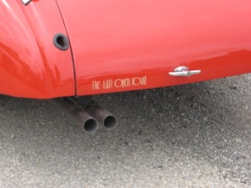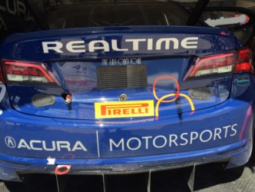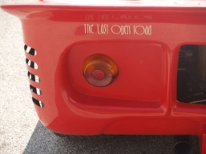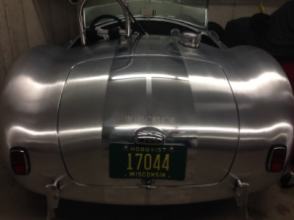 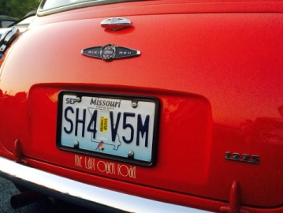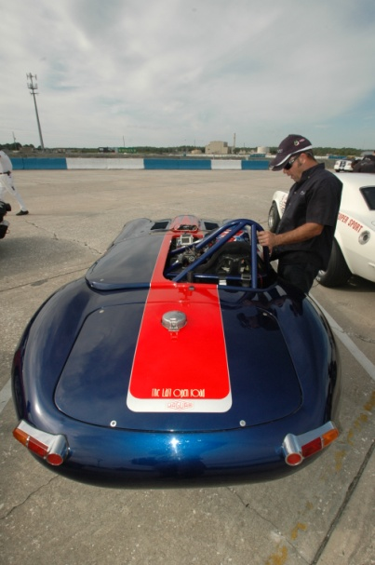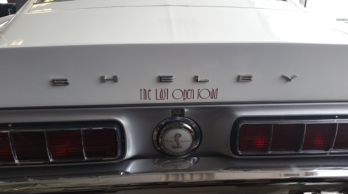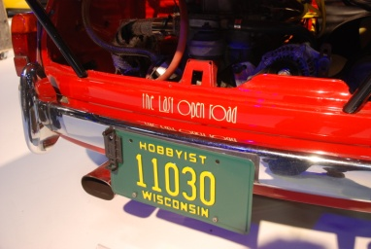 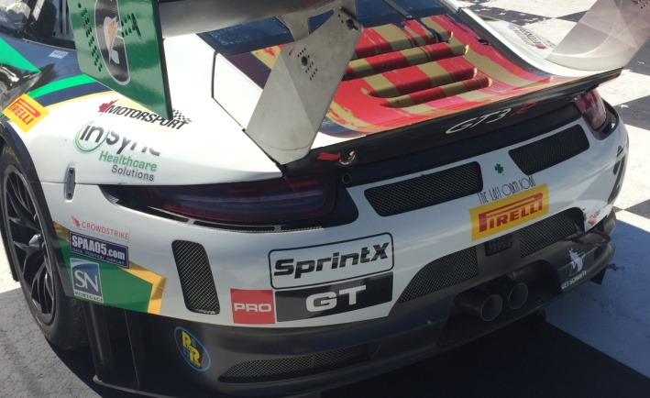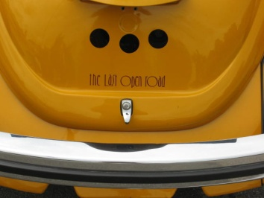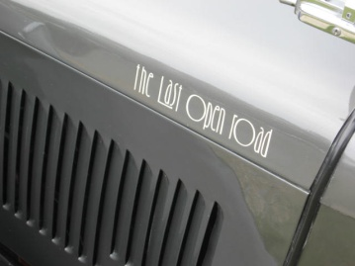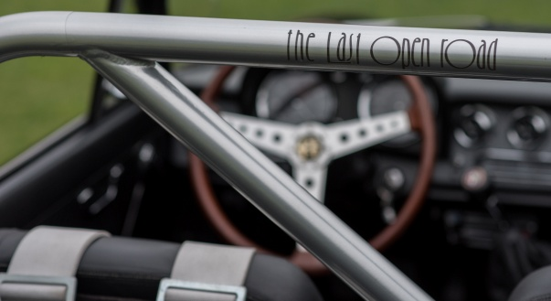 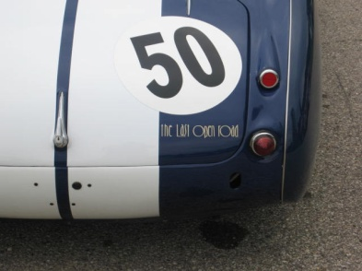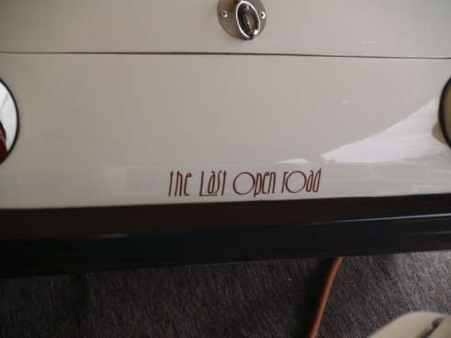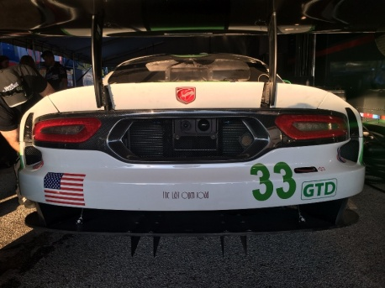 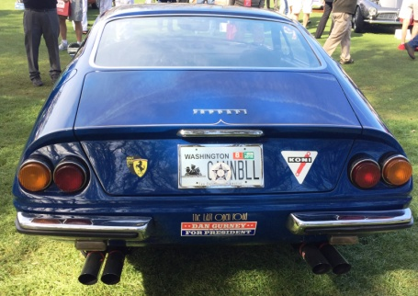 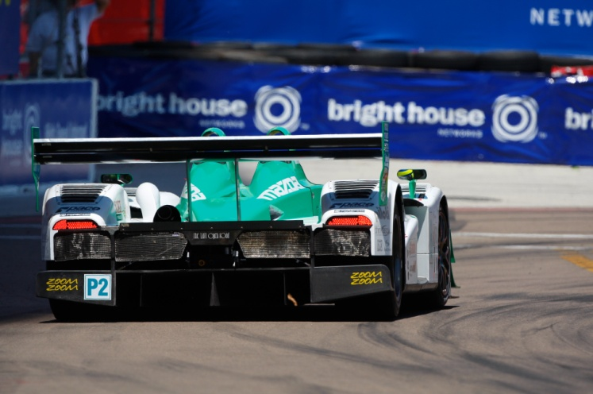 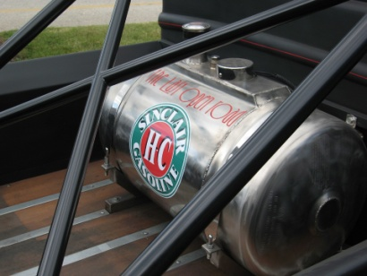

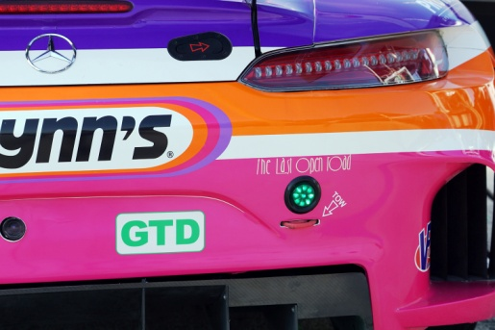 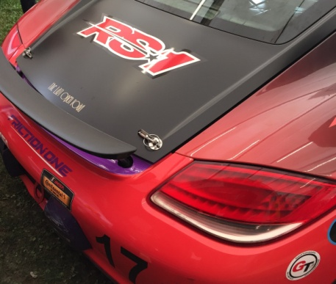 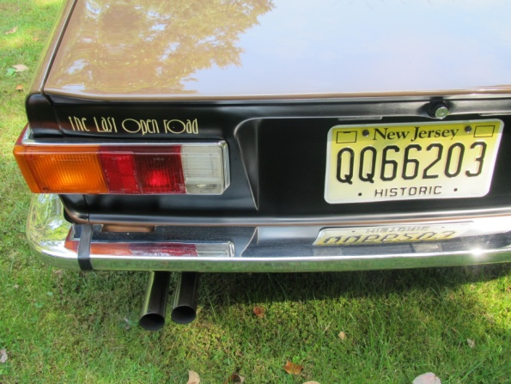

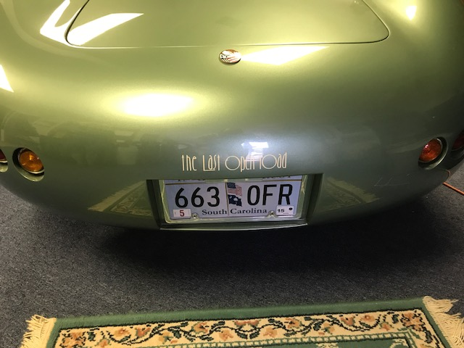 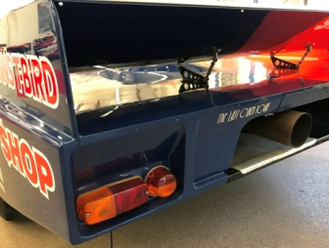 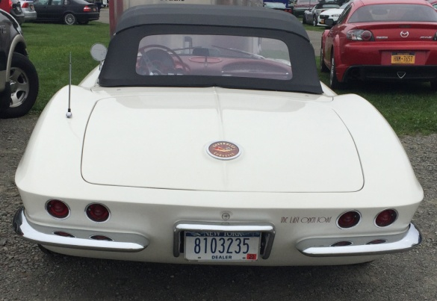

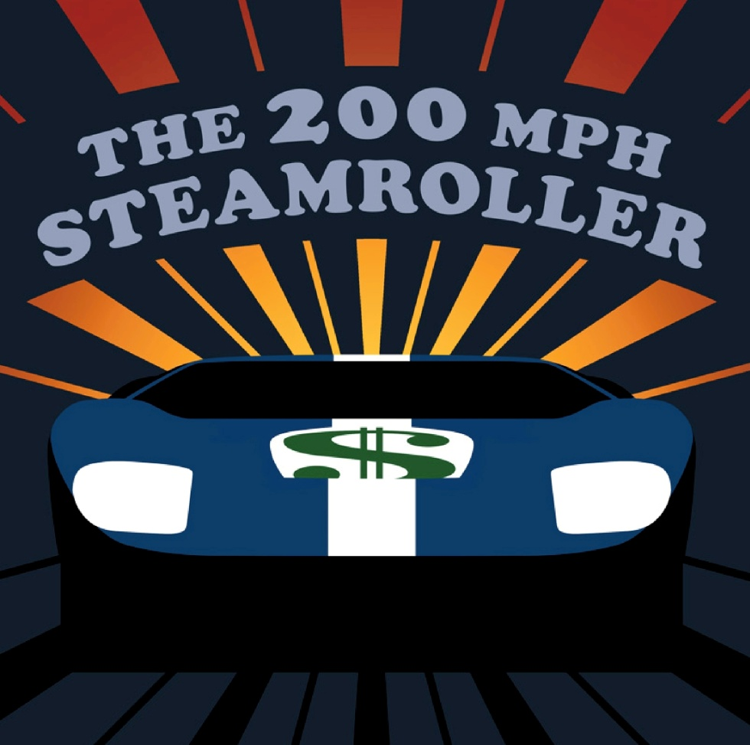

**The 200mph Steamroller Book III: Display Advertising Rates**

Full Page (5”W x 8”H) @ $3000 Half Page (8”W x 4”H or 4”W x 8”H) @ $2000

Third Page (5” W x 2.66H) @ $1750 Quarter Page (2.5W x 4”H) @ $1500

Eighth Page (Business Card) @ $750

$250 discount OR a free size upgrade for non-profits, clubs and personal (non-commercial) content.

**The 200mph Steamroller Book III: Personal Ad Rates**

This can be a picture of a favorite or historic car, a person or people to be honored or remembered (in good taste, of course), a particular event, a print message, whatever.

Quarter Page (2.5”W x 4”H) @ $1000 Eighth Page (business card size) @ $500

**The 200mph Steamroller Book III: Individual/Group Sponsorships**

This will be a listing (in alphabetical order) on the sponsor/advertiser page in the color insert section of the new book. Can be done as a name, company, club, in memory of, etc. @ $250. Includes a copy of the leather-bound, never-offered-for-retail sale sponsor/advertiser edition of the new book plus a “beater” copy to actually read plus a very nice *The 200mph Steamroller* “sponsor/sucker” polo shirt that you’ll be proud to own yet embarrassed to wear.

**About the Author**

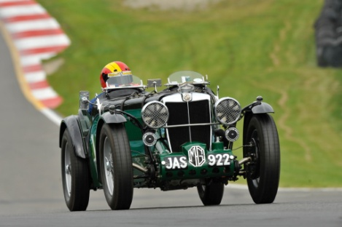 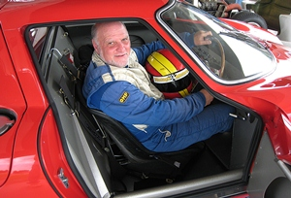 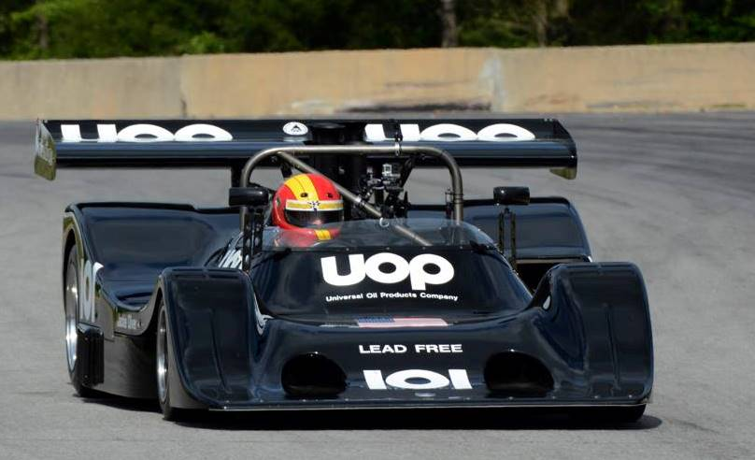

Burt Levy has been racing, wrenching and writing about cars for almost 50 years. He’s been a successful amateur and semi-professional racing driver, sports car and motorcycle mechanic and shop-owner, dealership service manager, car salesman (while selling cars at an upscale, Chicago “gold coast” dealership, he had a used Rolls-Royce Silver Shadow convertible taken from him at gunpoint on a test drive!), renowned motorsports novelist, car-club/special-event banquet speaker, concours judge, guest color PA announcer at numerous North American racetracks including Road America, Watkins Glen, Sebring, VIR, Laguna Seca, Lime Rock Park, Mosport, Mid Ohio, Pacific Raceways and The Indianapolis Motor Speedway and is a multiple award-winning motorsports journalist. He also served as a short-term, second-string stunt driver when *The Blues Brothers* movie was filming in Chicago. As a driver, he’s won roughly 100 amateur and vintage races and 8 season championships in a truly staggering variety of cars—he’s known as the world’s most accomplished “ride mooch”—and is still actively involved (in other people’s cars, of course!), and serves as a racing and high-performance driving instructor several times each year.