Winter’s clutches are starting to loosen just a bit, which means road trip season is just around the corner. If you’re planning a spring road trip, but are undecided about where to go, [read](https://blog.thediscoverer.com/5-u-s-road-trips-to-take-this-spring/) on. These fabulous road trip ideas will inspire you to load up the car and embark on an adventure to welcome spring.

**The Florida Keys Overseas Highway, Florida**

Credit: pisaphotography/Shutterstock

U.S. Route 1, also known as the Florida Keys Overseas Highway, is a classic drive that is perfect for a spring road trip, especially if the dregs of winter have you longing for palm trees and warm, salty air. Stretching 100 miles from Key Largo south to Key West, you’ll find a relaxed island atmosphere, beautiful beaches, parks, and towns, and some of the best seafood around. Plus, long stretches of the highway pass over the ocean, offering stunning turquoise views every mile of the road. Highlights of a Florida Keys road trip include J[ohn Pennekamp Coral Reef State Park](http://pennekamppark.com/) in Key Largo, which is the nation’s first undersea park, kayaking at [Long Key State Park](https://www.floridastateparks.org/parks-and-trails/long-key-state-park) in Marathon, and exploring the attractions, bars, and beaches in Key West.

**Scenic Byway 12, Utah**

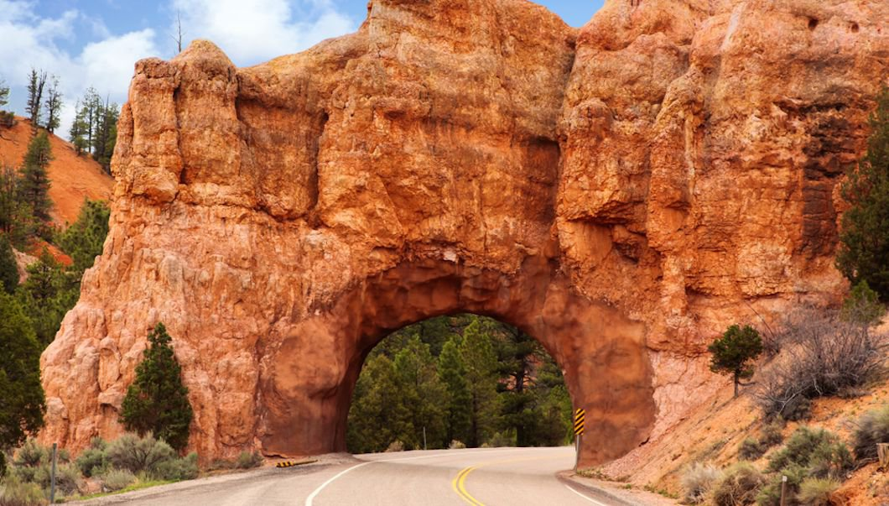Credit Jane Rix/Shutterstock

Arguably one of the most beautiful stretches of pavement in the country, Scenic Byway 12 spans 124 miles in Utah’s red-rock country. Most of the land on either side of the byway are public, and there are numerous places to stop, stretch your legs, and explore. Be sure to check out B[ryce Canyon National Park,](https://www.nps.gov/brca/index.htm) Grand Staircase-Escalante National Monument, [Capitol Reef National Park](https://www.nps.gov/care/index.htm) and Kodachrome Basin State Park. This part of Utah is an outdoor lover's paradise and even if you stay in the car most of the time you'll feel at one with the great outdoors.

[https://assets.thediscoverer.com/discoverer/blog/images/icon-earth.png](https://blog.thediscoverer.com/essential-west-coast-road-trips/)

[You may also like: 4 Essential West Coast Road Trips](https://blog.thediscoverer.com/essential-west-coast-road-trips/)

**Oregon Coast Highway 101, Oregon**

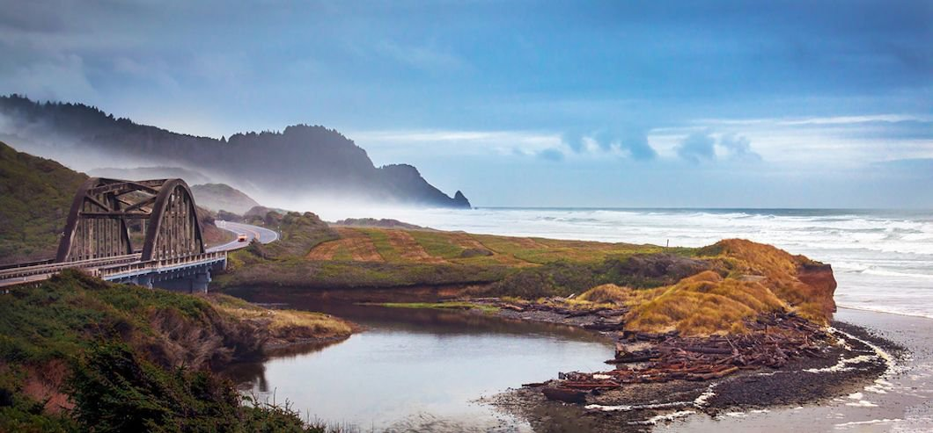Credit: Catherine B Johnson/Shutterstock

Also known as the Pacific Coast Scenic Byway, Highway 101 begins in the Oregon town of Astoria and hugs the coast for hundreds of miles, passing secluded beaches, rocky headlands and quiet beach towns. While temps will still be chilly on your spring road trip, you’ll be glad to escape the traffic that can clog this coastal route during the summer months. Highlights of an Oregon Coast road trip include the [Lewis and Clark National Historic Park](https://www.nps.gov/lewi/index.htm) near Astoria, Oregon Dunes National Recreation Area and the [Oregon Coast Aquarium](https://aquarium.org/) in Newport.

**Finger Lakes Waterfall Road Trip, New York**

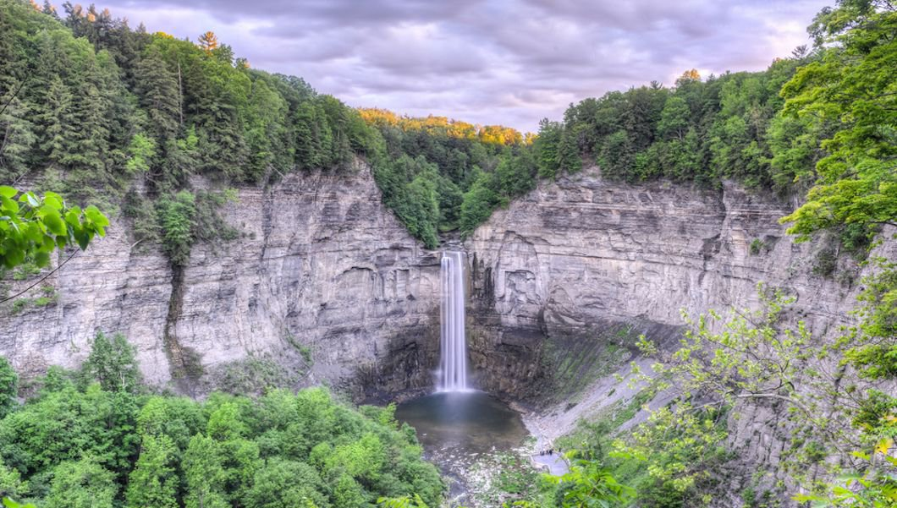Credit: Felix Lipov/Shutterstock

The Finger Lakes region of Western New York is characterized by deep, glacial lakes, incredible gorges and waterfalls, and an abundance of award-winning vineyards. Spring is a perfect time to visit the [waterfalls of the Finger Lakes](https://backroadramblers.com/finger-lakes-wine-and-waterfall-road-trip/) because the falls will be at capacity and the crowds will be minimal. Be sure to visit Taughannock Falls, which is the highest single-drop waterfall east of the Rocky Mountains. Other must-visit spots for waterfall hunting include Watkins Glen State Park, Robert Treman State Park and Buttermilk Falls State Park. All of these state parks include an easy-to-moderate gorge hike where you can get up [close](https://blog.thediscoverer.com/5-u-s-road-trips-to-take-this-spring/) to dozens of beautiful waterfalls.

**Natchez Trace, Mississippi to Tennessee**

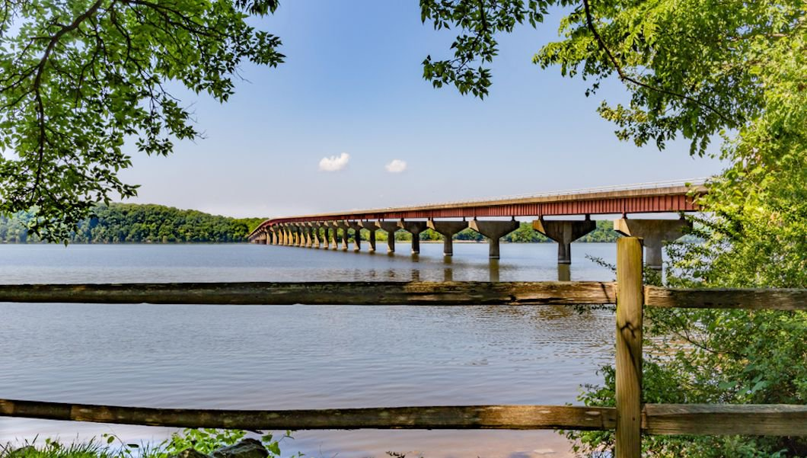Credit: MilesbeforeIsleep/Shutterstock

The Natchez Trace Parkway travels 444 miles through three states and 10,000 years of North American history. This year-round road trip is a National Scenic Byway and an All-American Road. It is maintained by the National Park Service and travels from the lower Mississippi River, through Alabama, to the Appalachian foothills in Tennessee. Highlights of the Natchez Trace include cypress swamps, virgin forests and the Pharr Mounds — 2,000-year-old ancient Native American burial grounds. Along with historical stops and numerous hiking opportunities, the Natchez Trace also offers up huge servings of southern hospitality to go with fantastic culinary delights.