TRIUMPH VITESSE

TRANS-AM RACE CAR

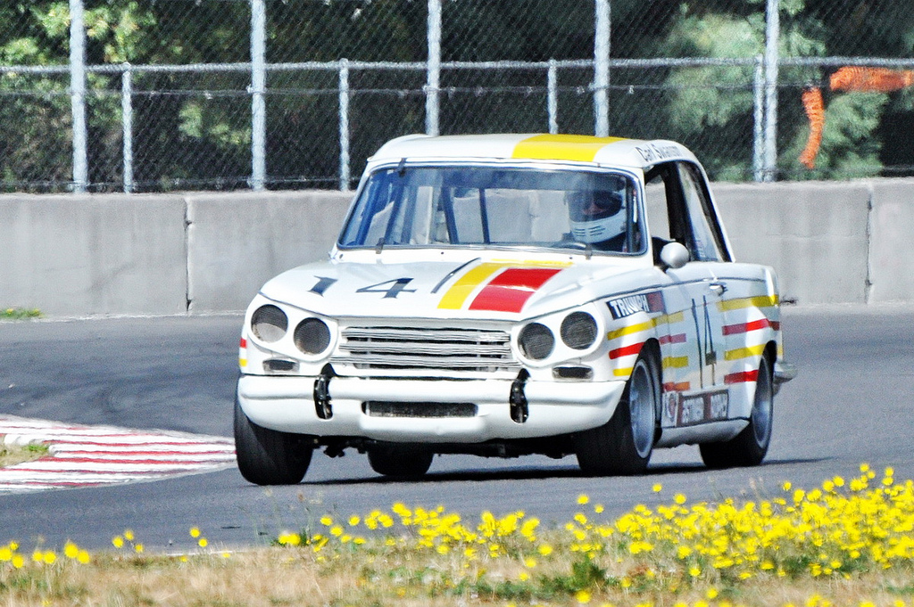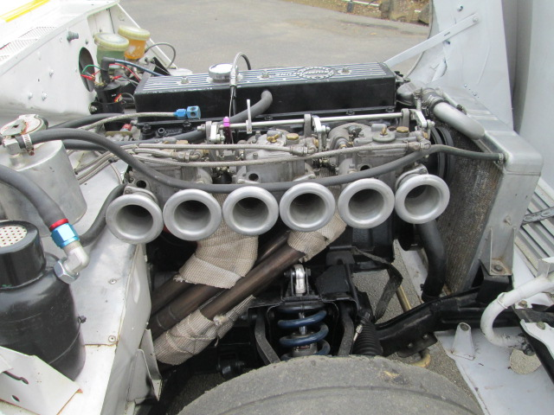
SHARON GILBERT
209-894-3950 bsgil99@hughes.net

REAL TRANS-AM HISTORY

RAN 4 RACES IN 1971 SPONSORED BY BRITISH LEYLAND AND PREPARED BY KAS KASTNER
FRESH TRIUMPH 6 CYLINDER TR6 ENGINE WITH FORGED CRANK, CARILLO RODS AND ROLLER ROCKERS
HOUSEMAN 5 SPEED TRANSMISSION AND TRIPLE 45 DCOE WEBER CARBS
UPGRADED FRONT AND REAR SUSPENSION WITH DOUBLE ADJUSTABLE SHOCKS, UPGRADED SPINDLES, UPRIGHTS AND STUB AXLES
COMES WITH SPARE RACE PREPARED GT6 ENGINE AND 4 SPEED TRIUMPH TRANSMISSION WITH DOLOMITE SPRINT HELICAL CLOSE RATIO GEAR SET AND A SECOND SET OF PANASPORT WHEELS
211 HP TO THE REAR WHEELS ON CHASSIS DYNO
$45,000

