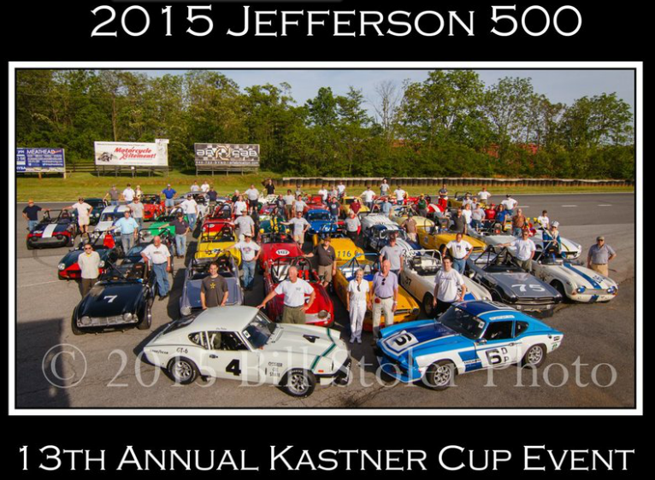

Planning for the Kastner Cup started back in early February 2014, as the Friends of Triumph started discussing where the 2015 event should be held – it was the year to have it somewhere on the East Coast. Regulars at the Jefferson suggested Summit Point, and the list got narrowed to the Jefferson and the Wild Hare (VIR) as the final two choices. The VRG board was enthusiastic about having Triumph as a featured marque, and we offered that we could deliver 30-35 cars, more than the usual 12-15 Triumphs that turn up for this event. We ended up with 43 Triumphs at the track, surpassing everyone’s expectations.

A little background - Friends of Triumph is the vintage Triumph racers' "non-organization", linked solely by an email list and our shared love of racing Triumphs. We designate one event a year as the Kastner Cup, trying to rotate it around the country so that it's accessible to everyone. In 2014 it was in Texas, 2013 at the Elkhart Lake Vintage Festival in September (another great turn-out) and the most recent prior East Coast event was Watkins Glen in 2007. I'm going to guess there are about 100 active Triumph vintage racers nationwide, so we had nearly half of them here at the Jefferson.

The Kastner Cup is awarded by Kas Kastner himself, who was in attendance with his lovely wife Peggy for the whole weekend. Kas and Peggy live in California, so this was a long trip for them, but Kas is very actively involved in the Triumph community, still writing books on the subject of racing Triumphs and how to prep the various models for racing. Kas awards the Cup to the car and racer who, while perhaps not the fastest car, best embodies the spirit of Triumph racing. So who is Kas Kastner, you ask?

R. W. "Kas" Kastner was a well known production car driver in the late 1950's and class Champion of the California Sports Car Club in 1959, as well as winner of the SCCA Championship during that same year, driving a 1958 Triumph TR3A. Kas worked for Cal Sales, the west coast Triumph distributor (then independent, subsequently factory owned) by day and raced on his own time with dealership support. Kas lead the Triumph entry for Sebring 1963 from Cal Sales, winning the class with three Triumph TR4s (then the new model), finishing 1st, 2nd and 4th. The success of that effort caused Triumph to formally establish the factory competition department in the U.S., led by Kas from 1963 through 1970.

Subsequently, he formed his own company, Kastner Brophy Racing, and fielded Triumphs under contract with the Triumph factory for the next two years. One of his cars from that era, the blue and white #6 GT6, a D production car, was very competitive in the Jefferson this year. Kas is well-known for his pursuit of power increases and handling improvements for the Triumph cars, with long experience in engine dynamometer testing, and the modifications he perfected still are the basis for the faster Triumphs today.

Kas, ever the competitor, also participated in sailboat racing for twenty years and was National Champion in two classes, along with many regional and divisional titles.
R.W. was the owner/manager of several companies including Arkay Inc., Kastner Brophy Racing and Roy Woods Racing. Under the flag of these companies he was the team manager of Formula 5000, Can Am and Indy car teams, and was also involved with the design, manufacturing and sale of automotive performance components - engine, suspension, turbocharger systems, brakes, and aerodynamic improvements.
He was equally successful as the Motorsports National Manager for Nissan of North America from 1986 thru 1990. Kas led the groups which designed, built and raced the Nissan prototype cars which dominated the International Motorsports Association (IMSA) series in the period. He led the team of Nissan Prototype cars to four consecutive Drivers Championships for Geoff Brabham and three consecutive Manufacturers championships for Nissan. The 12 hours of Sebring, 24 hours of Daytona and 24 hours of Le Mans were all on the long schedule of events.

So, the guy has spent his life in motorsports, with many successes, and he still likes to help us with our fifty-year-old LBCs!

How about the Jefferson?

First, some stats- there were 43 Triumphs and a Triumph-powered Peerless registered and at the track. We had participation almost across the entire model range:

Herald – 1 TR250 - 2
Spitfire – 13 GT6 - 8
TR3 – 3 TR6- 6
TR4 – 9 TR7 - 1

The cars ran in three groups, with TR4, 250, 6 and GT6 in Group 3, the Spitfires in Group 4 with their regular competition, the Spridgets, and the three TR3s in Group 5. The highlight of the weekend was to be the Kastner Cup, the all-Triumph race scheduled for the last slot of the day on Saturday. However, that was not to be as the skies opened up about 4:15, with about an inch of rain delivered in 20 minutes. The Carousel was flooded, pit-in was under water, and wheels/tires went floating by in the low end of the paddock. Even though it stopped raining by 5 PM, there was no way the race could be run with all the standing water on the track, and it was re-scheduled for the first slot on Sunday.

We woke to grey skies and mostly dry pavement. There were 32 cars on the grid for the start of the race. A damp track, family schedules, prior incidents (one Spitfire lost) and failed mechanicals cut into the Cup turn-out but it was still a full grid. The sky started spitting just before the race, then stopped, then resumed one lap in. By lap two, turn one-two was slick and the lap time for the leader - Mike Munson in a TR6 - was down nine seconds from his best the day before, to a 1:35. By lap four, the wet conditions worsened, and led to Boyd Wagner in a TR6 dropping two wheels into the grass exiting turn eight on the uphill (a fast corner) and backing up onto the tire wall. There was only minor damage to the car and the driver was fine, but the session was black flagged while the car was pulled. Three of us, including yours truly, missed two black flags prior to pit-in and continued to race. Oops. We got to sit in the pits for the balance of the race, which resumed and ran several more laps in wet conditions, with Mike Munson finishing in first place, and Mark Wheatley in a TR4 in second. This was the first wet Cup race in thirteen years!

So, who won the Kastner Cup? It went to Mark Wheatley from New Hampshire, who pilots his TR4 to lap times beyond the capability of most TR4s, while still sporting an historic NH license plate with a car that retains its stock appearance.

For me, other than the idiot factor of blowing the black flags, the wet race almost didn't matter. This was a fantastic race weekend - we all had lots of track time - I had nine sessions on track, and that's with skipping the last race on Sunday, and not running the two enduros.

Group 3, my group, was almost all TRs - there were 31 cars, and the only non-Triumphs were a Europa, a Daimler SP250 and a fast Lotus Elan - the only car that could match Mike Munson in the TR6. So, for Group 3 it was the Kastner Cup all weekend - all the big TRs and the GT6s. Sam Halkias, normally the driver of the fastest Triumph there (he was D production champion in a different TR6 in 2009) was battling carb float and jet issues, and was generally a little off Mike's pace, though still faster than the rest of us. Other than the leaders - the Lotus, Sam, Mike and Dick Stockton in his TR4 - the next 8-10 cars were separated by a second a lap over the whole bunch, and sometimes much less. There was fantastic, competitive racing, and mostly beautiful weather other than the massive thunderstorm. Even on Sunday, it dried out an hour after the Cup, and Group 3 - those of us who went out - had one of the most competitive races of the weekend, with Henry Frye in the screaming yellow TR-250 trading places with Mark Wheatley's TR4 at the front a number of times.

As usual, the vintage racing spirit prevailed. When Joe Lesnowski damaged the front end of his Spitfire in an incident and was out for the weekend, he offered the use of his rear axles to Jerry Barker, who had broken one in his Herald and the replacement failed to show up by FedEx as expected. Parts were shared, clutches were replaced, problems diagnosed throughout the paddock.

Triumph racers came from as far away as Iowa, California, Canada and Florida. First-timers at the track loved it, both for the driving challenge and for the old-school feel of the place.

Socially, it was great! 35+ Triumph racers were paddocked together in the grass around a big tent canopy - the others elected to scatter - and the canopy was a gathering point all weekend. Kas was based there, and we had some eye candy in the form of a couple of historic race Triumph tribute cars and two Triumph vendors with some fun shiny parts to look at. The Western Pennsylvania Triumph Association sponsored the canopy - thanks, guys! - and we had a barbecue with about 170 Triumph people under and around it Friday night. The pulled pork, brisket, cornbread, etc was amazing – next time you are at Summit you should make the quick trip down the road to Jordan Springs Market for some award-winning food. Beer was consumed (almost two kegs) and it was a great time for the racers, friends, family and Triumph street car club members to get together. Street Triumphs were all around the track most of the weekend, with a strong showing from some of the clubs in the region.

History flowed – for me, one of the prior owners of my car was there, as was a former GT6 racer who competed against my car at this track in the 1970s and knew/knows its then-owner well. I heard some great stories, and I'm sure others had similar experiences. That's part of what vintage racing is all about.

I’m hoping the Jefferson will become a regular event on the Triumph racers’ calendar!

